**Before Lts Upgrade**

**Create curl -**

curl --location 'http://localhost:8087/asset-services/v1/assets/_create' \

--header 'Accept: application/json, text/plain, */*' \

--header 'Accept-Language: en-US,en;q=0.9,hi;q=0.8' \

--header 'Connection: keep-alive' \

--header 'Content-Type: application/json;charset=UTF-8' \

--header 'Origin: http://localhost:3000' \

--header 'Referer: http://localhost:3000/digit-ui/employee/asset/assetservice/new-assets/acknowledgement' \

--header 'Sec-Fetch-Dest: empty' \

--header 'Sec-Fetch-Mode: cors' \

--header 'Sec-Fetch-Site: same-origin' \

--header 'User-Agent: Mozilla/5.0 (Windows NT 10.0; Win64; x64) AppleWebKit/537.36 (KHTML, like Gecko) Chrome/131.0.0.0 Safari/537.36' \

--header 'sec-ch-ua: "Google Chrome";v="131", "Chromium";v="131", "Not_A Brand";v="24"' \

--header 'sec-ch-ua-mobile: ?0' \

--header 'sec-ch-ua-platform: "Windows"' \

--data '{

"Asset": {

"accountId": "",

"tenantId": "pg.citya",

"assetBookRefNo": "Refence/2024",

"assetName": "Chair for NIUA",

"description": "Description Lorem Ipsum data is coming from Lorem ipsum offical site",

"assetClassification": "MOVABLE",

"assetParentCategory": "IT",

"assetCategory": "STORAGE_DEVICES",

"assetSubCategory": "HARD_DRIVES_HDDS",

"department": "DEPT_5",

"assetType": "INFRASTRUCTURE_ASSET",

"assetUsage": "DISPOSED",

"financialYear": "2024-25",

"sourceOfFinance": "MUNICIPAL_FUNDS",

"applicationNo": "",

"approvalDate": "",

"applicationDate": "",

"status": "",

"modeOfPossessionOrAcquisition": "AST_LEASED",

"invoiceDate": 1730419200,

"invoiceNumber": "Invoice _nuuuuu33333",

"purchaseDate": 1730419200,

"purchaseOrderNumber": "2331232213",

"warranty": "15_YEAR",

"assetAge": "1 MONTH",

"location": "28.590213, 77.2257146",

"purchaseCost": 222222,

"acquisitionCost": 33333,

"bookValue": 255555,

"action": "",

"businessService": "asset-create",

"addressDetails": {

"city": "City A",

"locality": {

"code": "JLC414",

"area": "Area1"

}

},

"documents": [

{

"documentType": "OWNER.RECIEPTPHOTO",

"fileStoreId": "bd4932e3-d199-48a0-b1a7-db4c5a804551",

"documentUid": "bd4932e3-d199-48a0-b1a7-db4c5a804551",

"latitude": null,

"longitude": null

},

{

"documentType": "OWNER.ASSETPHOTO",

"fileStoreId": "2a776858-784a-4673-b32c-bdf20e5d3bc6",

"documentUid": "2a776858-784a-4673-b32c-bdf20e5d3bc6",

"latitude": null,

"longitude": null

}

],

"workflow": {

"action": "INITIATE",

"businessService": "asset-create",

"moduleName": "asset-services"

},

"additionalDetails": {

"assetParentCategory": "IT",

"warranty": {

"i18nKey": "15_YEAR",

"code": "15_YEAR",

"name": "warranty"

},

"modeOfPossessionOrAcquisition": {

"i18nKey": "AST_LEASED",

"code": "AST_LEASED",

"name": "modeOfPossessionOrAcquisition"

},

"brand": "Brand ",

"manufacturer": "Manufacturer "

}

},

"RequestInfo": {

"apiId": "Rainmaker",

"authToken": "98902e75-6108-4ca5-b6ac-c2fc42c7816f",

"userInfo": {

"id": 194,

"uuid": "ab5db0ed-b3ae-4fb8-bd93-f9913a0fa5da",

"userName": "ASSET_INITIATOR",

"name": "Asset Initiator",

"mobileNumber": "9999075991",

"emailId": null,

"locale": null,

"type": "EMPLOYEE",

"roles": [

{

"name": "Asset Initiator Employee",

"code": "ASSET_INITIATOR",

"tenantId": "pg.citya"

},

{

"name": "Asset Approver",

"code": "ASSET_APPROVER",

"tenantId": "pg.citya"

}

],

"active": true,

"tenantId": "pg.citya",

"permanentCity": null

},

"msgId": "1734002475778|en_IN",

"plainAccessRequest": {}

}

}'

**Postman-**

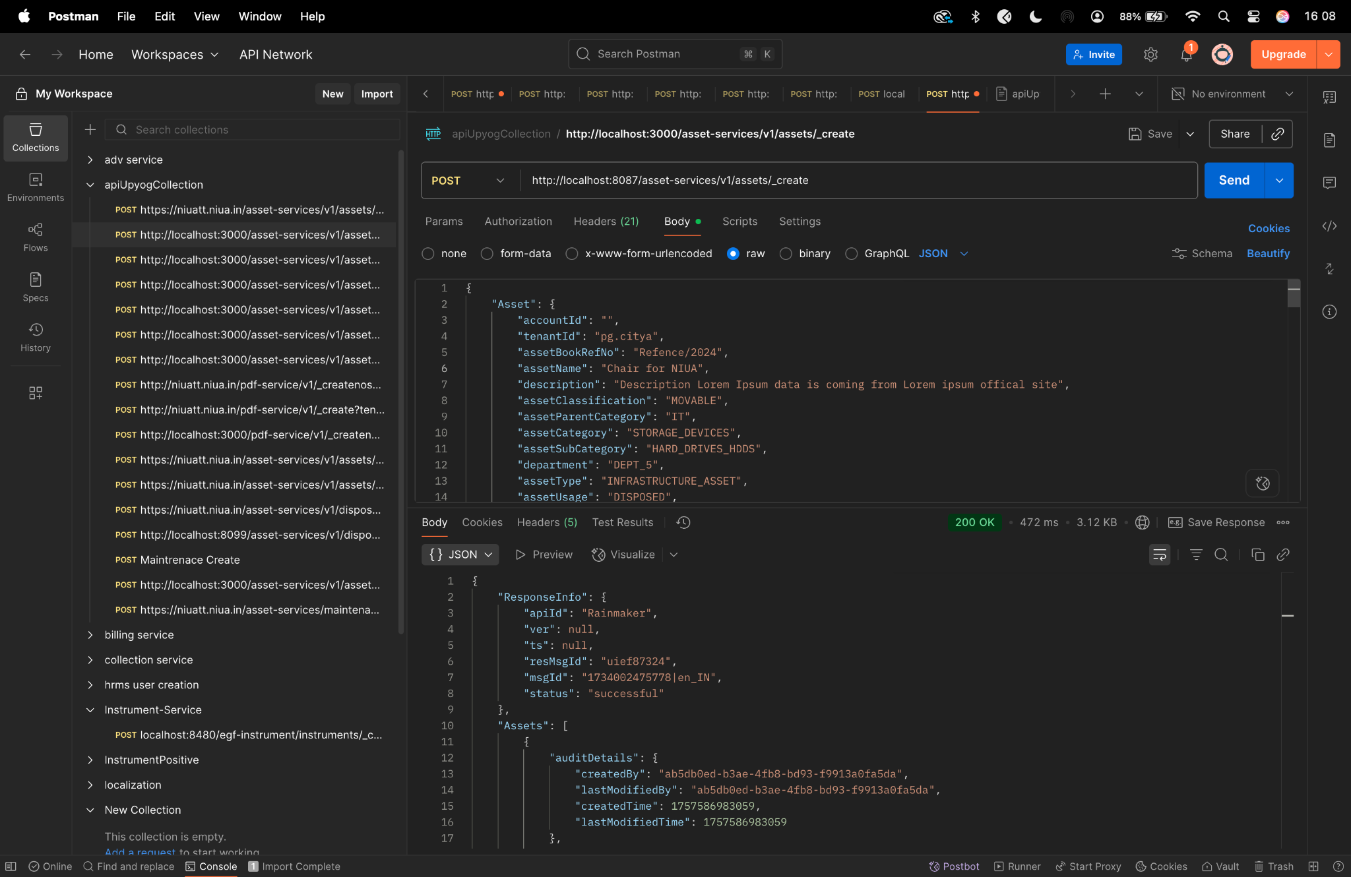

**Update curl -**

curl --location 'http://localhost:8087/asset-services/v1/assets/_update' \

--header 'Accept: application/json, text/plain, */*' \

--header 'Accept-Language: en-US,en;q=0.9,hi;q=0.8' \

--header 'Connection: keep-alive' \

--header 'Content-Type: application/json;charset=UTF-8' \

--header 'Origin: http://localhost:3000' \

--header 'Referer: http://localhost:3000/digit-ui/employee/asset/assetservice/edit-response' \

--header 'Sec-Fetch-Dest: empty' \

--header 'Sec-Fetch-Mode: cors' \

--header 'Sec-Fetch-Site: same-origin' \

--header 'User-Agent: Mozilla/5.0 (Windows NT 10.0; Win64; x64) AppleWebKit/537.36 (KHTML, like Gecko) Chrome/131.0.0.0 Safari/537.36' \

--header 'sec-ch-ua: "Google Chrome";v="131", "Chromium";v="131", "Not_A Brand";v="24"' \

--header 'sec-ch-ua-mobile: ?0' \

--header 'sec-ch-ua-platform: "Windows"' \

--data '{

"Asset": {

"accountId": "ab5db0ed-b3ae-4fb8-bd93-f9913a0fa5da",

"tenantId": "pg.citya",

"assetBookRefNo": "HP/20022/Ref_No/2222",

"assetName": "Chair for NIUA - UPDATED",

"description": "Lorem Ipsum is simply dummy text of the printing and typesetting industry. Lorem Ipsum has been the industry'\''s standard dummy text ever since UPdate - UPDATED",

"assetClassification": "MOVABLE",

"assetParentCategory": "FURNITURE",

"assetCategory": "HOME_EQUIPMENT",

"assetSubCategory": "SITTER",

"department": "DEPT_2",

"financialYear": "2024-25",

"sourceOfFinance": "AMRUT",

"applicationNo": "PG-1013-2025-I-001235",

"approvalDate": "",

"id": "292c3bd8-4060-4efa-9f0d-d1fc81926625",

"applicationDate": "",

"status": "Employee Action Pending",

"action": "",

"businessService": "asset-create",

"addressDetails": {

"addressLine1": null,

"addressLine2": null,

"buildingName": null,

"doorNo": null,

"street": null,

"pincode": null,

"city": "City A",

"locality": {

"code": "JLC254",

"latitude": 0,

"longitude": 0

}

},

"documents": [

{

"documentId": "bd2d05d5-5462-4dde-a096-fed7df2c7b02",

"documentType": "OWNER.RECIEPTPHOTO",

"fileStoreId": "f0d569d7-8c71-4d6d-81a1-1ec93eb91981",

"documentUid": "6c5e4398-8a2f-4489-8459-611fa5ecc42c",

"docDetails": null

},

{

"documentId": "e82c5649-0591-44fe-b5f3-363e88e54505",

"documentType": "OWNER.ANYSUPPORTINGDOCUMENT",

"fileStoreId": "bee8e2cc-5d72-4abc-bc98-18b2e1223c64",

"documentUid": "77235dfb-3758-400c-8b00-10a8d711387b",

"docDetails": null

},

{

"documentId": "25f96703-2005-4b90-b696-b14601c4407a",

"documentType": "OWNER.ASSETPHOTO",

"fileStoreId": "769d03cd-4f95-4b86-ab3d-ceec1b741f88",

"documentUid": "845e0cc3-0aa2-4d03-b1a0-290726e7da60",

"docDetails": null

}

],

"workflow": {

"action": "VERIFY",

"businessService": "asset-create",

"moduleName": "asset-services"

},

"additionalDetails": {

"key": 1733743796659,

"brand": "LG Brand UPdate",

"manufacturer": "LG Manufacturer UPdate",

"warranty": {

"code": "1_YEAR",

"name": "warranty",

"value": "1 Year",

"i18nKey": "1 Year"

},

"acquisitionProcessionDetails": {}

}

},

"RequestInfo": {

"apiId": "Rainmaker",

"authToken": "2f302a1f-161a-4d9e-8c02-7fbad9b98f0f",

"userInfo": {

"id": 194,

"uuid": "ab5db0ed-b3ae-4fb8-bd93-f9913a0fa5da",

"userName": "ASSET_INITIATOR",

"name": "Asset Initiator",

"mobileNumber": "9999075991",

"emailId": null,

"locale": null,

"type": "EMPLOYEE",

"roles": [

{

"name": "Asset Initiator Employee",

"code": "ASSET_INITIATOR",

"tenantId": "pg.citya"

},

{

"name": "Asset Approver",

"code": "ASSET_APPROVER",

"tenantId": "pg.citya"

},

{

"name": "Asset Document Verifier",

"code": "ASSET_VERIFIER",

"tenantId": "pg.citya"

}

],

"active": true,

"tenantId": "pg.citya",

"permanentCity": null

},

"msgId": "1733743900982|en_IN",

"plainAccessRequest": {}

}

}'

**Postman-**

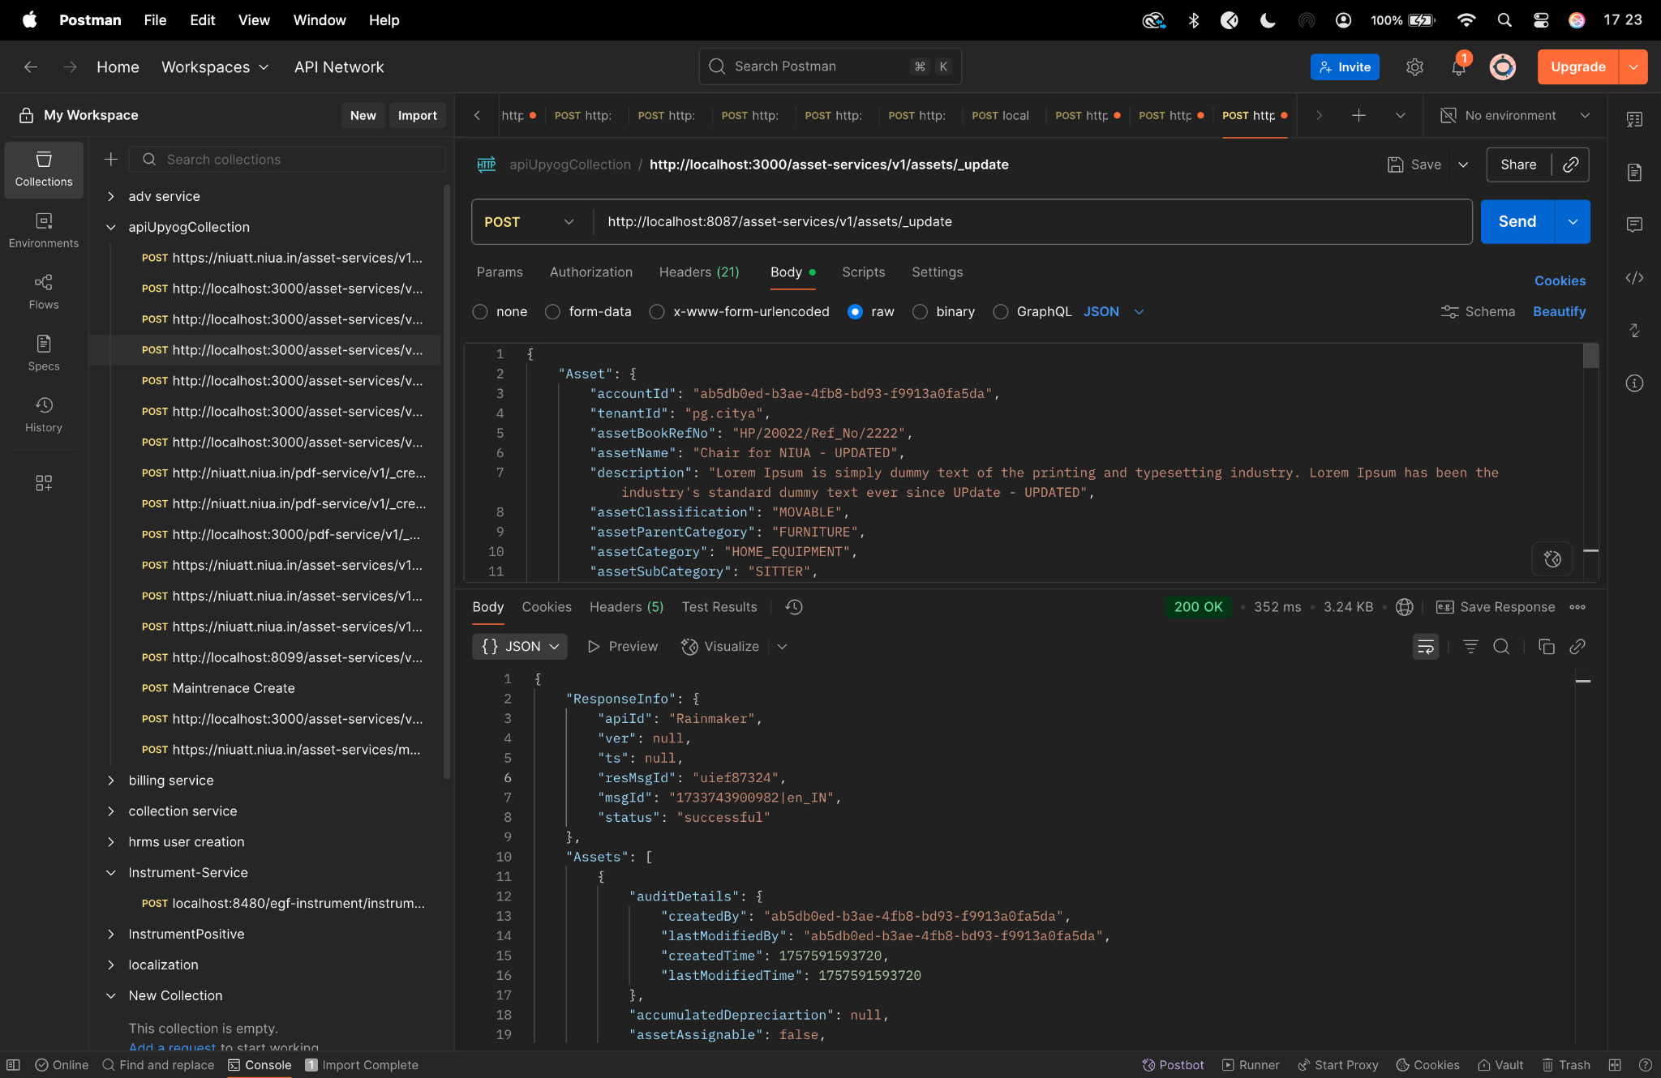

**Search curl-**

curl --location 'http://localhost:8087/asset-services/v1/assets/_search?tenantId=pg.citya&fromDate=1717180200000&toDate=1732645799000&limit=10&sortBy=commencementDate&sortOrder=DESC&_=1732600268762' \

--header 'Accept: application/json, text/plain, */*' \

--header 'Accept-Language: en-US,en;q=0.9,hi;q=0.8' \

--header 'Connection: keep-alive' \

--header 'Content-Type: application/json;charset=UTF-8' \

--header 'Origin: http://localhost:3000' \

--header 'Referer: http://localhost:3000/digit-ui/employee/asset/assetservice/my-asset' \

--header 'Sec-Fetch-Dest: empty' \

--header 'Sec-Fetch-Mode: cors' \

--header 'Sec-Fetch-Site: same-origin' \

--header 'User-Agent: Mozilla/5.0 (Windows NT 10.0; Win64; x64) AppleWebKit/537.36 (KHTML, like Gecko) Chrome/131.0.0.0 Safari/537.36' \

--header 'sec-ch-ua: "Google Chrome";v="131", "Chromium";v="131", "Not_A Brand";v="24"' \

--header 'sec-ch-ua-mobile: ?0' \

--header 'sec-ch-ua-platform: "Windows"' \

--data-raw '{

"RequestInfo": {

"apiId": "Rainmaker",

"authToken": "eceb5456-e376-4fe0-9598-b710bfb741d6",

"userInfo": {

"id": 194,

"uuid": "a9c4c021-f97b-49d2-8339-969ca2c376f8",

"userName": "BimalAAI2",

"name": "BimalAAITow",

"mobileNumber": "9912722222",

"emailId": "BimalAAITow^@gmail.com",

"locale": null,

"type": "EMPLOYEE",

"roles": [

{

"name": "Asset Initiator Employee",

"code": "ASSET_INITIATOR",

"tenantId": "pg.citya"

}

],

"active": true,

"tenantId": "pg.citya",

"permanentCity": null

},

"msgId": "1732600268762|en_IN",

"plainAccessRequest": {}

}

}'

**Postman-** 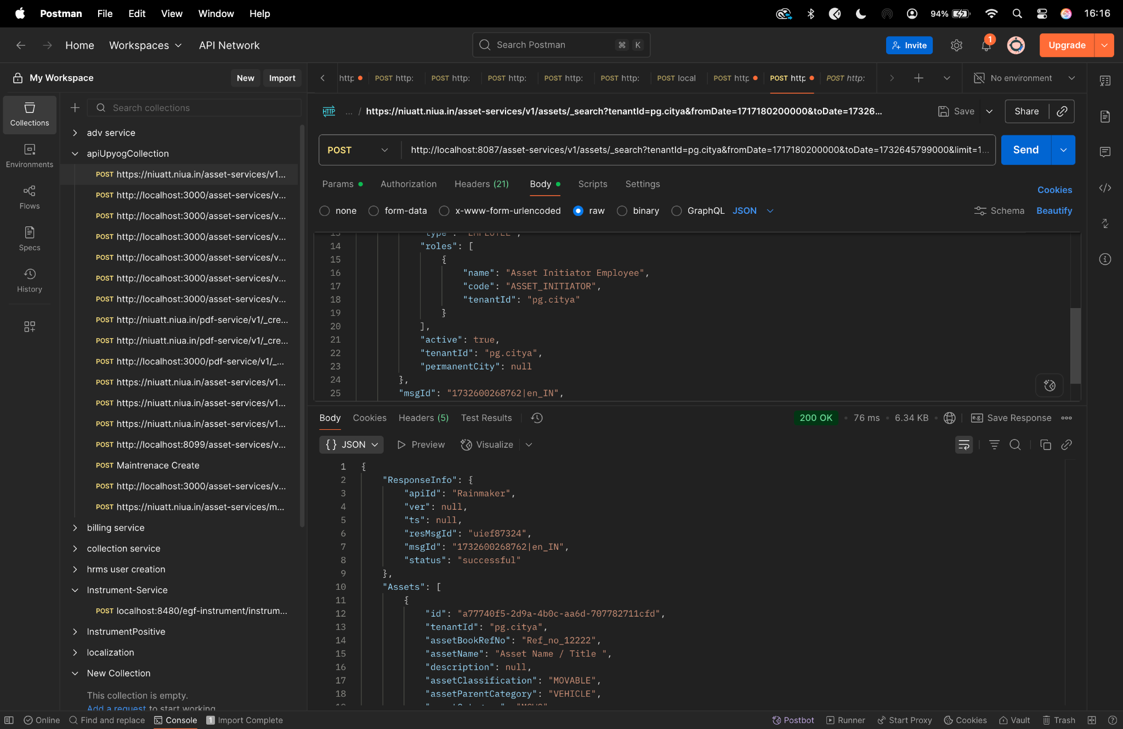

**assignment/_create -**

curl --location 'http://localhost:8087/asset-services/v1/assets/assignment/_create' \

--header 'accept: application/json, text/plain, */*' \

--header 'accept-language: en-GB,en-US;q=0.9,en;q=0.8,hi;q=0.7' \

--header 'content-type: application/json;charset=UTF-8' \

--header 'origin: https://niuatt.niua.in' \

--header 'priority: u=1, i' \

--header 'referer: https://niuatt.niua.in/digit-ui/employee/asset/assetservice/assign-response' \

--header 'sec-ch-ua: "Not;A=Brand";v="99", "Google Chrome";v="139", "Chromium";v="139"' \

--header 'sec-ch-ua-mobile: ?0' \

--header 'sec-ch-ua-platform: "macOS"' \

--header 'sec-fetch-dest: empty' \

--header 'sec-fetch-mode: cors' \

--header 'sec-fetch-site: same-origin' \

--header 'user-agent: Mozilla/5.0 (Macintosh; Intel Mac OS X 10_15_7) AppleWebKit/537.36 (KHTML, like Gecko) Chrome/139.0.0.0 Safari/537.36' \

--header 'Cookie: locale=en_IN; _ga=GA1.1.559242739.1756447705; _clck=19weqns%5E2%5Efyv%5E0%5E2067; _ga_VZ9TNBTB3X=GS2.1.s1756447704$o1$g1$t1756447780$j59$l0$h0; _ga_E39TFV5YXM=GS2.1.s1756447709$o1$g1$t1756448684$j60$l0$h0' \

--data '{

"Asset": {

"id": "292c3bd8-4060-4efa-9f0d-d1fc81926625",

"tenantId": "pg.citya",

"applicationNo": "PG-1013-2025-I-001236",

"assetAssignment": {

"assignmentId": "",

"assetApplicaltionNo": "",

"assetId": "",

"assignedUserName": "Kunal Gaurav",

"designation": "DESIG_01",

"department": "DEPT_1",

"assignedDate": 1756924200000,

"isAssigned": true,

"allocatedDepartment": "DEPT_1",

"employeeCode": "EMP-001",

"auditDetails": {

"createdBy": "",

"lastModifiedBy": "",

"createdTime": "",

"lastModifiedTime": ""

}

}

},

"RequestInfo": {

"apiId": "Rainmaker",

"authToken": "54552937-0eb8-4cec-910a-182918416f7f",

"userInfo": {

"id": 909,

"uuid": "491381fb-858c-4582-a8cd-24ea08394bb8",

"userName": "ASSET_APPROVER",

"name": "Asset Approver",

"mobileNumber": "8448489439",

"emailId": null,

"locale": null,

"type": "EMPLOYEE",

"roles": [

{

"name": "Asset Approver",

"code": "ASSET_APPROVER",

"tenantId": "pg.citya"

},

{

"name": "Asset Allocator",

"code": "ASSET_ALLOCATOR",

"tenantId": "pg.citya"

}

],

"active": true,

"tenantId": "pg.citya",

"permanentCity": null

},

"msgId": "1757667814971|en_IN",

"plainAccessRequest": {}

}

}'

**Postman-**

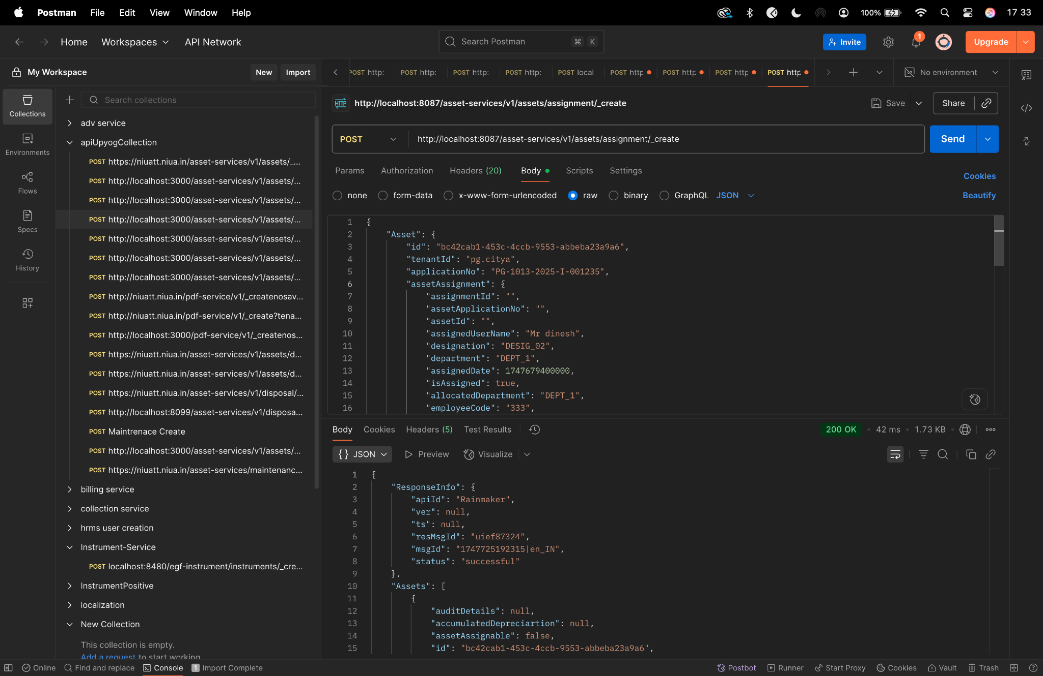

**assignment/_update -**

curl --location 'http://localhost:8087/asset-services/v1/assets/assignment/_update' \

--header 'accept: application/json, text/plain, */*' \

--header 'accept-language: en-GB,en-US;q=0.9,en;q=0.8,hi;q=0.7' \

--header 'content-type: application/json;charset=UTF-8' \

--header 'origin: https://niuatt.niua.in' \

--header 'priority: u=1, i' \

--header 'referer: https://niuatt.niua.in/digit-ui/employee/asset/assetservice/assign-response' \

--header 'sec-ch-ua: "Not;A=Brand";v="99", "Google Chrome";v="139", "Chromium";v="139"' \

--header 'sec-ch-ua-mobile: ?0' \

--header 'sec-ch-ua-platform: "macOS"' \

--header 'sec-fetch-dest: empty' \

--header 'sec-fetch-mode: cors' \

--header 'sec-fetch-site: same-origin' \

--header 'user-agent: Mozilla/5.0 (Macintosh; Intel Mac OS X 10_15_7) AppleWebKit/537.36 (KHTML, like Gecko) Chrome/139.0.0.0 Safari/537.36' \

--header 'Cookie: locale=en_IN; _ga=GA1.1.559242739.1756447705; _clck=19weqns%5E2%5Efyv%5E0%5E2067; _ga_VZ9TNBTB3X=GS2.1.s1756447704$o1$g1$t1756447780$j59$l0$h0; _ga_E39TFV5YXM=GS2.1.s1756447709$o1$g1$t1756448684$j60$l0$h0' \

--data '{

"Asset": {

"id": "292c3bd8-4060-4efa-9f0d-d1fc81926625",

"tenantId": "pg.citya",

"applicationNo": "PG-1013-2025-I-001236",

"assetAssignment": {

"assignmentId": "34566d7a-e49f-45a2-8673-7c412546ebdd",

"assetApplicaltionNo": "PG-1013-2025-I-001236",

"assetId": "292c3bd8-4060-4efa-9f0d-d1fc81926625",

"assignedUserName": "Kunal Gaurav - Updated",

"designation": "DESIG_02",

"department": "DEPT_2",

"assignedDate": 1756924200000,

"returnDate": 1757529000000,

"isAssigned": false,

"allocatedDepartment": "DEPT_2",

"employeeCode": "EMP-002",

"auditDetails": {

"createdBy": "admin",

"lastModifiedBy": "admin",

"createdTime": 1672531200000,

"lastModifiedTime": 1672534800000

}

}

},

"RequestInfo": {

"apiId": "Rainmaker",

"authToken": "54552937-0eb8-4cec-910a-182918416f7f",

"userInfo": {

"id": 909,

"uuid": "491381fb-858c-4582-a8cd-24ea08394bb8",

"userName": "ASSET_APPROVER",

"name": "Asset Approver",

"mobileNumber": "8448489439",

"emailId": null,

"locale": null,

"type": "EMPLOYEE",

"roles": [

{

"name": "Asset Approver",

"code": "ASSET_APPROVER",

"tenantId": "pg.citya"

},

{

"name": "Asset Allocator",

"code": "ASSET_ALLOCATOR",

"tenantId": "pg.citya"

}

],

"active": true,

"tenantId": "pg.citya",

"permanentCity": null

},

"msgId": "1757667814971|en_IN",

"plainAccessRequest": {}

}

}'

**Postman -**

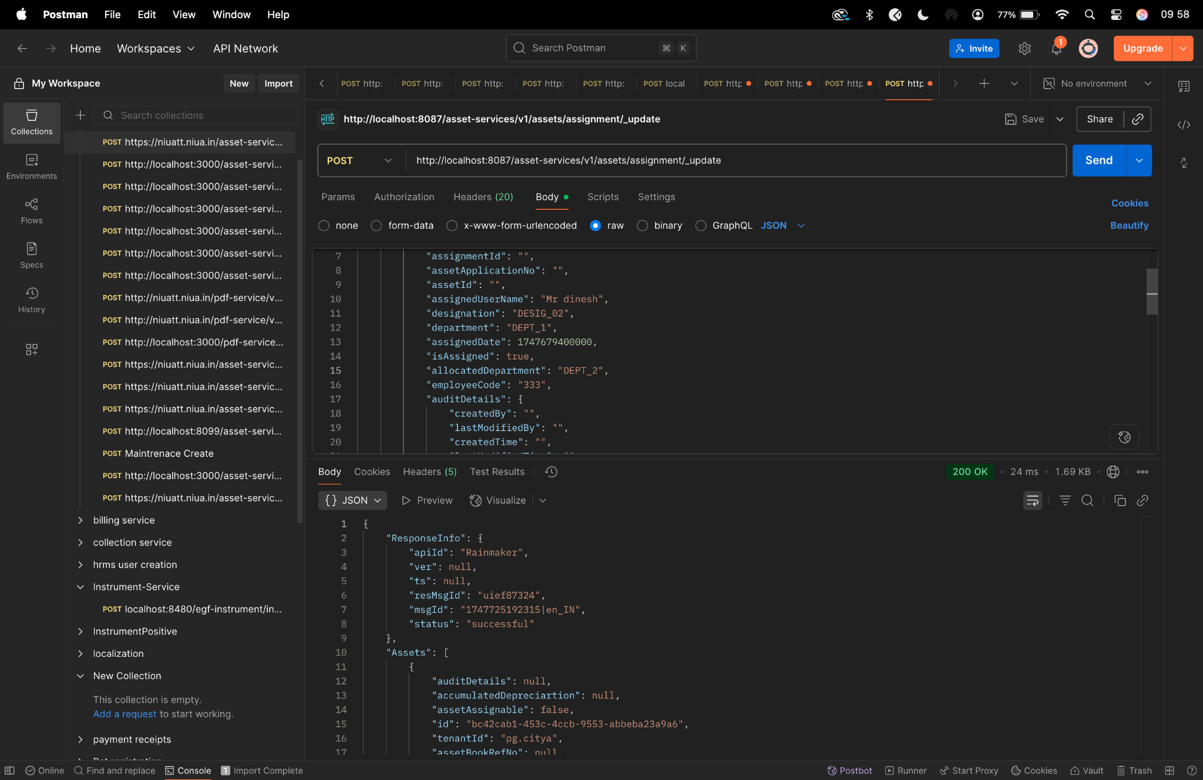

**assignment _search-**

curl --location 'http://localhost:8087/asset-services/v1/assets/assignment/_search' \

--header 'accept: application/json, text/plain, */*' \

--header 'accept-language: en-GB,en-US;q=0.9,en;q=0.8,hi;q=0.7' \

--header 'content-type: application/json;charset=UTF-8' \

--header 'origin: https://niuatt.niua.in' \

--header 'priority: u=1, i' \

--header 'referer: https://niuatt.niua.in/digit-ui/employee/asset/assetservice/assign-response' \

--header 'sec-ch-ua: "Not;A=Brand";v="99", "Google Chrome";v="139", "Chromium";v="139"' \

--header 'sec-ch-ua-mobile: ?0' \

--header 'sec-ch-ua-platform: "macOS"' \

--header 'sec-fetch-dest: empty' \

--header 'sec-fetch-mode: cors' \

--header 'sec-fetch-site: same-origin' \

--header 'user-agent: Mozilla/5.0 (Macintosh; Intel Mac OS X 10_15_7) AppleWebKit/537.36 (KHTML, like Gecko) Chrome/139.0.0.0 Safari/537.36' \

--header 'Cookie: locale=en_IN; _ga=GA1.1.559242739.1756447705; _clck=19weqns%5E2%5Efyv%5E0%5E2067; _ga_VZ9TNBTB3X=GS2.1.s1756447704$o1$g1$t1756447780$j59$l0$h0; _ga_E39TFV5YXM=GS2.1.s1756447709$o1$g1$t1756448684$j60$l0$h0' \

--data '{

"Asset": {

"id": "292c3bd8-4060-4efa-9f0d-d1fc81926625",

"tenantId": "pg.citya"

},

"RequestInfo": {

"apiId": "Rainmaker",

"authToken": "54552937-0eb8-4cec-910a-182918416f7f",

"userInfo": {

"id": 909,

"uuid": "491381fb-858c-4582-a8cd-24ea08394bb8",

"userName": "ASSET_APPROVER",

"name": "Asset Approver",

"mobileNumber": "8448489439",

"emailId": null,

"locale": null,

"type": "EMPLOYEE",

"roles": [

{

"name": "Asset Approver",

"code": "ASSET_APPROVER",

"tenantId": "pg.citya"

},

{

"name": "Asset Allocator",

"code": "ASSET_ALLOCATOR",

"tenantId": "pg.citya"

}

],

"active": true,

"tenantId": "pg.citya",

"permanentCity": null

},

"msgId": "1757667814971|en_IN",

"plainAccessRequest": {}

}

}'

**Postman-**

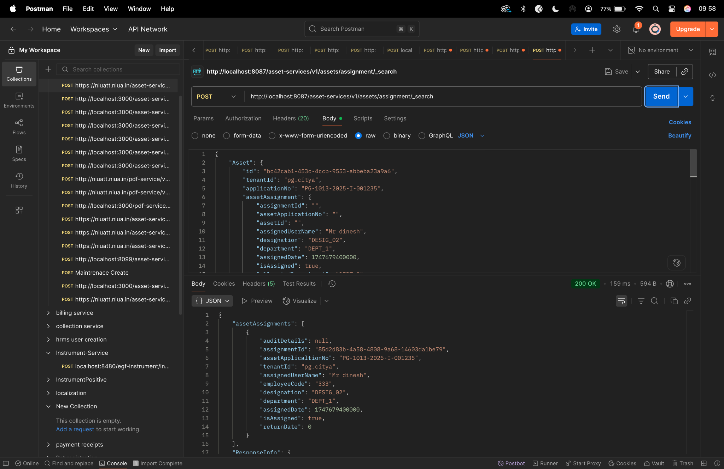

**Depreciation_process-**

curl --location 'http://localhost:8087/asset-services/v1/assets/depreciation/_process' \

--header 'accept: application/json, text/plain, */*' \

--header 'accept-language: en-GB,en-US;q=0.9,en;q=0.8,hi;q=0.7' \

--header 'content-type: application/json;charset=UTF-8' \

--header 'origin: https://niuatt.niua.in' \

--header 'priority: u=1, i' \

--header 'referer: https://niuatt.niua.in/digit-ui/employee/asset/assetservice/my-asset' \

--header 'sec-ch-ua: "Not;A=Brand";v="99", "Google Chrome";v="139", "Chromium";v="139"' \

--header 'sec-ch-ua-mobile: ?0' \

--header 'sec-ch-ua-platform: "macOS"' \

--header 'sec-fetch-dest: empty' \

--header 'sec-fetch-mode: cors' \

--header 'sec-fetch-site: same-origin' \

--header 'user-agent: Mozilla/5.0 (Macintosh; Intel Mac OS X 10_15_7) AppleWebKit/537.36 (KHTML, like Gecko) Chrome/139.0.0.0 Safari/537.36' \

--header 'Cookie: locale=en_IN; _ga=GA1.1.559242739.1756447705; _clck=19weqns%5E2%5Efyv%5E0%5E2067; _ga_VZ9TNBTB3X=GS2.1.s1756447704$o1$g1$t1756447780$j59$l0$h0; _ga_E39TFV5YXM=GS2.1.s1756447709$o1$g1$t1756448684$j60$l0$h0' \

--data '{

"Asset": {

"tenantId": "pg.citya",

"id": "689726aa-bfe0-43d8-97bf-9b678e6ba147",

"accountId": ""

},

"RequestInfo": {

"apiId": "Rainmaker",

"authToken": "54552937-0eb8-4cec-910a-182918416f7f",

"userInfo": {

"id": 909,

"uuid": "491381fb-858c-4582-a8cd-24ea08394bb8",

"userName": "ASSET_APPROVER",

"name": "Asset Approver",

"mobileNumber": "8448489439",

"emailId": null,

"locale": null,

"type": "EMPLOYEE",

"roles": [

{

"name": "Asset Approver",

"code": "ASSET_APPROVER",

"tenantId": "pg.citya"

},

{

"name": "Asset Allocator",

"code": "ASSET_ALLOCATOR",

"tenantId": "pg.citya"

}

],

"active": true,

"tenantId": "pg.citya",

"permanentCity": null

},

"msgId": "1757669988361|en_IN",

"plainAccessRequest": {}

}

}'

**Postman-**

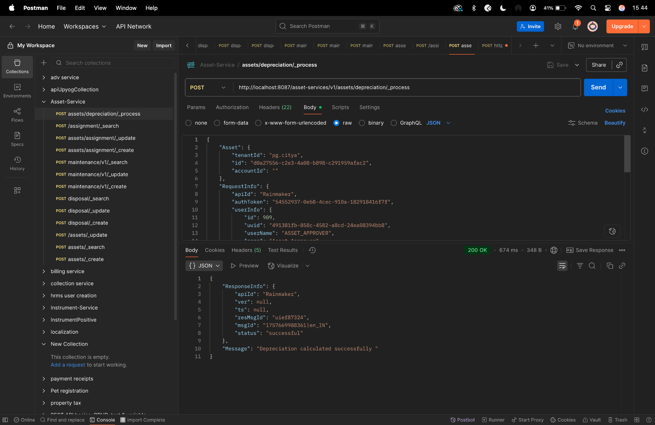

**depreciation/_list-**

curl --location 'http://localhost:8087/asset-services/v1/assets/depreciation/list' \

--header 'accept: application/json, text/plain, */*' \

--header 'accept-language: en-GB,en-US;q=0.9,en;q=0.8,hi;q=0.7' \

--header 'content-type: application/json;charset=UTF-8' \

--header 'origin: https://niuatt.niua.in' \

--header 'priority: u=1, i' \

--header 'referer: https://niuatt.niua.in/digit-ui/employee/asset/assetservice/applicationsearch/application-details/PG-1013-2025-I-001237' \

--header 'sec-ch-ua: "Not;A=Brand";v="99", "Google Chrome";v="139", "Chromium";v="139"' \

--header 'sec-ch-ua-mobile: ?0' \

--header 'sec-ch-ua-platform: "macOS"' \

--header 'sec-fetch-dest: empty' \

--header 'sec-fetch-mode: cors' \

--header 'sec-fetch-site: same-origin' \

--header 'user-agent: Mozilla/5.0 (Macintosh; Intel Mac OS X 10_15_7) AppleWebKit/537.36 (KHTML, like Gecko) Chrome/139.0.0.0 Safari/537.36' \

--header 'Cookie: locale=en_IN; _ga=GA1.1.559242739.1756447705; _clck=19weqns%5E2%5Efyv%5E0%5E2067; _ga_VZ9TNBTB3X=GS2.1.s1756447704$o1$g1$t1756447780$j59$l0$h0; _ga_E39TFV5YXM=GS2.1.s1756447709$o1$g1$t1756448684$j60$l0$h0' \

--data '{

"Asset": {

"tenantId": "pg.citya",

"id": "d0a27556-c2e3-4a08-b898-c291959afac2",

"accountId": ""

},

"RequestInfo": {

"apiId": "Rainmaker",

"authToken": "54552937-0eb8-4cec-910a-182918416f7f",

"userInfo": {

"id": 909,

"uuid": "491381fb-858c-4582-a8cd-24ea08394bb8",

"userName": "ASSET_APPROVER",

"name": "Asset Approver",

"mobileNumber": "8448489439",

"emailId": null,

"locale": null,

"type": "EMPLOYEE",

"roles": [

{

"name": "Asset Approver",

"code": "ASSET_APPROVER",

"tenantId": "pg.citya"

},

{

"name": "Asset Allocator",

"code": "ASSET_ALLOCATOR",

"tenantId": "pg.citya"

}

],

"active": true,

"tenantId": "pg.citya",

"permanentCity": null

},

"msgId": "1757670044190|en_IN",

"plainAccessRequest": {}

}

}'

**Postman-**

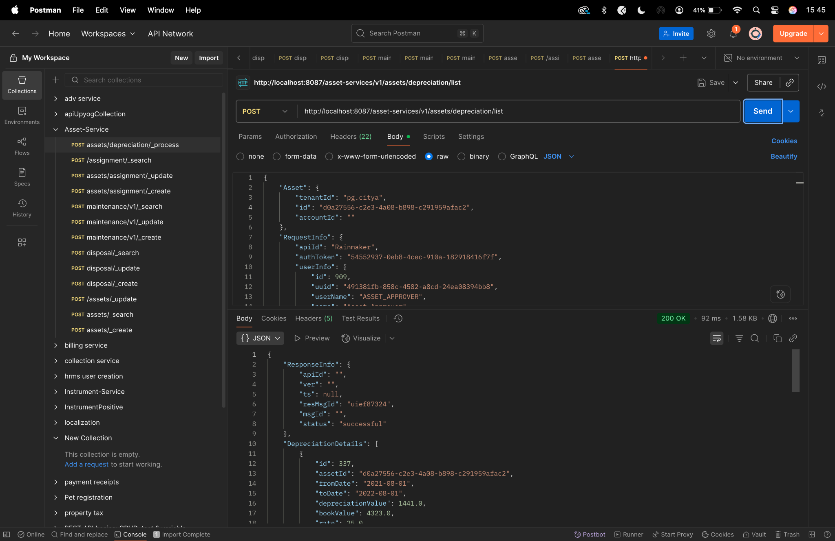

**maintenance/_create**

curl --location 'http://localhost:8087/asset-services/maintenance/v1/_create' \

--header 'sec-ch-ua-platform: "macOS"' \

--header 'Referer: https://niuatt.niua.in/digit-ui/employee/asset/assetservice/maintenance' \

--header 'User-Agent: Mozilla/5.0 (Macintosh; Intel Mac OS X 10_15_7) AppleWebKit/537.36 (KHTML, like Gecko) Chrome/133.0.0.0 Safari/537.36' \

--header 'Accept: application/json, text/plain, */*' \

--header 'sec-ch-ua: "Not(A:Brand";v="99", "Google Chrome";v="133", "Chromium";v="133"' \

--header 'Content-Type: application/json;charset=UTF-8' \

--header 'sec-ch-ua-mobile: ?0' \

--data '{

"AssetMaintenance": {

"maintenanceId": "",

"assetId": "292c3bd8-4060-4efa-9f0d-d1fc81926625",

"tenantId": "pg.citya",

"warrantyStatus": "IN_AMC",

"assetWarrantyDescription": "sdfdsf",

"amcDetails": "sdfsd",

"assetMaintenanceDate": 1756771200,

"assetNextMaintenanceDate": null,

"maintenanceType": "CORRECTIVE",

"paymentType": "BANK_TRANSFER",

"costOfMaintenance": "",

"description": "warranty",

"vendor": "dsfs",

"maintenanceCycle": "QUARTERLY",

"partsAddedOrReplaced": "sdfsdf",

"preConditionRemarks": "dfsdf",

"postConditionRemarks": "dsfsdf",

"isAMCExpired": true,

"isWarrantyExpired": false,

"isLifeOfAssetAffected": "TRUE",

"assetMaintenanceIncreasedYear": "2",

"documents": [

{

"documentType": "ASSET.MAINTENANCE.DOC3",

"fileStoreId": "16ce3c83-a416-4e60-b6ff-1eaa1a47c278",

"documentUid": "16ce3c83-a416-4e60-b6ff-1eaa1a47c278"

},

{

"documentType": "ASSET.MAINTENANCE.DOC1",

"fileStoreId": "ba1ca218-ca65-438c-9a2e-519acf799f3e",

"documentUid": "ba1ca218-ca65-438c-9a2e-519acf799f3e"

},

{

"documentType": "ASSET.MAINTENANCE.DOC2",

"fileStoreId": "48e2932e-432b-4f83-8b0a-09229f107fbc",

"documentUid": "48e2932e-432b-4f83-8b0a-09229f107fbc"

}

],

"auditDetails": {

"createdBy": "",

"createdTime": "",

"lastModifiedBy": "",

"lastModifiedTime": ""

}

},

"RequestInfo": {

"apiId": "Rainmaker",

"authToken": "54552937-0eb8-4cec-910a-182918416f7f",

"userInfo": {

"id": 909,

"uuid": "491381fb-858c-4582-a8cd-24ea08394bb8",

"userName": "ASSET_APPROVER",

"name": "Asset Approver",

"mobileNumber": "8448489439",

"emailId": null,

"locale": null,

"type": "EMPLOYEE",

"roles": [

{

"name": "Asset Approver",

"code": "ASSET_APPROVER",

"tenantId": "pg.citya"

},

{

"name": "Asset Allocator",

"code": "ASSET_ALLOCATOR",

"tenantId": "pg.citya"

}

],

"active": true,

"tenantId": "pg.citya",

"permanentCity": null

},

"msgId": "1757659710772|en_IN",

"plainAccessRequest": {}

}

}'

**Postman-**

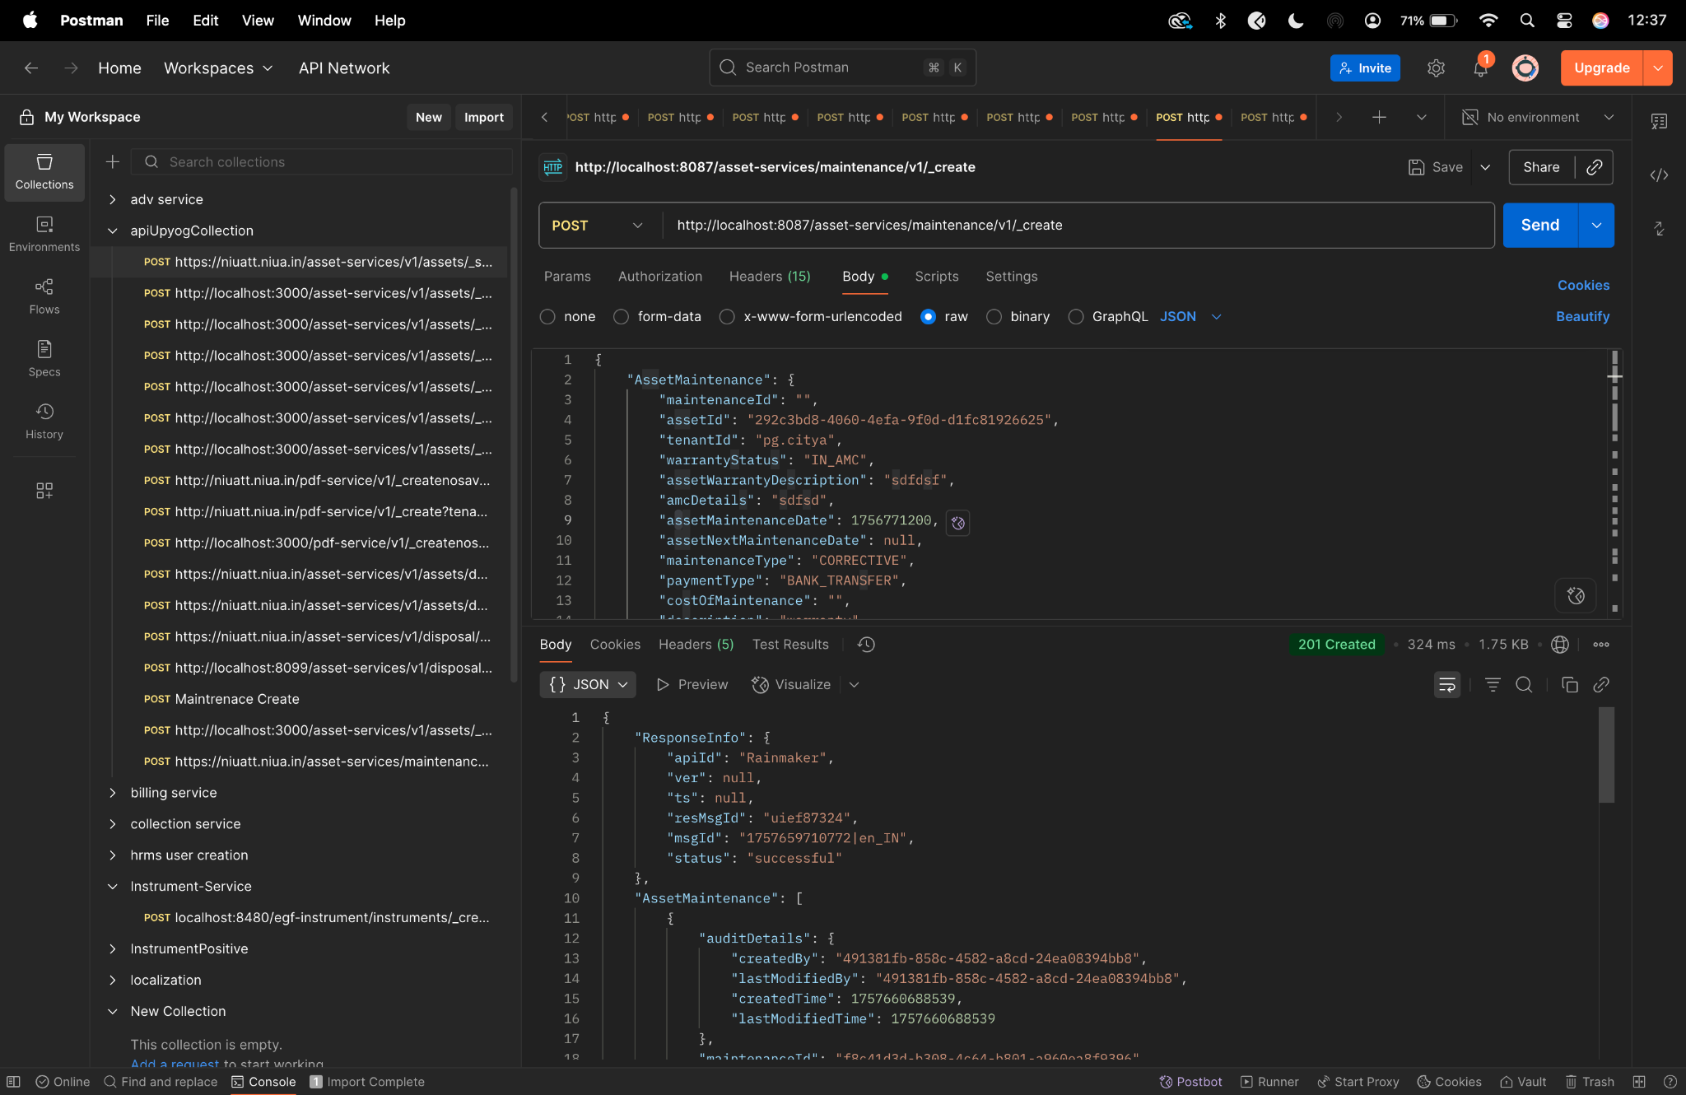

**maintenance/_update-**

curl --location 'http://localhost:8087/asset-services/maintenance/v1/_update' \

--header 'sec-ch-ua-platform: "macOS"' \

--header 'Referer: https://niuatt.niua.in/digit-ui/employee/asset/assetservice/maintenance' \

--header 'User-Agent: Mozilla/5.0 (Macintosh; Intel Mac OS X 10_15_7) AppleWebKit/537.36 (KHTML, like Gecko) Chrome/133.0.0.0 Safari/537.36' \

--header 'Accept: application/json, text/plain, */*' \

--header 'sec-ch-ua: "Not(A:Brand";v="99", "Google Chrome";v="133", "Chromium";v="133"' \

--header 'Content-Type: application/json;charset=UTF-8' \

--header 'sec-ch-ua-mobile: ?0' \

--data '{

"AssetMaintenance": {

"maintenanceId": "45d9c743-54c5-41c7-8211-53bb329df78e",

"assetId": "292c3bd8-4060-4efa-9f0d-d1fc81926625",

"tenantId": "pg.citya",

"warrantyStatus": "IN_AMC",

"assetWarrantyDescription": "sdfdsf",

"amcDetails": "sdfsd",

"assetMaintenanceDate": 1756771200,

"assetNextMaintenanceDate": null,

"maintenanceType": "CORRECTIVE",

"paymentType": "BANK_TRANSFER",

"costOfMaintenance": "",

"description": "warranty",

"vendor": "Kunal Gaurav",

"maintenanceCycle": "QUARTERLY",

"partsAddedOrReplaced": "sdfsdf",

"preConditionRemarks": "dfsdf",

"postConditionRemarks": "dsfsdf",

"isAMCExpired": true,

"isWarrantyExpired": false,

"isLifeOfAssetAffected": "TRUE",

"assetMaintenanceIncreasedYear": "2",

"documents": [

{

"documentType": "ASSET.MAINTENANCE.DOC3",

"fileStoreId": "16ce3c83-a416-4e60-b6ff-1eaa1a47c278",

"documentUid": "16ce3c83-a416-4e60-b6ff-1eaa1a47c278",

"documentId": "1"

},

{

"documentType": "ASSET.MAINTENANCE.DOC1",

"fileStoreId": "ba1ca218-ca65-438c-9a2e-519acf799f3e",

"documentUid": "ba1ca218-ca65-438c-9a2e-519acf799f3e",

"documentId": "1"

},

{

"documentType": "ASSET.MAINTENANCE.DOC2",

"fileStoreId": "48e2932e-432b-4f83-8b0a-09229f107fbc",

"documentUid": "48e2932e-432b-4f83-8b0a-09229f107fbc",

"documentId": "1"

}

],

"auditDetails": {

"createdBy": "",

"createdTime": "",

"lastModifiedBy": "",

"lastModifiedTime": ""

}

},

"RequestInfo": {

"apiId": "Rainmaker",

"authToken": "54552937-0eb8-4cec-910a-182918416f7f",

"userInfo": {

"id": 909,

"uuid": "491381fb-858c-4582-a8cd-24ea08394bb8",

"userName": "ASSET_APPROVER",

"name": "Asset Approver",

"mobileNumber": "8448489439",

"emailId": null,

"locale": null,

"type": "EMPLOYEE",

"roles": [

{

"name": "Asset Approver",

"code": "ASSET_APPROVER",

"tenantId": "pg.citya"

},

{

"name": "Asset Allocator",

"code": "ASSET_ALLOCATOR",

"tenantId": "pg.citya"

}

],

"active": true,

"tenantId": "pg.citya",

"permanentCity": null

},

"msgId": "1757659710772|en_IN",

"plainAccessRequest": {}

}

}'

**Postman-**

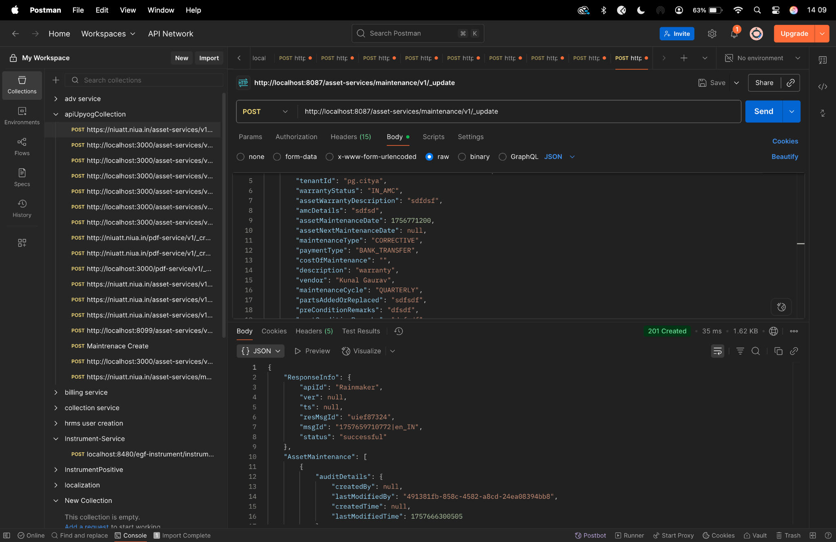

**maintenance/_search-**

curl --location 'http://localhost:8087/asset-services/maintenance/v1/_search' \

--header 'sec-ch-ua-platform: "macOS"' \

--header 'Referer: https://niuatt.niua.in/digit-ui/employee/asset/assetservice/maintenance' \

--header 'User-Agent: Mozilla/5.0 (Macintosh; Intel Mac OS X 10_15_7) AppleWebKit/537.36 (KHTML, like Gecko) Chrome/133.0.0.0 Safari/537.36' \

--header 'Accept: application/json, text/plain, */*' \

--header 'sec-ch-ua: "Not(A:Brand";v="99", "Google Chrome";v="133", "Chromium";v="133"' \

--header 'Content-Type: application/json;charset=UTF-8' \

--header 'sec-ch-ua-mobile: ?0' \

--data '{

"AssetMaintenanceSearchCriteria": {

"tenantId": "pg.citya",

"assetId": "292c3bd8-4060-4efa-9f0d-d1fc81926625",

"maintenanceId": "45d9c743-54c5-41c7-8211-53bb329df78e",

"maintenanceType": "CORRECTIVE",

"offset": 0,

"limit": 10

},

"RequestInfo": {

"apiId": "Rainmaker",

"authToken": "54552937-0eb8-4cec-910a-182918416f7f",

"userInfo": {

"id": 909,

"uuid": "491381fb-858c-4582-a8cd-24ea08394bb8",

"userName": "ASSET_APPROVER",

"name": "Asset Approver",

"mobileNumber": "8448489439",

"emailId": null,

"locale": null,

"type": "EMPLOYEE",

"roles": [

{

"name": "Asset Approver",

"code": "ASSET_APPROVER",

"tenantId": "pg.citya"

},

{

"name": "Asset Allocator",

"code": "ASSET_ALLOCATOR",

"tenantId": "pg.citya"

}

],

"active": true,

"tenantId": "pg.citya",

"permanentCity": null

},

"msgId": "1757659710772|en_IN",

"plainAccessRequest": {}

}

}'

**Postman-**

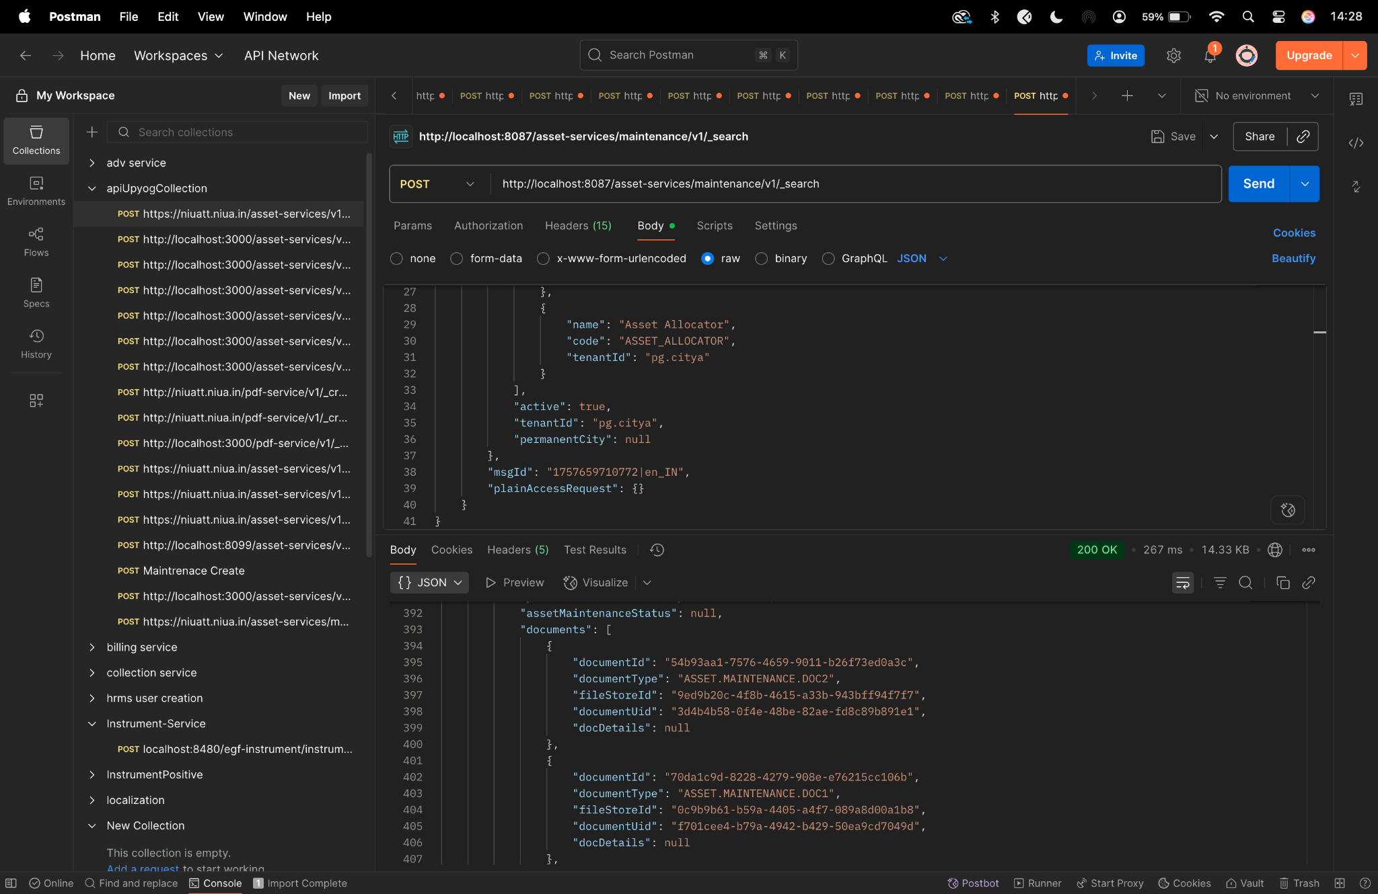

**disposal/_create-**

curl --location 'http://localhost:8087/asset-services/v1/disposal/_create' \

--header 'accept: application/json, text/plain, */*' \

--header 'accept-language: en-GB,en-US;q=0.9,en;q=0.8,hi;q=0.7' \

--header 'content-type: application/json;charset=UTF-8' \

--header 'origin: https://niuatt.niua.in' \

--header 'priority: u=1, i' \

--header 'referer: https://niuatt.niua.in/upyog-ui/employee/asset/assetservice/dispose-assets/PG-1013-2025-I-001236' \

--header 'sec-ch-ua: "Not;A=Brand";v="99", "Google Chrome";v="139", "Chromium";v="139"' \

--header 'sec-ch-ua-mobile: ?0' \

--header 'sec-ch-ua-platform: "macOS"' \

--header 'sec-fetch-dest: empty' \

--header 'sec-fetch-mode: cors' \

--header 'sec-fetch-site: same-origin' \

--header 'user-agent: Mozilla/5.0 (Macintosh; Intel Mac OS X 10_15_7) AppleWebKit/537.36 (KHTML, like Gecko) Chrome/139.0.0.0 Safari/537.36' \

--header 'Cookie: locale=en_IN; _ga=GA1.1.559242739.1756447705; _clck=19weqns%5E2%5Efyv%5E0%5E2067; _ga_VZ9TNBTB3X=GS2.1.s1756447704$o1$g1$t1756447780$j59$l0$h0; _ga_E39TFV5YXM=GS2.1.s1756447709$o1$g1$t1756448684$j60$l0$h0' \

--data '{

"AssetDisposal": {

"disposalId": "",

"assetId": "292c3bd8-4060-4efa-9f0d-d1fc81926625",

"tenantId": "pg.citya",

"lifeOfAsset": "5",

"isAssetDisposedInFacility": true,

"currentAgeOfAsset": 2,

"disposalDate": 1756924200000,

"reasonForDisposal": "Others",

"amountReceived": 500,

"purchaserName": "",

"paymentMode": "",

"comments": "for assest",

"glCode": "111111",

"assetDisposalStatus": "DISPOSED",

"additionalDetails": {

"approvalNumber": "APPROVAL-2020",

"disposedBy": "Kunal Gaurav"

},

"auditDetail": {

"createdBy": "admin",

"createdTime": 1672531200000,

"lastModifiedBy": "admin",

"lastModifiedTime": 1672534800000

},

"documents": [

{

"documentType": "OWNER.RECIEPTPHOTO",

"fileStoreId": "ba740edc-006d-4a34-98d7-96dd2947c795",

"documentUid": "ba740edc-006d-4a34-98d7-96dd2947c795",

"latitude": null,

"longitude": null

}

]

},

"RequestInfo": {

"apiId": "Rainmaker",

"authToken": "54552937-0eb8-4cec-910a-182918416f7f",

"userInfo": {

"id": 909,

"uuid": "491381fb-858c-4582-a8cd-24ea08394bb8",

"userName": "ASSET_APPROVER",

"name": "Asset Approver",

"mobileNumber": "8448489439",

"emailId": null,

"locale": null,

"type": "EMPLOYEE",

"roles": [

{

"name": "Asset Approver",

"code": "ASSET_APPROVER",

"tenantId": "pg.citya"

},

{

"name": "Asset Allocator",

"code": "ASSET_ALLOCATOR",

"tenantId": "pg.citya"

}

],

"active": true,

"tenantId": "pg.citya",

"permanentCity": null

},

"msgId": "1757656020981|en_IN",

"plainAccessRequest": {}

}

}'

**Postman-**

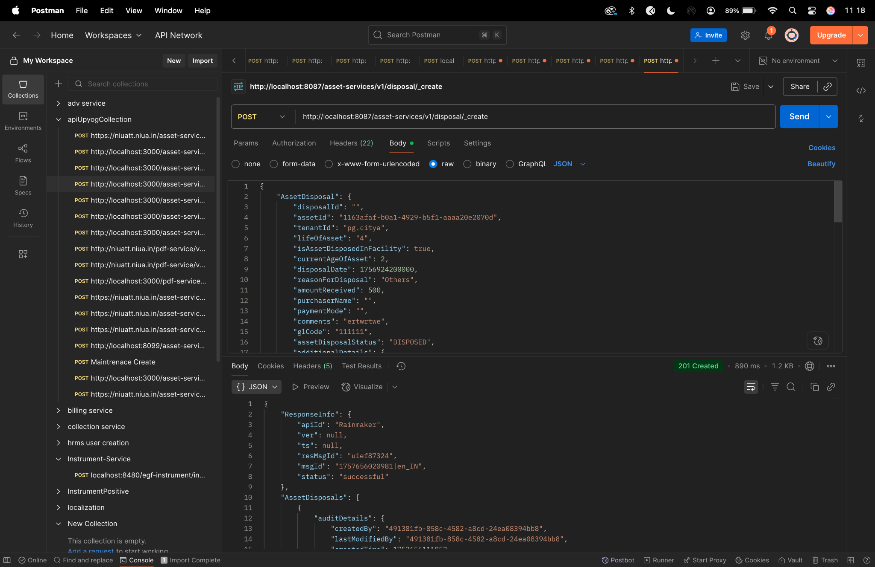

**disposal/_update-**

curl --location 'http://localhost:8087/asset-services/v1/disposal/_update' \

--header 'accept: application/json, text/plain, */*' \

--header 'accept-language: en-GB,en-US;q=0.9,en;q=0.8,hi;q=0.7' \

--header 'content-type: application/json;charset=UTF-8' \

--header 'origin: https://niuatt.niua.in' \

--header 'priority: u=1, i' \

--header 'referer: https://niuatt.niua.in/upyog-ui/employee/asset/assetservice/dispose-assets/PG-1013-2025-I-001236' \

--header 'sec-ch-ua: "Not;A=Brand";v="99", "Google Chrome";v="139", "Chromium";v="139"' \

--header 'sec-ch-ua-mobile: ?0' \

--header 'sec-ch-ua-platform: "macOS"' \

--header 'sec-fetch-dest: empty' \

--header 'sec-fetch-mode: cors' \

--header 'sec-fetch-site: same-origin' \

--header 'user-agent: Mozilla/5.0 (Macintosh; Intel Mac OS X 10_15_7) AppleWebKit/537.36 (KHTML, like Gecko) Chrome/139.0.0.0 Safari/537.36' \

--header 'Cookie: locale=en_IN; _ga=GA1.1.559242739.1756447705; _clck=19weqns%5E2%5Efyv%5E0%5E2067; _ga_VZ9TNBTB3X=GS2.1.s1756447704$o1$g1$t1756447780$j59$l0$h0; _ga_E39TFV5YXM=GS2.1.s1756447709$o1$g1$t1756448684$j60$l0$h0' \

--data '{

"AssetDisposal": {

"disposalId": "d2e7d64f-b39a-4f20-908c-ea0c0497710e",

"assetId": "292c3bd8-4060-4efa-9f0d-d1fc81926625",

"tenantId": "pg.citya",

"lifeOfAsset": "6",

"isAssetDisposedInFacility": true,

"currentAgeOfAsset": 2,

"disposalDate": 1756924200000,

"reasonForDisposal": "Others",

"amountReceived": 500,

"purchaserName": "",

"paymentMode": "",

"comments": "ertwrtwe-UPDATED",

"glCode": "111111",

"assetDisposalStatus": "DISPOSED",

"additionalDetails": {

"approvalNumber": "APPROVAL202501",

"disposedBy": "Jane Smith"

},

"auditDetail": {

"createdBy": "admin",

"createdTime": 1672531200000,

"lastModifiedBy": "admin",

"lastModifiedTime": 1672534800000

},

"documents": [

{

"documentType": "OWNER.RECIEPTPHOTO",

"fileStoreId": "ba740edc-006d-4a34-98d7-96dd2947c795",

"documentUid": "ba740edc-006d-4a34-98d7-96dd2947c795",

"latitude": null,

"longitude": null

}

]

},

"RequestInfo": {

"apiId": "Rainmaker",

"authToken": "54552937-0eb8-4cec-910a-182918416f7f",

"userInfo": {

"id": 909,

"uuid": "491381fb-858c-4582-a8cd-24ea08394bb8",

"userName": "ASSET_APPROVER",

"name": "Asset Approver",

"mobileNumber": "8448489439",

"emailId": null,

"locale": null,

"type": "EMPLOYEE",

"roles": [

{

"name": "Asset Approver",

"code": "ASSET_APPROVER",

"tenantId": "pg.citya"

},

{

"name": "Asset Allocator",

"code": "ASSET_ALLOCATOR",

"tenantId": "pg.citya"

}

],

"active": true,

"tenantId": "pg.citya",

"permanentCity": null

},

"msgId": "1757656020981|en_IN",

"plainAccessRequest": {}

}

}'

**Postman-**

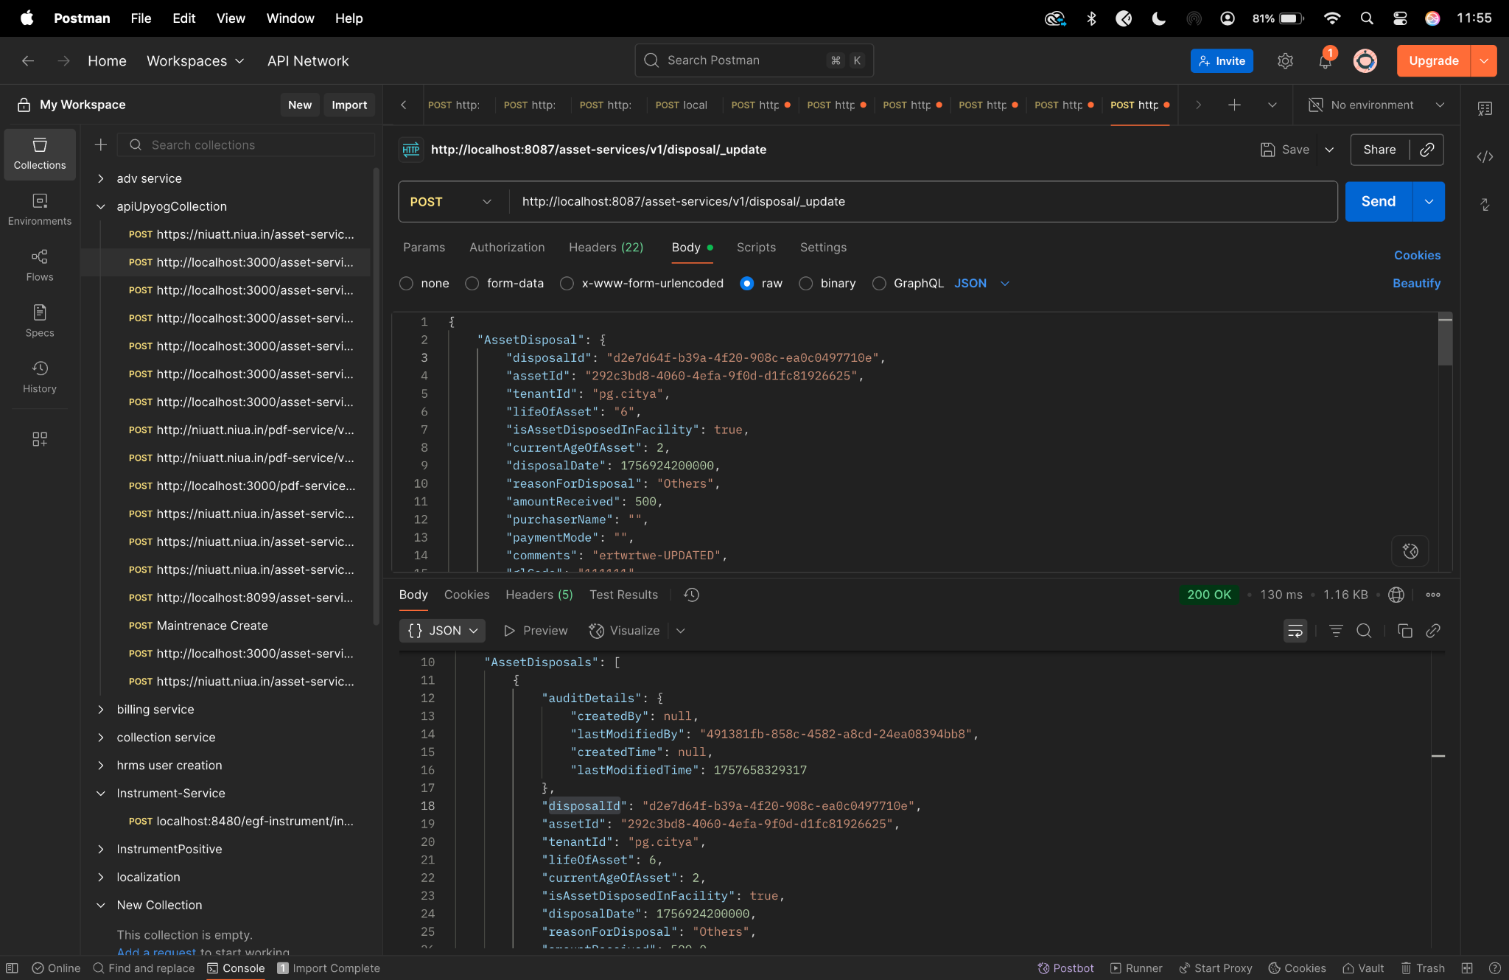

**disposal/_search-**

curl --location 'http://localhost:8087/asset-services/v1/disposal/_search' \

--header 'accept: application/json, text/plain, */*' \

--header 'accept-language: en-GB,en-US;q=0.9,en;q=0.8,hi;q=0.7' \

--header 'content-type: application/json;charset=UTF-8' \

--header 'origin: https://niuatt.niua.in' \

--header 'priority: u=1, i' \

--header 'referer: https://niuatt.niua.in/upyog-ui/employee/asset/assetservice/dispose-assets/' \

--header 'sec-ch-ua: "Not;A=Brand";v="99", "Google Chrome";v="139", "Chromium";v="139"' \

--header 'sec-ch-ua-mobile: ?0' \

--header 'sec-ch-ua-platform: "macOS"' \

--header 'sec-fetch-dest: empty' \

--header 'sec-fetch-mode: cors' \

--header 'sec-fetch-site: same-origin' \

--header 'user-agent: Mozilla/5.0 (Macintosh; Intel Mac OS X 10_15_7) AppleWebKit/537.36 (KHTML, like Gecko) Chrome/139.0.0.0 Safari/537.36' \

--header 'Cookie: locale=en_IN; _ga=GA1.1.559242739.1756447705; _clck=19weqns%5E2%5Efyv%5E0%5E2067; _ga_VZ9TNBTB3X=GS2.1.s1756447704$o1$g1$t1756447780$j59$l0$h0; _ga_E39TFV5YXM=GS2.1.s1756447709$o1$g1$t1756448684$j60$l0$h0' \

--data '{

"searchCriteria": {

"tenantId": "pg.citya",

"assetId": "292c3bd8-4060-4efa-9f0d-d1fc81926625",

"assetDisposalStatus": "DISPOSED",

"offset": 0,

"limit": 10

},

"RequestInfo": {

"apiId": "Rainmaker",

"authToken": "54552937-0eb8-4cec-910a-182918416f7f",

"userInfo": {

"id": 909,

"uuid": "491381fb-858c-4582-a8cd-24ea08394bb8",

"userName": "ASSET_APPROVER",

"name": "Asset Approver",

"mobileNumber": "8448489439",

"emailId": null,

"locale": null,

"type": "EMPLOYEE",

"roles": [

{

"name": "Asset Approver",

"code": "ASSET_APPROVER",

"tenantId": "pg.citya"

},

{

"name": "Asset Allocator",

"code": "ASSET_ALLOCATOR",

"tenantId": "pg.citya"

}

],

"active": true,

"tenantId": "pg.citya",

"permanentCity": null

},

"msgId": "1757656020981|en_IN",

"plainAccessRequest": {}

}

}'

**Postman-**

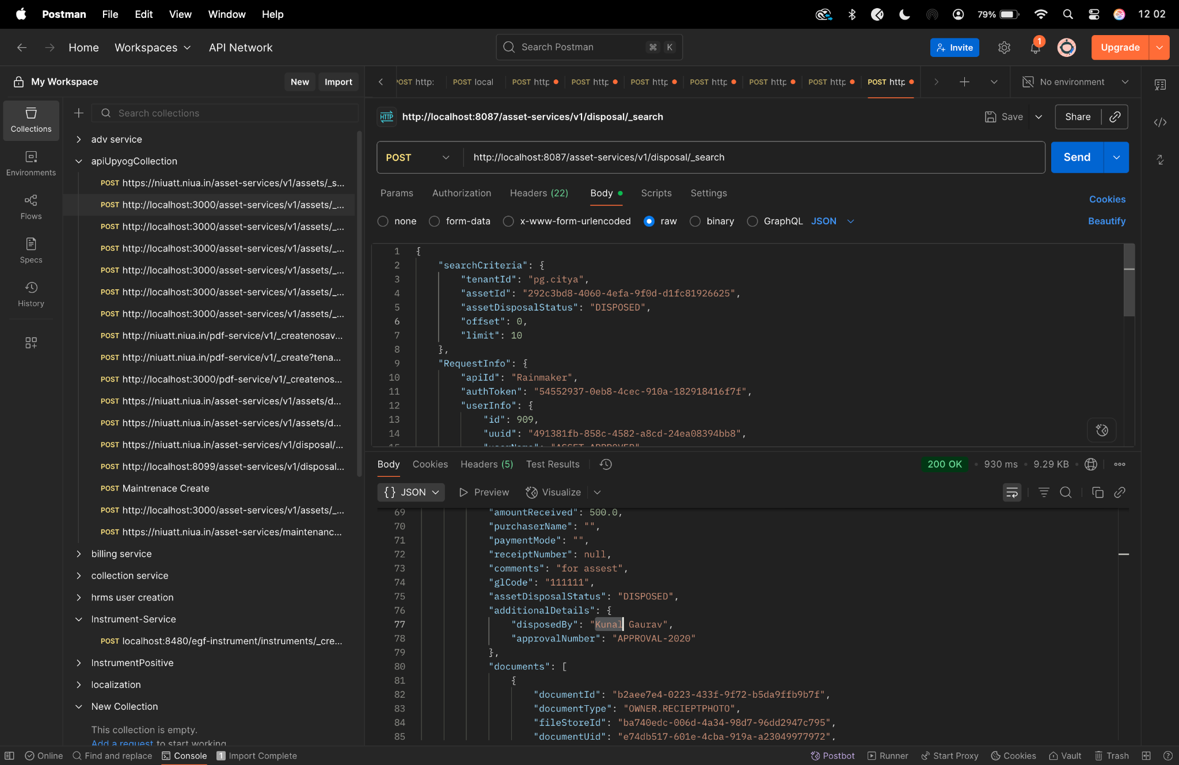

**AFTER LTS UPDATE**

**Create curl-**

curl --location 'http://localhost:8087/asset-services/v1/assets/_create' \

--header 'Accept: application/json, text/plain, */*' \

--header 'Accept-Language: en-US,en;q=0.9,hi;q=0.8' \

--header 'Connection: keep-alive' \

--header 'Content-Type: application/json;charset=UTF-8' \

--header 'Origin: http://localhost:3000' \

--header 'Referer: http://localhost:3000/digit-ui/employee/asset/assetservice/new-assets/acknowledgement' \

--header 'Sec-Fetch-Dest: empty' \

--header 'Sec-Fetch-Mode: cors' \

--header 'Sec-Fetch-Site: same-origin' \

--header 'User-Agent: Mozilla/5.0 (Windows NT 10.0; Win64; x64) AppleWebKit/537.36 (KHTML, like Gecko) Chrome/131.0.0.0 Safari/537.36' \

--header 'sec-ch-ua: "Google Chrome";v="131", "Chromium";v="131", "Not_A Brand";v="24"' \

--header 'sec-ch-ua-mobile: ?0' \

--header 'sec-ch-ua-platform: "Windows"' \

--data '{

"Asset": {

"accountId": "",

"tenantId": "pg.citya",

"assetBookRefNo": "Refence/2025",

"assetName": "Desks for NIUA",

"description": "Testing after LTs upgrade",

"assetClassification": "MOVABLE",

"assetParentCategory": "IT",

"assetCategory": "STORAGE_DEVICES",

"assetSubCategory": "HARD_DRIVES_HDDS",

"department": "DEPT_5",

"assetType": "INFRASTRUCTURE_ASSET",

"assetUsage": "DISPOSED",

"financialYear": "2024-25",

"sourceOfFinance": "MUNICIPAL_FUNDS",

"applicationNo": "",

"approvalDate": "",

"applicationDate": "",

"status": "",

"modeOfPossessionOrAcquisition": "AST_LEASED",

"invoiceDate": 1730419200,

"invoiceNumber": "Invoice _nuuuuu33333",

"purchaseDate": 1730419200,

"purchaseOrderNumber": "2331232213",

"warranty": "15_YEAR",

"assetAge": "1 MONTH",

"location": "28.590213, 77.2257146",

"purchaseCost": 222222,

"acquisitionCost": 33333,

"bookValue": 255555,

"action": "",

"businessService": "asset-create",

"addressDetails": {

"city": "City A",

"locality": {

"code": "JLC414",

"area": "Area1"

}

},

"documents": [

{

"documentType": "OWNER.RECIEPTPHOTO",

"fileStoreId": "bd4932e3-d199-48a0-b1a7-db4c5a804551",

"documentUid": "bd4932e3-d199-48a0-b1a7-db4c5a804551",

"latitude": null,

"longitude": null

},

{

"documentType": "OWNER.ASSETPHOTO",

"fileStoreId": "2a776858-784a-4673-b32c-bdf20e5d3bc6",

"documentUid": "2a776858-784a-4673-b32c-bdf20e5d3bc6",

"latitude": null,

"longitude": null

}

],

"workflow": {

"action": "INITIATE",

"businessService": "asset-create",

"moduleName": "asset-services"

},

"additionalDetails": {

"assetParentCategory": "IT",

"warranty": {

"i18nKey": "15_YEAR",

"code": "15_YEAR",

"name": "warranty"

},

"modeOfPossessionOrAcquisition": {

"i18nKey": "AST_LEASED",

"code": "AST_LEASED",

"name": "modeOfPossessionOrAcquisition"

},

"brand": "Brand ",

"manufacturer": "Manufacturer "

}

},

"RequestInfo": {

"apiId": "Rainmaker",

"authToken": "98902e75-6108-4ca5-b6ac-c2fc42c7816f",

"userInfo": {

"id": 194,

"uuid": "ab5db0ed-b3ae-4fb8-bd93-f9913a0fa5da",

"userName": "ASSET_INITIATOR",

"name": "Asset Initiator",

"mobileNumber": "9999075991",

"emailId": null,

"locale": null,

"type": "EMPLOYEE",

"roles": [

{

"name": "Asset Initiator Employee",

"code": "ASSET_INITIATOR",

"tenantId": "pg.citya"

},

{

"name": "Asset Approver",

"code": "ASSET_APPROVER",

"tenantId": "pg.citya"

}

],

"active": true,

"tenantId": "pg.citya",

"permanentCity": null

},

"msgId": "1734002475778|en_IN",

"plainAccessRequest": {}

}

}'

**Response-**

{

"ResponseInfo": {

"apiId": "Rainmaker",

"ver": null,

"ts": null,

"resMsgId": "uief87324",

"msgId": "1734002475778|en_IN",

"status": "successful"

},

"Assets": [

{

"accumulatedDepreciartion": null,

"assetAssignable": false,

"id": "bac70f7b-7a7f-47c3-86ef-a6eebe526420",

"tenantId": "pg.citya",

"assetBookRefNo": "Refence/2025",

"assetName": "Desks for NIUA",

"description": "Testing after LTs upgrade",

"assetClassification": "MOVABLE",

"assetParentCategory": "IT",

"assetCategory": "STORAGE_DEVICES",

"assetSubCategory": "HARD_DRIVES_HDDS",

"department": "DEPT_5",

"applicationNo": "PG-1013-2025-I-001243",

"approvalNo": null,

"approvalDate": null,

"applicationDate": null,

"status": "INITIATED",

"addressDetails": {

"tenantId": null,

"doorNo": null,

"latitude": null,

"longitude": null,

"addressId": "c3283f90-67df-4511-9c5f-9f0fb3388337",

"addressNumber": null,

"type": null,

"addressLine1": null,

"addressLine2": null,

"landmark": null,

"city": "City A",

"pincode": null,

"detail": null,

"buildingName": null,

"street": null,

"locality": {

"code": "JLC414",

"name": null,

"label": null,

"latitude": null,

"longitude": null,

"children": null,

"materializedPath": null

}

},

"documents": [

{

"documentId": "ba16fa2e-2910-471e-ad80-b4936d8d3c8a",

"documentType": "OWNER.RECIEPTPHOTO",

"fileStoreId": "bd4932e3-d199-48a0-b1a7-db4c5a804551",

"documentUid": "ef227f43-d595-4945-b942-b5c89b5638d9",

"docDetails": null

},

{

"documentId": "315307ea-d6c7-430e-a2ae-a5e47d19ed8a",

"documentType": "OWNER.ASSETPHOTO",

"fileStoreId": "2a776858-784a-4673-b32c-bdf20e5d3bc6",

"documentUid": "0b52cbda-89cb-4377-866e-5d673282c4ba",

"docDetails": null

}

],

"auditDetails": {

"createdBy": "ab5db0ed-b3ae-4fb8-bd93-f9913a0fa5da",

"lastModifiedBy": "ab5db0ed-b3ae-4fb8-bd93-f9913a0fa5da",

"createdTime": 1757761369168,

"lastModifiedTime": 1757761369168

},

"assetAssignment": null,

"additionalDetails": {

"assetParentCategory": "IT",

"warranty": {

"i18nKey": "15_YEAR",

"code": "15_YEAR",

"name": "warranty"

},

"modeOfPossessionOrAcquisition": {

"i18nKey": "AST_LEASED",

"code": "AST_LEASED",

"name": "modeOfPossessionOrAcquisition"

},

"brand": "Brand ",

"manufacturer": "Manufacturer "

},

"accountId": "ab5db0ed-b3ae-4fb8-bd93-f9913a0fa5da",

"remarks": null,

"financialYear": "2024-25",

"sourceOfFinance": "MUNICIPAL_FUNDS",

"workflow": {

"id": null,

"tenantId": null,

"businessService": "asset-create",

"businessId": null,

"action": "INITIATE",

"moduleName": "asset-services",

"state": null,

"comment": null,

"documents": null,

"assigner": null,

"assignee": null,

"nextActions": null,

"stateSla": null,

"businesssServiceSla": null,

"previousStatus": null,

"entity": null,

"auditDetails": null,

"assignes": null

},

"scheme": null,

"subScheme": null,

"purchaseCost": 222222.0,

"acquisitionCost": 33333.0,

"bookValue": 255555.0,

"invoiceDate": 1730419200,

"invoiceNumber": "Invoice _nuuuuu33333",

"purchaseDate": 1730419200,

"purchaseOrderNumber": "2331232213",

"location": "28.590213, 77.2257146",

"oldCode": null,

"modeOfPossessionOrAcquisition": "AST_LEASED",

"unitOfMeasurement": null,

"lifeOfAsset": null,

"assetUsage": "DISPOSED",

"assetType": "INFRASTRUCTURE_ASSET",

"assetStatus": null,

"originalBookValue": 0.0,

"minimumValue": null,

"islegacyData": null

}

]

}

**Postman -**

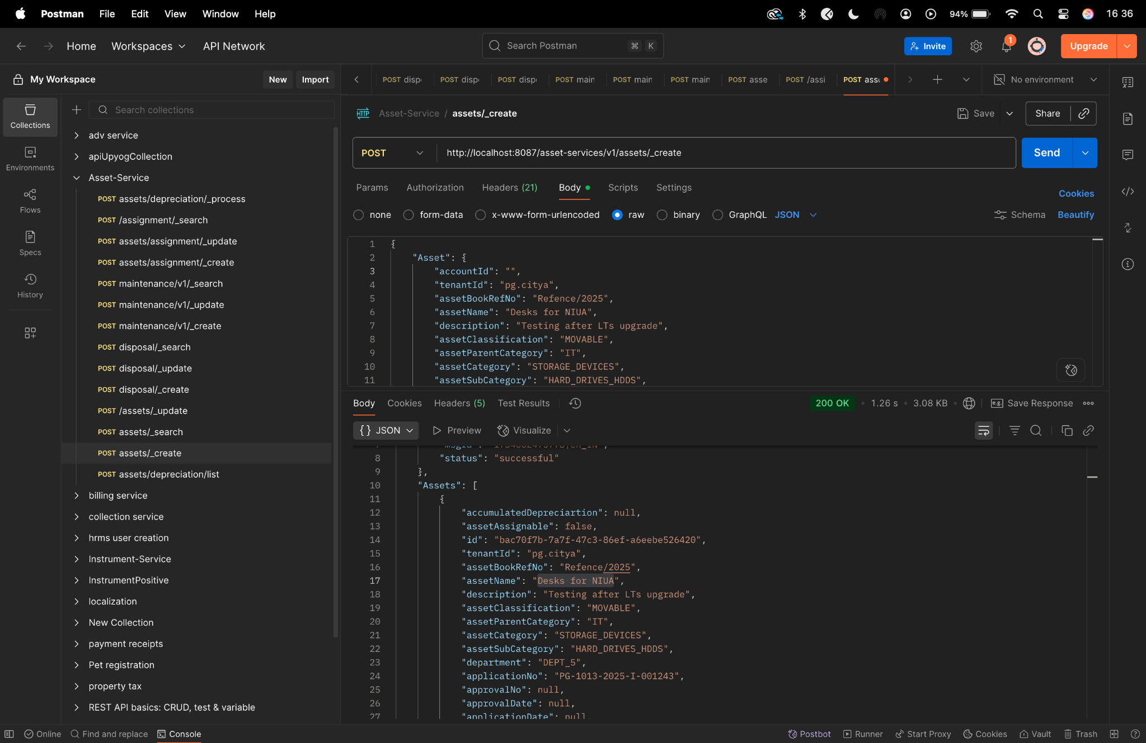

**Diff checker -**

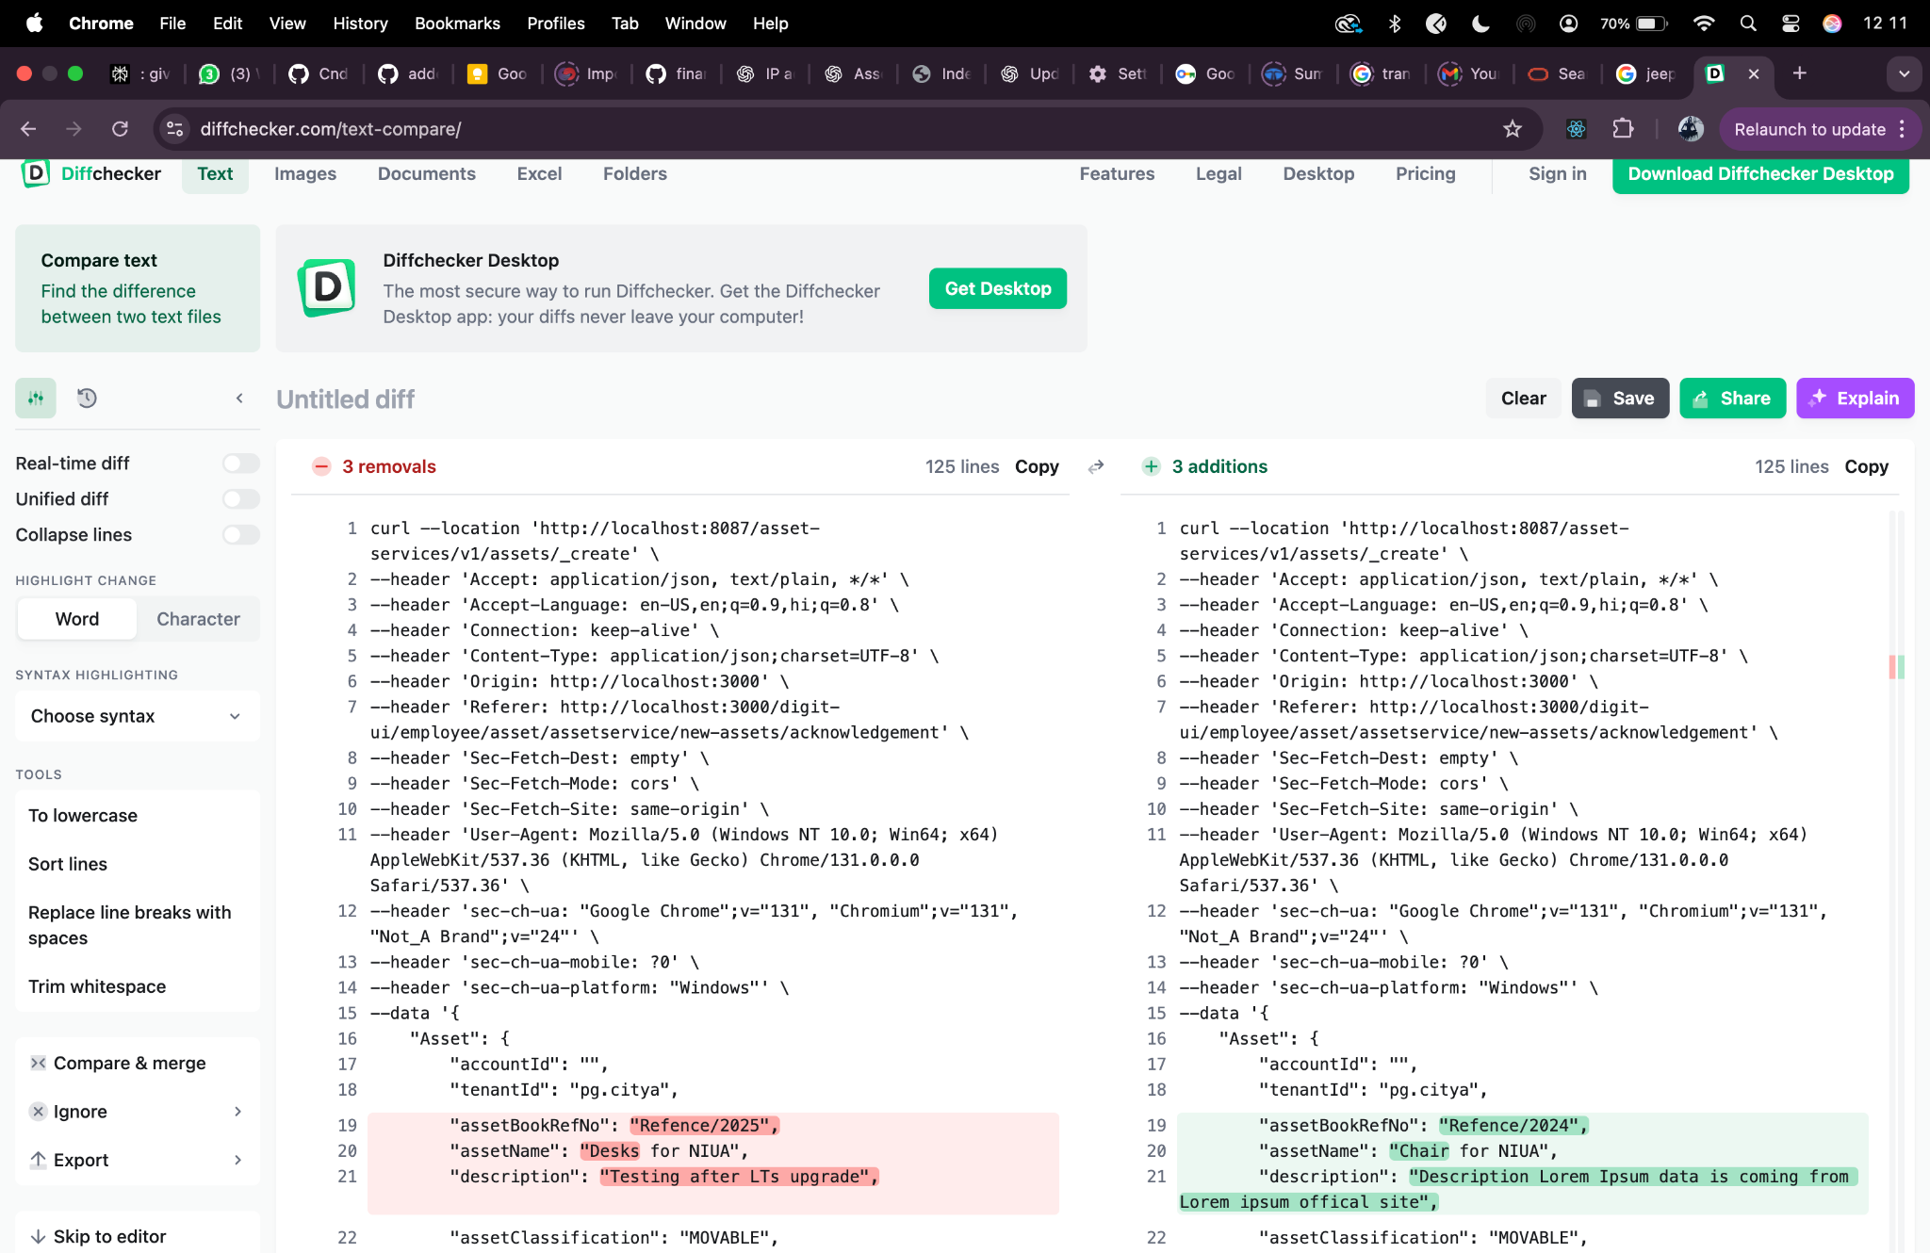

**Search Curl-**

curl --location 'http://localhost:8087/asset-services/v1/assets/_search?tenantId=pg.citya' \

--header 'Accept: application/json, text/plain, */*' \

--header 'Accept-Language: en-US,en;q=0.9,hi;q=0.8' \

--header 'Connection: keep-alive' \

--header 'Content-Type: application/json;charset=UTF-8' \

--header 'Origin: http://localhost:3000' \

--header 'Referer: http://localhost:3000/digit-ui/employee/asset/assetservice/my-asset' \

--header 'Sec-Fetch-Dest: empty' \

--header 'Sec-Fetch-Mode: cors' \

--header 'Sec-Fetch-Site: same-origin' \

--header 'User-Agent: Mozilla/5.0 (Windows NT 10.0; Win64; x64) AppleWebKit/537.36 (KHTML, like Gecko) Chrome/131.0.0.0 Safari/537.36' \

--header 'sec-ch-ua: "Google Chrome";v="131", "Chromium";v="131", "Not_A Brand";v="24"' \

--header 'sec-ch-ua-mobile: ?0' \

--header 'sec-ch-ua-platform: "Windows"' \

--data '{

"RequestInfo": {

"apiId": "Rainmaker",

"authToken": "eceb5456-e376-4fe0-9598-b710bfb741d6",

"userInfo": {

"id": 194,

"uuid": "ab5db0ed-b3ae-4fb8-bd93-f9913a0fa5da",

"userName": "ASSET_INITIATOR",

"name": "Asset Initiator",

"mobileNumber": "9999075991",

"emailId": null,

"locale": null,

"type": "EMPLOYEE",

"roles": [

{

"name": "Asset Initiator Employee",

"code": "ASSET_INITIATOR",

"tenantId": "pg.citya"

},

{

"name": "Asset Approver",

"code": "ASSET_APPROVER",

"tenantId": "pg.citya"

}

],

"active": true,

"tenantId": "pg.citya",

"permanentCity": null

},

"msgId": "1732600268762|en_IN",

"plainAccessRequest": {}

}

}'

**Response -**

{

"ResponseInfo": {

"apiId": "Rainmaker",

"ver": null,

"ts": null,

"resMsgId": "uief87324",

"msgId": "1732600268762|en_IN",

"status": "successful"

},

"Assets": [

{

"id": "db1f9b71-1af8-4c49-a75a-a77cd4104e33",

"tenantId": "pg.citya",

"assetBookRefNo": "313221",

"assetName": "asadsd",

"description": null,

"assetClassification": "MOVABLE",

"assetParentCategory": "VEHICLE",

"assetCategory": "STORAGE_DEVICES",

"assetSubCategory": "SOLID_STATE_DRIVES_SSDS",

"department": "DEPT_3",

"applicationNo": "PG-1013-2025-V-001211",

"applicationDate": 1752137427999,

"status": "INITIATED",

"assetStatus": "1",

"location": "28.59014367780806, 77.22578380548445",

"assetAssignment": {

"assignmentId": null,

"assignedUserName": null,

"employeeCode": null,

"designation": null,

"department": "DEPT_3",

"assignedDate": 0,

"isAssigned": false,

"returnDate": 0

}

}

]

}

**Postman-**

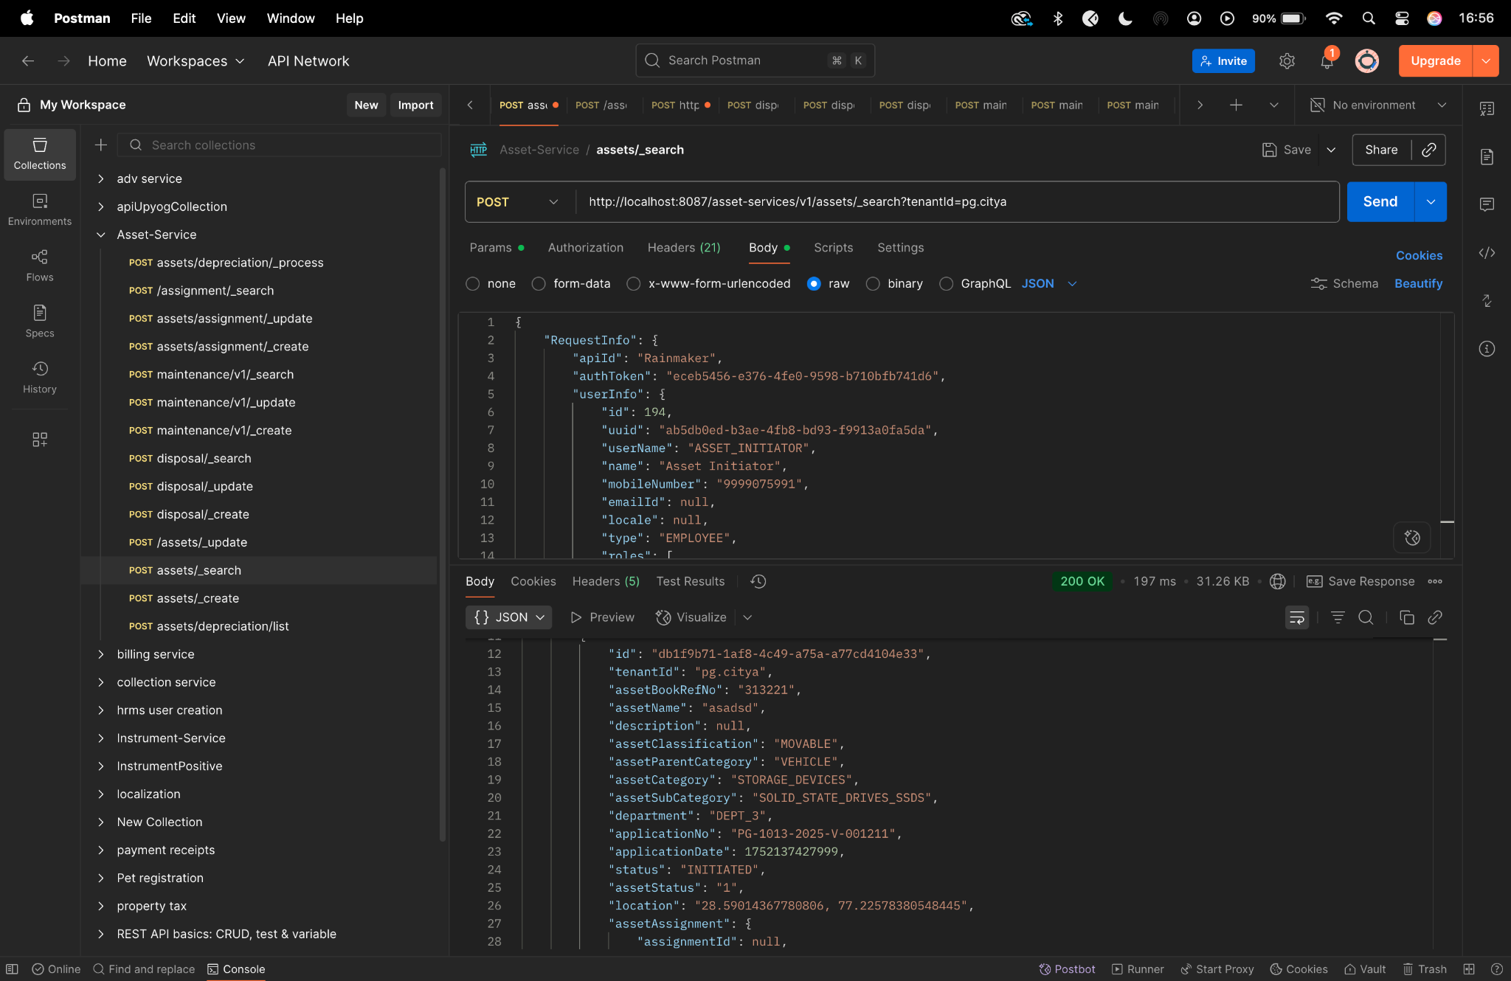

**Diff checker -**

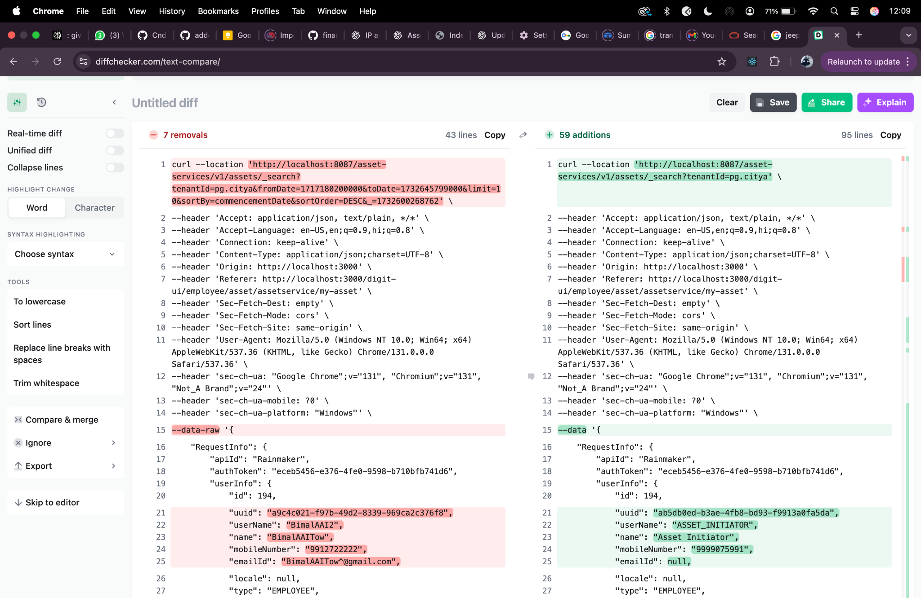

**Update curl -**

curl --location 'http://localhost:8087/asset-services/v1/assets/_update' \

--header 'Accept: application/json, text/plain, */*' \

--header 'Accept-Language: en-US,en;q=0.9,hi;q=0.8' \

--header 'Connection: keep-alive' \

--header 'Content-Type: application/json;charset=UTF-8' \

--header 'Origin: http://localhost:3000' \

--header 'Referer: http://localhost:3000/digit-ui/employee/asset/assetservice/edit-response' \

--header 'Sec-Fetch-Dest: empty' \

--header 'Sec-Fetch-Mode: cors' \

--header 'Sec-Fetch-Site: same-origin' \

--header 'User-Agent: Mozilla/5.0 (Windows NT 10.0; Win64; x64) AppleWebKit/537.36 (KHTML, like Gecko) Chrome/131.0.0.0 Safari/537.36' \

--header 'sec-ch-ua: "Google Chrome";v="131", "Chromium";v="131", "Not_A Brand";v="24"' \

--header 'sec-ch-ua-mobile: ?0' \

--header 'sec-ch-ua-platform: "Windows"' \

--data '{

"Asset": {

"accountId": "ab5db0ed-b3ae-4fb8-bd93-f9913a0fa5da",

"tenantId": "pg.citya",

"assetBookRefNo": "HP/20022/Ref_No/2222",

"assetName": "Desks for NIUA-UPDATED",

"description": "update curl after lts upgrade - UPDATED",

"assetClassification": "MOVABLE",

"assetParentCategory": "FURNITURE",

"assetCategory": "HOME_EQUIPMENT",

"assetSubCategory": "SITTER",

"department": "DEPT_2",

"financialYear": "2024-25",

"sourceOfFinance": "AMRUT",

"applicationNo": "PG-1013-2025-I-001243",

"approvalDate": "",

"id": "bac70f7b-7a7f-47c3-86ef-a6eebe526420",

"applicationDate": "",

"status": "Employee Action Pending",

"action": "",

"businessService": "asset-create",

"addressDetails": {

"addressLine1": null,

"addressLine2": null,

"buildingName": null,

"doorNo": null,

"street": null,

"pincode": null,

"city": "City A",

"locality": {

"code": "JLC254",

"latitude": 0,

"longitude": 0

}

},

"documents": [

{

"documentId": "bd2d05d5-5462-4dde-a096-fed7df2c7b02",

"documentType": "OWNER.RECIEPTPHOTO",

"fileStoreId": "f0d569d7-8c71-4d6d-81a1-1ec93eb91981",

"documentUid": "6c5e4398-8a2f-4489-8459-611fa5ecc42c",

"docDetails": null

},

{

"documentId": "e82c5649-0591-44fe-b5f3-363e88e54505",

"documentType": "OWNER.ANYSUPPORTINGDOCUMENT",

"fileStoreId": "bee8e2cc-5d72-4abc-bc98-18b2e1223c64",

"documentUid": "77235dfb-3758-400c-8b00-10a8d711387b",

"docDetails": null

},

{

"documentId": "25f96703-2005-4b90-b696-b14601c4407a",

"documentType": "OWNER.ASSETPHOTO",

"fileStoreId": "769d03cd-4f95-4b86-ab3d-ceec1b741f88",

"documentUid": "845e0cc3-0aa2-4d03-b1a0-290726e7da60",

"docDetails": null

}

],

"workflow": {

"action": "VERIFY",

"businessService": "asset-create",

"moduleName": "asset-services"

},

"additionalDetails": {

"key": 1733743796659,

"brand": "LG Brand UPdate",

"manufacturer": "LG Manufacturer UPdate",

"warranty": {

"code": "1_YEAR",

"name": "warranty",

"value": "1 Year",

"i18nKey": "1 Year"

},

"acquisitionProcessionDetails": {}

}

},

"RequestInfo": {

"apiId": "Rainmaker",

"authToken": "2f302a1f-161a-4d9e-8c02-7fbad9b98f0f",

"userInfo": {

"id": 194,

"uuid": "ab5db0ed-b3ae-4fb8-bd93-f9913a0fa5da",

"userName": "ASSET_INITIATOR",

"name": "Asset Initiator",

"mobileNumber": "9999075991",

"emailId": null,

"locale": null,

"type": "EMPLOYEE",

"roles": [

{

"name": "Asset Initiator Employee",

"code": "ASSET_INITIATOR",

"tenantId": "pg.citya"

},

{

"name": "Asset Approver",

"code": "ASSET_APPROVER",

"tenantId": "pg.citya"

},

{

"name": "Asset Document Verifier",

"code": "ASSET_VERIFIER",

"tenantId": "pg.citya"

}

],

"active": true,

"tenantId": "pg.citya",

"permanentCity": null

},

"msgId": "1733743900982|en_IN",

"plainAccessRequest": {}

}

}'

**Response -**

{

"ResponseInfo": {

"apiId": "Rainmaker",

"ver": null,

"ts": null,

"resMsgId": "uief87324",

"msgId": "1733743900982|en_IN",

"status": "successful"

},

"Assets": [

{

"accumulatedDepreciartion": null,

"assetAssignable": false,

"id": "bac70f7b-7a7f-47c3-86ef-a6eebe526420",

"tenantId": "pg.citya",

"assetBookRefNo": "HP/20022/Ref_No/2222",

"assetName": "Desks for NIUA-UPDATED",

"description": "update curl after lts upgrade - UPDATED",

"assetClassification": "MOVABLE",

"assetParentCategory": "FURNITURE",

"assetCategory": "HOME_EQUIPMENT",

"assetSubCategory": "SITTER",

"department": "DEPT_2",

"applicationNo": "PG-1013-2025-I-001243",

"approvalNo": null,

"approvalDate": null,

"applicationDate": null,

"status": "VERIFIED",

"addressDetails": {

"tenantId": null,

"doorNo": null,

"latitude": null,

"longitude": null,

"addressId": null,

"addressNumber": null,

"type": null,

"addressLine1": null,

"addressLine2": null,

"landmark": null,

"city": "City A",

"pincode": null,

"detail": null,

"buildingName": null,

"street": null,

"locality": {

"code": "JLC254",

"name": null,

"label": null,

"latitude": "0",

"longitude": "0",

"children": null,

"materializedPath": null

}

},

"documents": [

{

"documentId": "bd2d05d5-5462-4dde-a096-fed7df2c7b02",

"documentType": "OWNER.RECIEPTPHOTO",

"fileStoreId": "f0d569d7-8c71-4d6d-81a1-1ec93eb91981",

"documentUid": "6c5e4398-8a2f-4489-8459-611fa5ecc42c",

"docDetails": null

},

{

"documentId": "e82c5649-0591-44fe-b5f3-363e88e54505",

"documentType": "OWNER.ANYSUPPORTINGDOCUMENT",

"fileStoreId": "bee8e2cc-5d72-4abc-bc98-18b2e1223c64",

"documentUid": "77235dfb-3758-400c-8b00-10a8d711387b",

"docDetails": null

},

{

"documentId": "25f96703-2005-4b90-b696-b14601c4407a",

"documentType": "OWNER.ASSETPHOTO",

"fileStoreId": "769d03cd-4f95-4b86-ab3d-ceec1b741f88",

"documentUid": "845e0cc3-0aa2-4d03-b1a0-290726e7da60",

"docDetails": null

}

],

"auditDetails": {

"createdBy": "ab5db0ed-b3ae-4fb8-bd93-f9913a0fa5da",

"lastModifiedBy": "ab5db0ed-b3ae-4fb8-bd93-f9913a0fa5da",

"createdTime": 1757769371491,

"lastModifiedTime": 1757769371491

},

"assetAssignment": null,

"additionalDetails": {

"key": 1733743796659,

"brand": "LG Brand UPdate",

"manufacturer": "LG Manufacturer UPdate",

"warranty": {

"code": "1_YEAR",

"name": "warranty",

"value": "1 Year",

"i18nKey": "1 Year"

},

"acquisitionProcessionDetails": {}

},

"accountId": "ab5db0ed-b3ae-4fb8-bd93-f9913a0fa5da",

"remarks": null,

"financialYear": "2024-25",

"sourceOfFinance": "AMRUT",

"workflow": {

"id": null,

"tenantId": null,

"businessService": "asset-create",

"businessId": null,

"action": "VERIFY",

"moduleName": "asset-services",

"state": null,

"comment": null,

"documents": null,

"assigner": null,

"assignee": null,

"nextActions": null,

"stateSla": null,

"businesssServiceSla": null,

"previousStatus": null,

"entity": null,

"auditDetails": null,

"assignes": null

},

"scheme": null,

"subScheme": null,

"purchaseCost": 0.0,

"acquisitionCost": 0.0,

"bookValue": 0.0,

"invoiceDate": null,

"invoiceNumber": null,

"purchaseDate": null,

"purchaseOrderNumber": null,

"location": null,

"oldCode": null,

"modeOfPossessionOrAcquisition": null,

"unitOfMeasurement": null,

"lifeOfAsset": null,

"assetUsage": null,

"assetType": null,

"assetStatus": null,

"originalBookValue": 0.0,

"minimumValue": null,

"islegacyData": null

}

]

}

**Postman-**

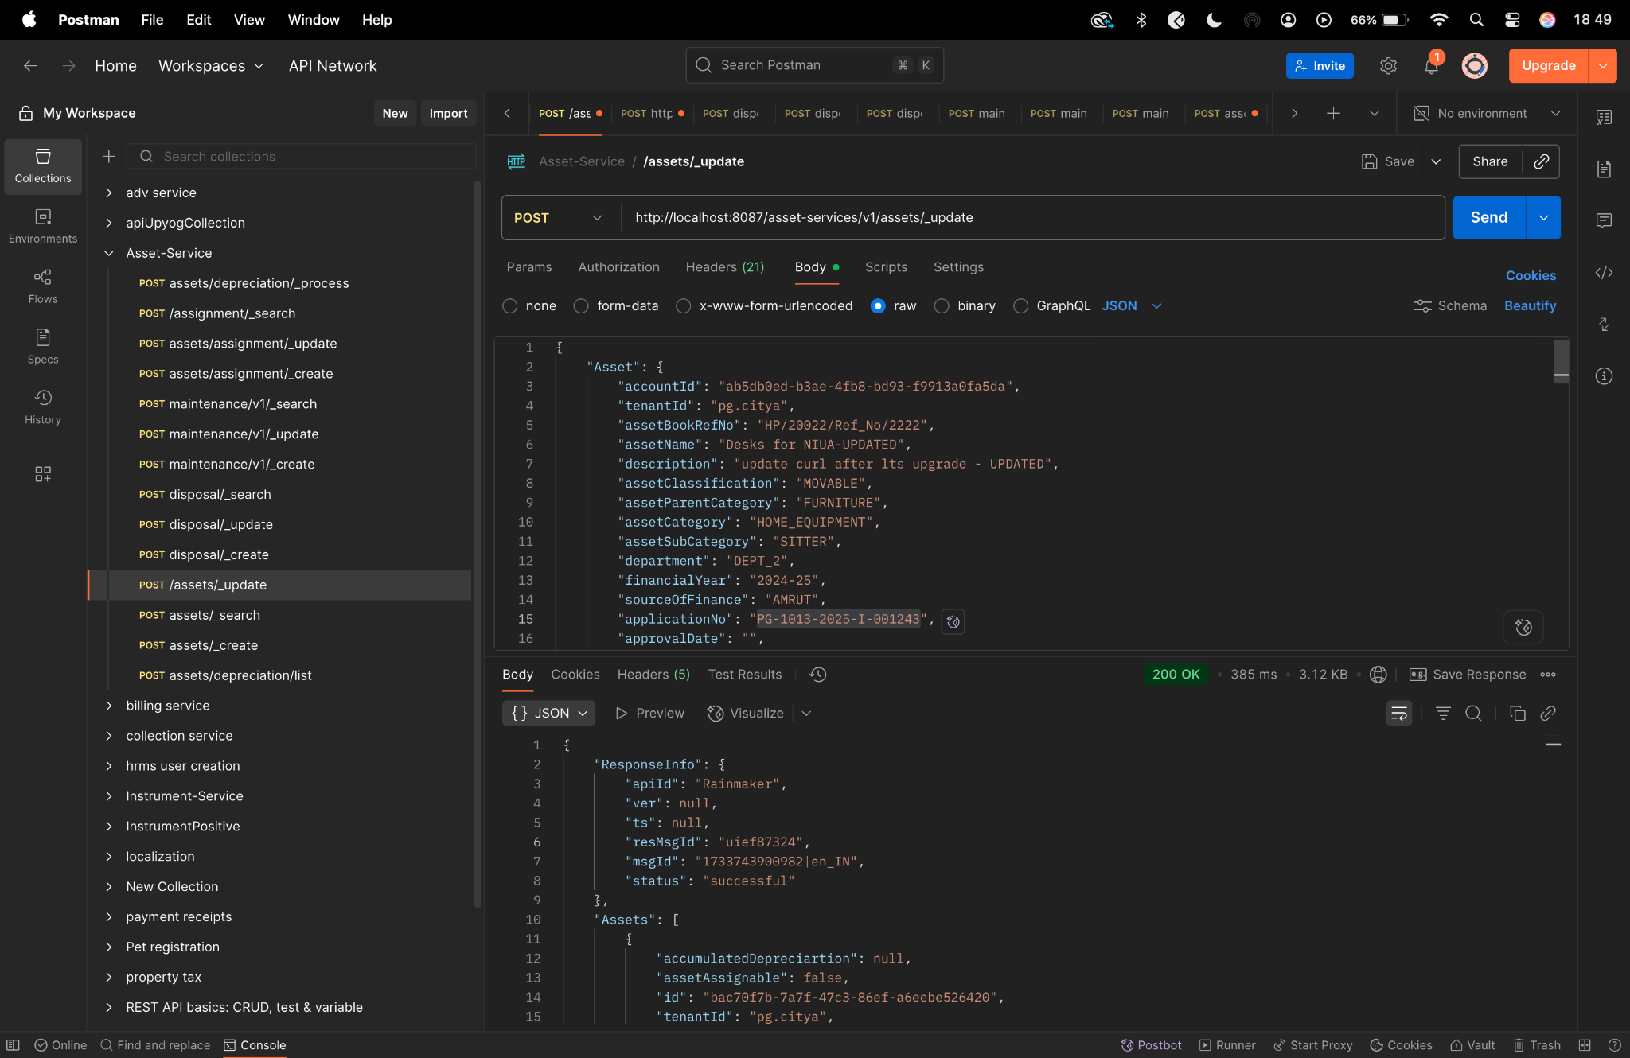

**Diff checker-**

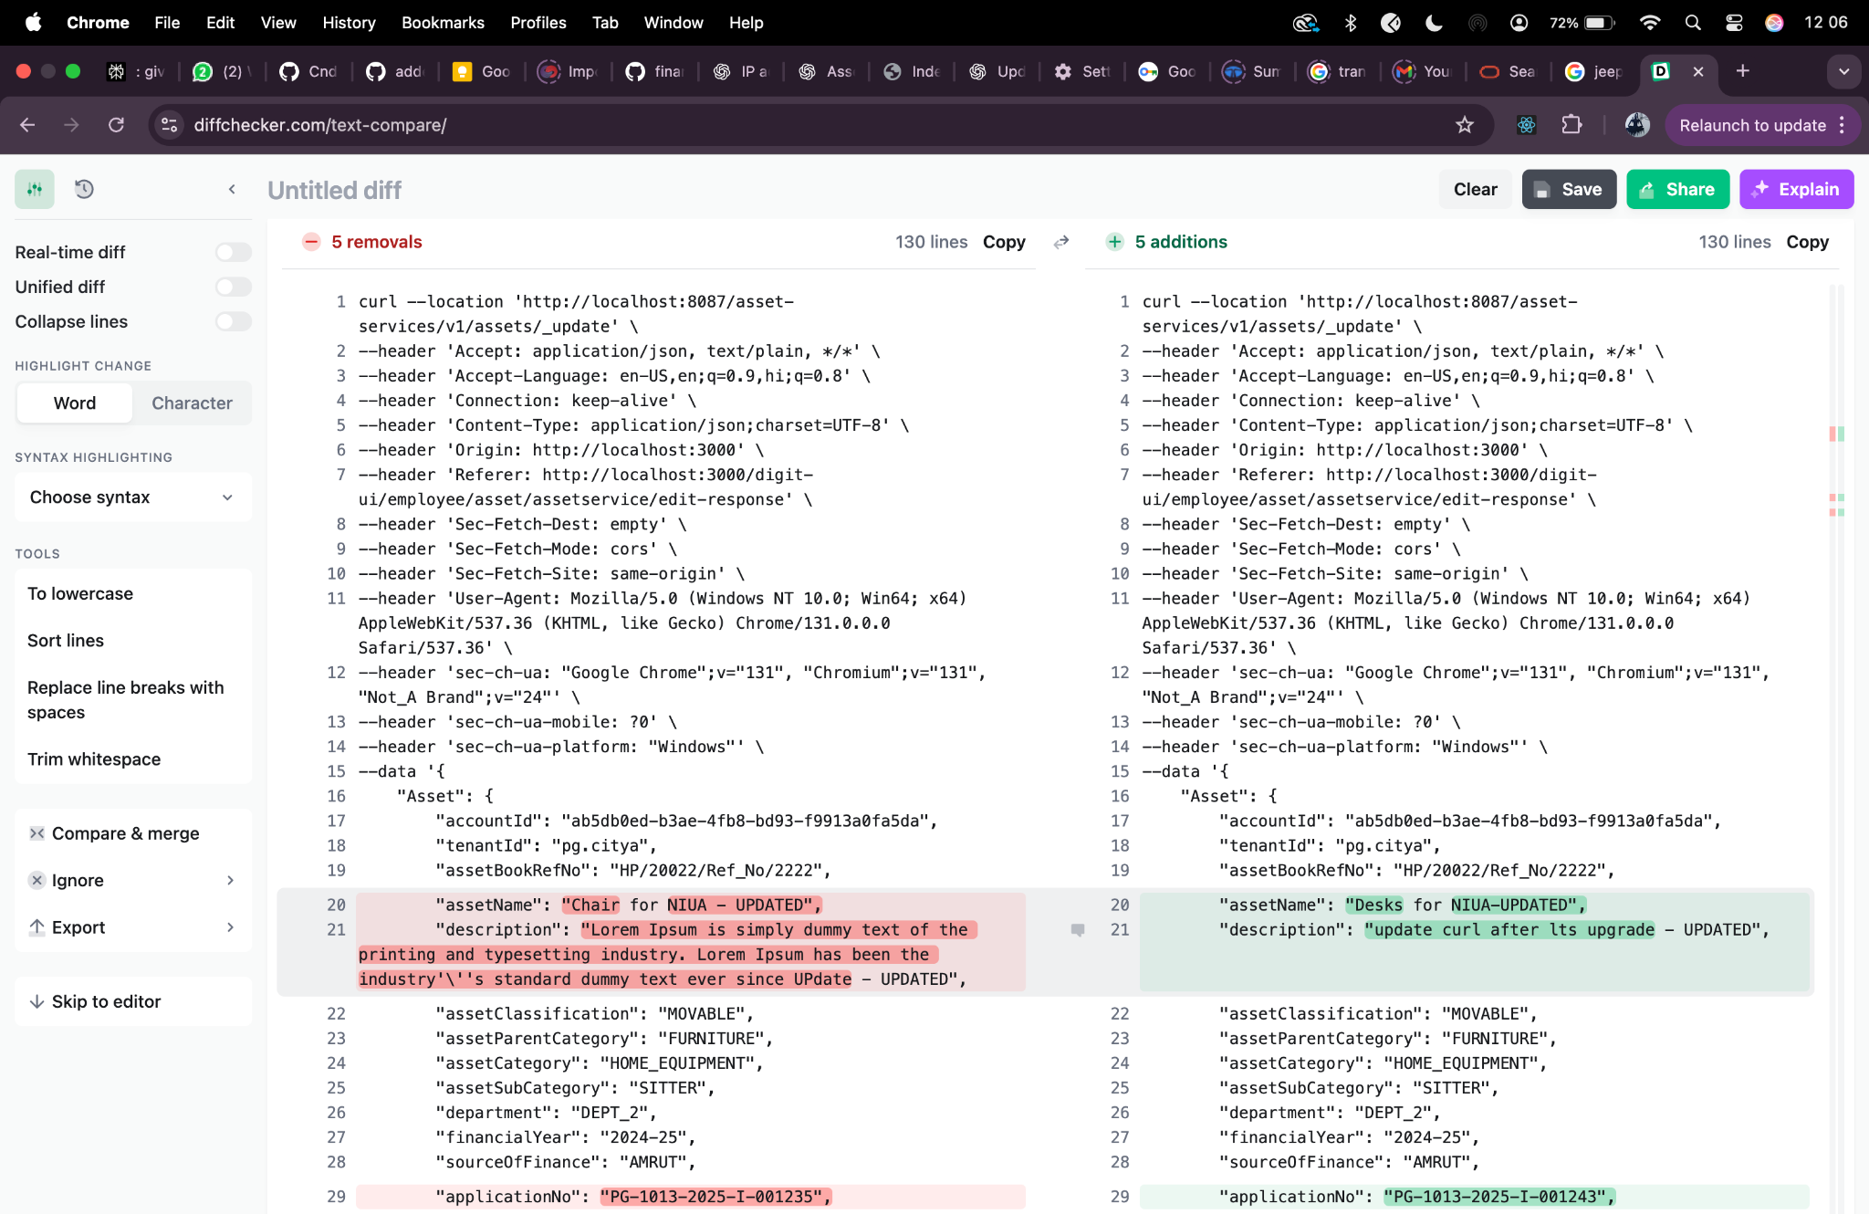

**Assignment/_create-**

curl --location 'http://localhost:8087/asset-services/v1/assets/assignment/_create' \

--header 'accept: application/json, text/plain, */*' \

--header 'accept-language: en-GB,en-US;q=0.9,en;q=0.8,hi;q=0.7' \

--header 'content-type: application/json;charset=UTF-8' \

--header 'origin: https://niuatt.niua.in' \

--header 'priority: u=1, i' \

--header 'referer: https://niuatt.niua.in/digit-ui/employee/asset/assetservice/assign-response' \

--header 'sec-ch-ua: "Not;A=Brand";v="99", "Google Chrome";v="139", "Chromium";v="139"' \

--header 'sec-ch-ua-mobile: ?0' \

--header 'sec-ch-ua-platform: "macOS"' \

--header 'sec-fetch-dest: empty' \

--header 'sec-fetch-mode: cors' \

--header 'sec-fetch-site: same-origin' \

--header 'user-agent: Mozilla/5.0 (Macintosh; Intel Mac OS X 10_15_7) AppleWebKit/537.36 (KHTML, like Gecko) Chrome/139.0.0.0 Safari/537.36' \

--header 'Cookie: locale=en_IN; _ga=GA1.1.559242739.1756447705; _clck=19weqns%5E2%5Efyv%5E0%5E2067; _ga_VZ9TNBTB3X=GS2.1.s1756447704$o1$g1$t1756447780$j59$l0$h0; _ga_E39TFV5YXM=GS2.1.s1756447709$o1$g1$t1756448684$j60$l0$h0' \

--data '{

"Asset": {

"id": "292c3bd8-4060-4efa-9f0d-d1fc81926625",

"tenantId": "pg.citya",

"applicationNo": "PG-1013-2025-I-001243",

"assetAssignment": {

"assignmentId": "",

"assetApplicaltionNo": "",

"assetId": "",

"assignedUserName": "Kunal Gaurav",

"designation": "DESIG_01",

"department": "DEPT_1",

"assignedDate": 1756924200000,

"isAssigned": true,

"allocatedDepartment": "DEPT_1",

"employeeCode": "EMP-001",

"auditDetails": {

"createdBy": "",

"lastModifiedBy": "",

"createdTime": "",

"lastModifiedTime": ""

}

}

},

"RequestInfo": {

"apiId": "Rainmaker",

"authToken": "54552937-0eb8-4cec-910a-182918416f7f",

"userInfo": {

"id": 909,

"uuid": "491381fb-858c-4582-a8cd-24ea08394bb8",

"userName": "ASSET_APPROVER",

"name": "Asset Approver",

"mobileNumber": "8448489439",

"emailId": null,

"locale": null,

"type": "EMPLOYEE",

"roles": [

{

"name": "Asset Approver",

"code": "ASSET_APPROVER",

"tenantId": "pg.citya"

},

{

"name": "Asset Allocator",

"code": "ASSET_ALLOCATOR",

"tenantId": "pg.citya"

}

],

"active": true,

"tenantId": "pg.citya",

"permanentCity": null

},

"msgId": "1757667814971|en_IN",

"plainAccessRequest": {}

}

}'

**Response -**

{

"ResponseInfo": {

"apiId": "Rainmaker",

"ver": null,

"ts": null,

"resMsgId": "uief87324",

"msgId": "1757667814971|en_IN",

"status": "successful"

},

"Assets": [

{

"accumulatedDepreciartion": null,

"assetAssignable": false,

"id": "292c3bd8-4060-4efa-9f0d-d1fc81926625",

"tenantId": "pg.citya",

"assetBookRefNo": null,

"assetName": null,

"description": null,

"assetClassification": null,

"assetParentCategory": null,

"assetCategory": null,

"assetSubCategory": null,

"department": null,

"applicationNo": "PG-1013-2025-I-001243",

"approvalNo": null,

"approvalDate": null,

"applicationDate": null,

"status": null,

"addressDetails": null,

"documents": null,

"auditDetails": null,

"assetAssignment": {

"assignmentId": "41896186-b912-4faf-901f-72649bb175f4",

"assetApplicaltionNo": "",

"tenantId": null,

"assignedUserName": "Kunal Gaurav",

"employeeCode": "EMP-001",

"designation": "DESIG_01",

"department": "DEPT_1",

"auditDetails": {

"createdBy": "491381fb-858c-4582-a8cd-24ea08394bb8",

"lastModifiedBy": "491381fb-858c-4582-a8cd-24ea08394bb8",

"createdTime": 1757770603122,

"lastModifiedTime": 1757770603122

},

"assignedDate": 1756924200000,

"isAssigned": true,

"returnDate": null

},

"additionalDetails": null,

"accountId": null,

"remarks": null,

"financialYear": null,

"sourceOfFinance": null,

"workflow": null,

"scheme": null,

"subScheme": null,

"purchaseCost": 0.0,

"acquisitionCost": 0.0,

"bookValue": 0.0,

"invoiceDate": null,

"invoiceNumber": null,

"purchaseDate": null,

"purchaseOrderNumber": null,

"location": null,

"oldCode": null,

"modeOfPossessionOrAcquisition": null,

"unitOfMeasurement": null,

"lifeOfAsset": null,

"assetUsage": null,

"assetType": null,

"assetStatus": null,

"originalBookValue": 0.0,

"minimumValue": null,

"islegacyData": null

}

]

}

**Postman-**

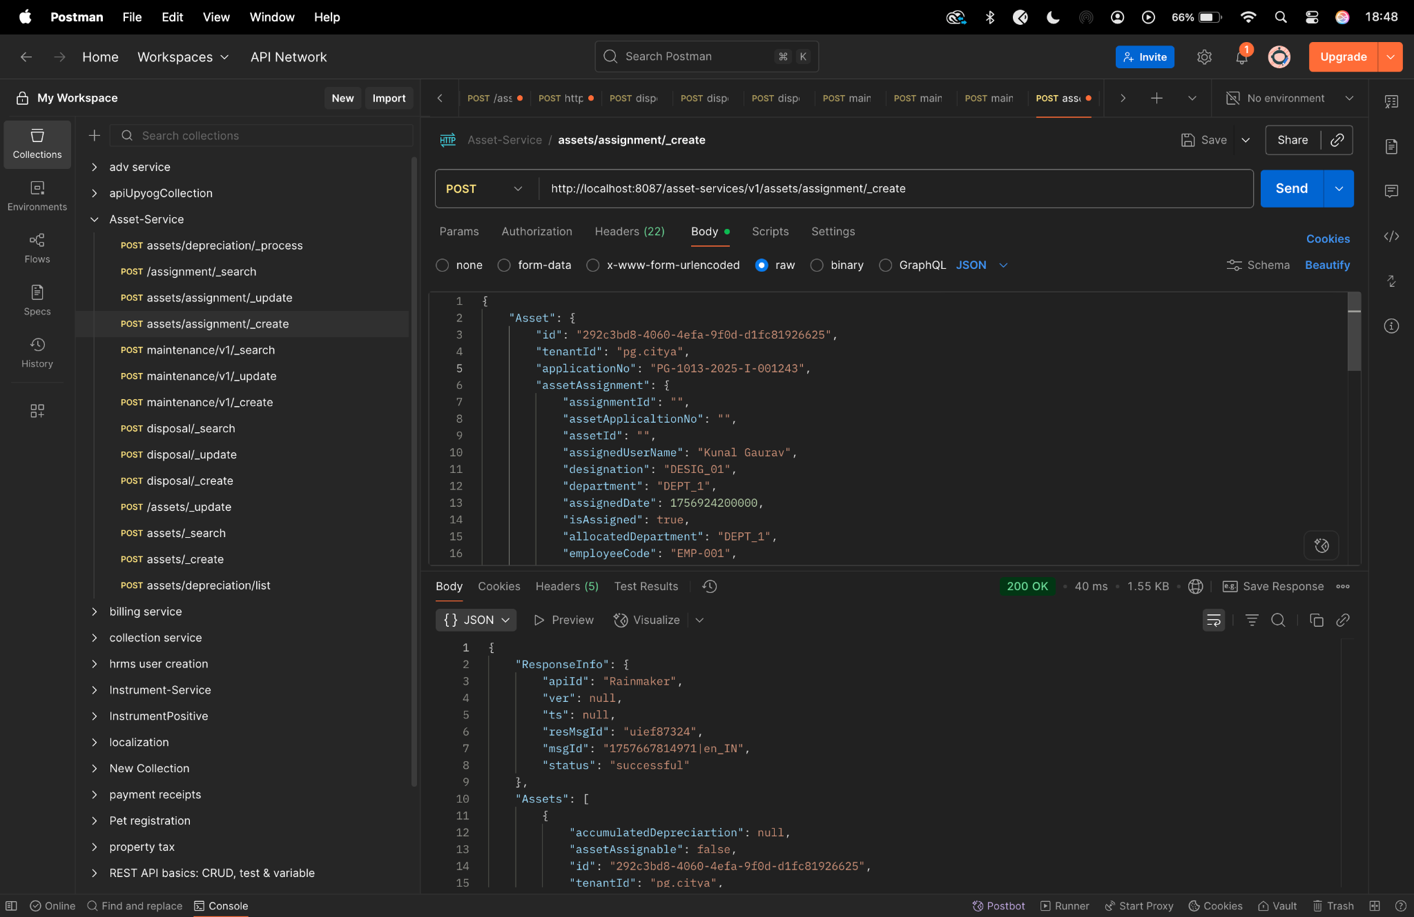

**Diff checker-**

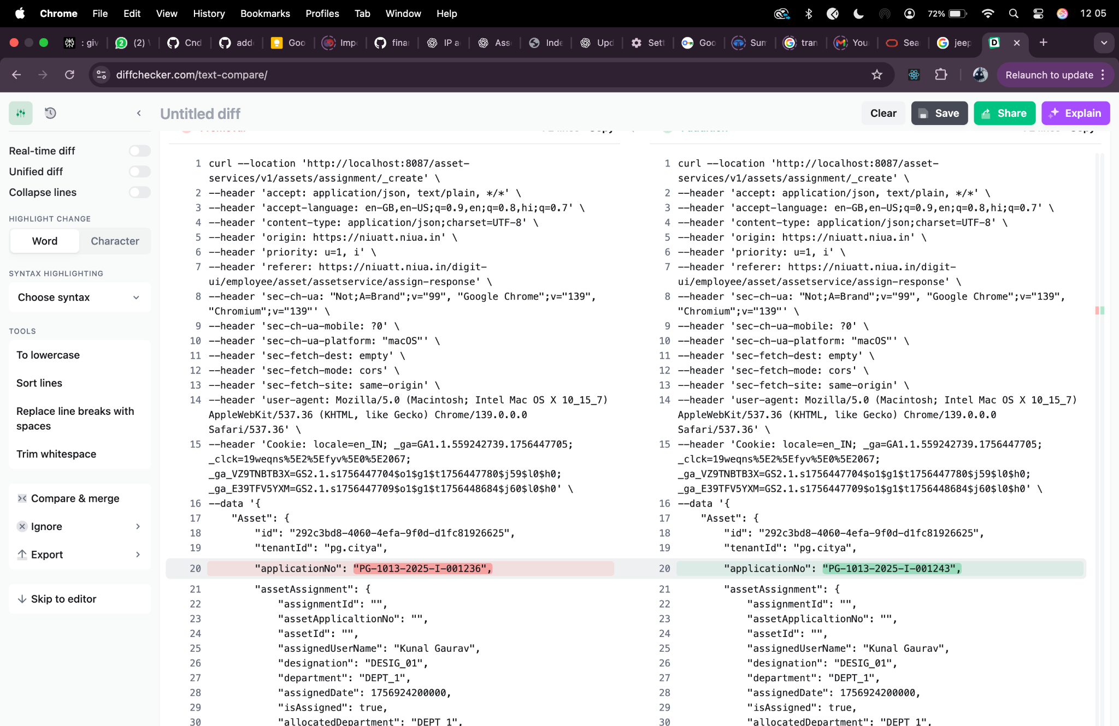

**Assignment/_update**

curl --location 'http://localhost:8087/asset-services/v1/assets/assignment/_update' \

--header 'accept: application/json, text/plain, */*' \

--header 'accept-language: en-GB,en-US;q=0.9,en;q=0.8,hi;q=0.7' \

--header 'content-type: application/json;charset=UTF-8' \

--header 'origin: https://niuatt.niua.in' \

--header 'priority: u=1, i' \

--header 'referer: https://niuatt.niua.in/digit-ui/employee/asset/assetservice/assign-response' \

--header 'sec-ch-ua: "Not;A=Brand";v="99", "Google Chrome";v="139", "Chromium";v="139"' \

--header 'sec-ch-ua-mobile: ?0' \

--header 'sec-ch-ua-platform: "macOS"' \

--header 'sec-fetch-dest: empty' \

--header 'sec-fetch-mode: cors' \

--header 'sec-fetch-site: same-origin' \

--header 'user-agent: Mozilla/5.0 (Macintosh; Intel Mac OS X 10_15_7) AppleWebKit/537.36 (KHTML, like Gecko) Chrome/139.0.0.0 Safari/537.36' \

--header 'Cookie: locale=en_IN; _ga=GA1.1.559242739.1756447705; _clck=19weqns%5E2%5Efyv%5E0%5E2067; _ga_VZ9TNBTB3X=GS2.1.s1756447704$o1$g1$t1756447780$j59$l0$h0; _ga_E39TFV5YXM=GS2.1.s1756447709$o1$g1$t1756448684$j60$l0$h0' \

--data '{

"Asset": {

"id": "292c3bd8-4060-4efa-9f0d-d1fc81926625",

"tenantId": "pg.citya",

"applicationNo": "PG-1013-2025-I-001243",

"assetAssignment": {

"assignmentId": "41896186-b912-4faf-901f-72649bb175f4",

"assetApplicaltionNo": "PG-1013-2025-I-001236",

"assetId": "292c3bd8-4060-4efa-9f0d-d1fc81926625",

"assignedUserName": "Kunal Gaurav - Updated",

"designation": "DESIG_02",

"department": "DEPT_2",

"assignedDate": 1756924200000,

"returnDate": 1757529000000,

"isAssigned": false,

"allocatedDepartment": "DEPT_2",

"employeeCode": "EMP-002",

"auditDetails": {

"createdBy": "admin",

"lastModifiedBy": "admin",

"createdTime": 1672531200000,

"lastModifiedTime": 1672534800000

}

}

},

"RequestInfo": {

"apiId": "Rainmaker",

"authToken": "54552937-0eb8-4cec-910a-182918416f7f",

"userInfo": {

"id": 909,

"uuid": "491381fb-858c-4582-a8cd-24ea08394bb8",

"userName": "ASSET_APPROVER",

"name": "Asset Approver",

"mobileNumber": "8448489439",

"emailId": null,

"locale": null,

"type": "EMPLOYEE",

"roles": [

{

"name": "Asset Approver",

"code": "ASSET_APPROVER",

"tenantId": "pg.citya"

},

{

"name": "Asset Allocator",

"code": "ASSET_ALLOCATOR",

"tenantId": "pg.citya"

}

],

"active": true,

"tenantId": "pg.citya",

"permanentCity": null

},

"msgId": "1757667814971|en_IN",

"plainAccessRequest": {}

}

}'

**Response -**

{

"ResponseInfo": {

"apiId": "Rainmaker",

"ver": null,

"ts": null,

"resMsgId": "uief87324",

"msgId": "1757667814971|en_IN",

"status": "successful"

},

"Assets": [

{

"accumulatedDepreciartion": null,

"assetAssignable": false,

"id": "292c3bd8-4060-4efa-9f0d-d1fc81926625",

"tenantId": "pg.citya",

"assetBookRefNo": null,

"assetName": null,

"description": null,

"assetClassification": null,

"assetParentCategory": null,

"assetCategory": null,

"assetSubCategory": null,

"department": null,

"applicationNo": "PG-1013-2025-I-001243",

"approvalNo": null,

"approvalDate": null,

"applicationDate": null,

"status": null,

"addressDetails": null,

"documents": null,

"auditDetails": null,

"assetAssignment": {

"assignmentId": "41896186-b912-4faf-901f-72649bb175f4",

"assetApplicaltionNo": "PG-1013-2025-I-001236",

"tenantId": null,

"assignedUserName": "Kunal Gaurav - Updated",

"employeeCode": "EMP-002",

"designation": "DESIG_02",

"department": "DEPT_2",

"auditDetails": {

"createdBy": "491381fb-858c-4582-a8cd-24ea08394bb8",

"lastModifiedBy": "491381fb-858c-4582-a8cd-24ea08394bb8",

"createdTime": 1757770871089,

"lastModifiedTime": 1757770871089

},

"assignedDate": 1756924200000,

"isAssigned": false,

"returnDate": 1757529000000

},

"additionalDetails": null,

"accountId": null,

"remarks": null,

"financialYear": null,

"sourceOfFinance": null,

"workflow": null,

"scheme": null,

"subScheme": null,

"purchaseCost": 0.0,

"acquisitionCost": 0.0,

"bookValue": 0.0,

"invoiceDate": null,

"invoiceNumber": null,

"purchaseDate": null,

"purchaseOrderNumber": null,

"location": null,

"oldCode": null,

"modeOfPossessionOrAcquisition": null,

"unitOfMeasurement": null,

"lifeOfAsset": null,

"assetUsage": null,

"assetType": null,

"assetStatus": null,

"originalBookValue": 0.0,

"minimumValue": null,

"islegacyData": null

}

]

}

**Postman -**

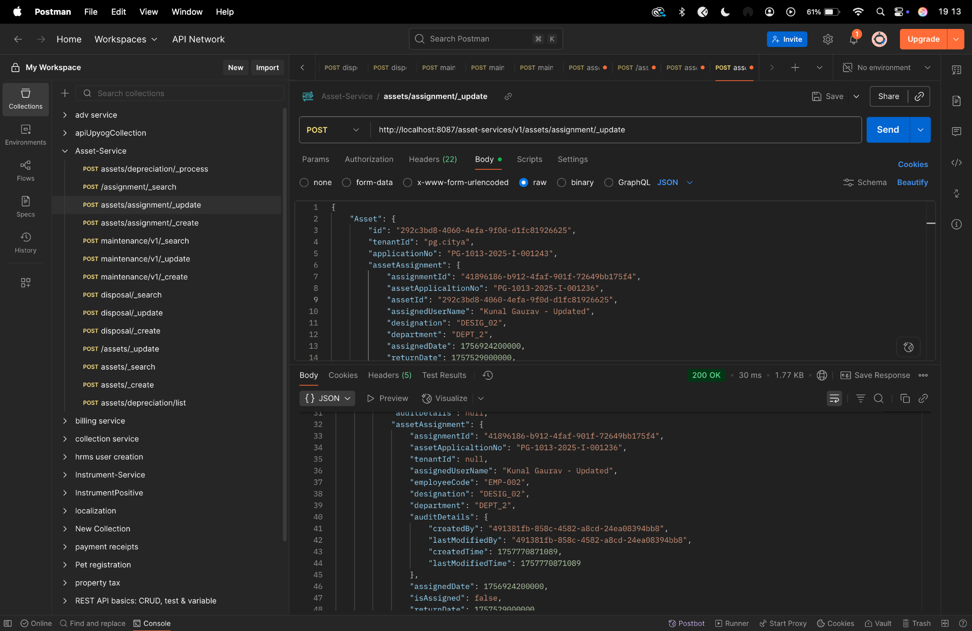

**Diff checker -**

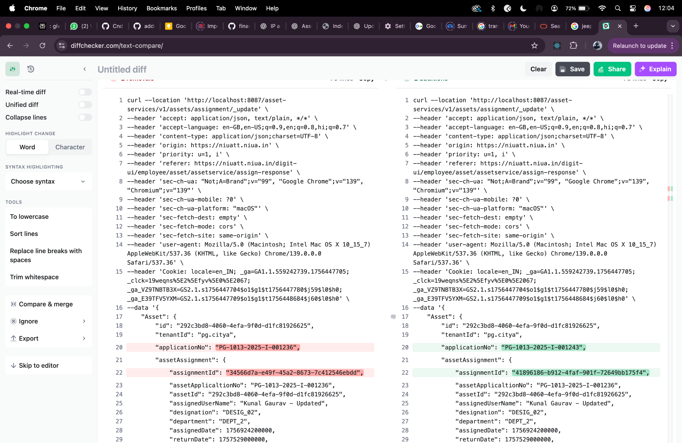

**Assignment/_search**

curl --location 'http://localhost:8087/asset-services/v1/assets/assignment/_search' \

--header 'accept: application/json, text/plain, */*' \

--header 'accept-language: en-GB,en-US;q=0.9,en;q=0.8,hi;q=0.7' \

--header 'content-type: application/json;charset=UTF-8' \

--header 'origin: https://niuatt.niua.in' \

--header 'priority: u=1, i' \

--header 'referer: https://niuatt.niua.in/digit-ui/employee/asset/assetservice/assign-response' \

--header 'sec-ch-ua: "Not;A=Brand";v="99", "Google Chrome";v="139", "Chromium";v="139"' \

--header 'sec-ch-ua-mobile: ?0' \

--header 'sec-ch-ua-platform: "macOS"' \

--header 'sec-fetch-dest: empty' \

--header 'sec-fetch-mode: cors' \

--header 'sec-fetch-site: same-origin' \

--header 'user-agent: Mozilla/5.0 (Macintosh; Intel Mac OS X 10_15_7) AppleWebKit/537.36 (KHTML, like Gecko) Chrome/139.0.0.0 Safari/537.36' \

--header 'Cookie: locale=en_IN; _ga=GA1.1.559242739.1756447705; _clck=19weqns%5E2%5Efyv%5E0%5E2067; _ga_VZ9TNBTB3X=GS2.1.s1756447704$o1$g1$t1756447780$j59$l0$h0; _ga_E39TFV5YXM=GS2.1.s1756447709$o1$g1$t1756448684$j60$l0$h0' \

--data '{

"Asset": {

"id": "292c3bd8-4060-4efa-9f0d-d1fc81926625",

"tenantId": "pg.citya"

},

"RequestInfo": {

"apiId": "Rainmaker",

"authToken": "54552937-0eb8-4cec-910a-182918416f7f",

"userInfo": {

"id": 909,

"uuid": "491381fb-858c-4582-a8cd-24ea08394bb8",

"userName": "ASSET_APPROVER",

"name": "Asset Approver",

"mobileNumber": "8448489439",

"emailId": null,

"locale": null,

"type": "EMPLOYEE",

"roles": [

{

"name": "Asset Approver",

"code": "ASSET_APPROVER",

"tenantId": "pg.citya"

},

{

"name": "Asset Allocator",

"code": "ASSET_ALLOCATOR",

"tenantId": "pg.citya"

}

],

"active": true,

"tenantId": "pg.citya",

"permanentCity": null

},

"msgId": "1757667814971|en_IN",

"plainAccessRequest": {}

}

}'

**Response-**

{

"assetAssignments": [

{

"assignmentId": "41896186-b912-4faf-901f-72649bb175f4",

"assetApplicaltionNo": "PG-1013-2025-I-001243",

"tenantId": "pg.citya",

"assignedUserName": "Kunal Gaurav - Updated",

"employeeCode": "EMP-002",

"designation": "DESIG_02",

"department": "DEPT_2",

"auditDetails": null,

"assignedDate": 1756924200000,

"isAssigned": false,

"returnDate": 1757529000000

},

{

"assignmentId": "41896186-b912-4faf-901f-72649bb175f4",

"assetApplicaltionNo": "PG-1013-2025-I-001243",

"tenantId": "pg.citya",

"assignedUserName": "Kunal Gaurav - Updated",

"employeeCode": "EMP-002",

"designation": "DESIG_02",

"department": "DEPT_2",

"auditDetails": null,

"assignedDate": 1756924200000,

"isAssigned": false,

"returnDate": 1757529000000

}

],

"ResponseInfo": {

"apiId": "",

"ver": "",

"ts": null,

"resMsgId": "uief87324",

"msgId": "",

"status": "successful"

}

}

**Postman -**

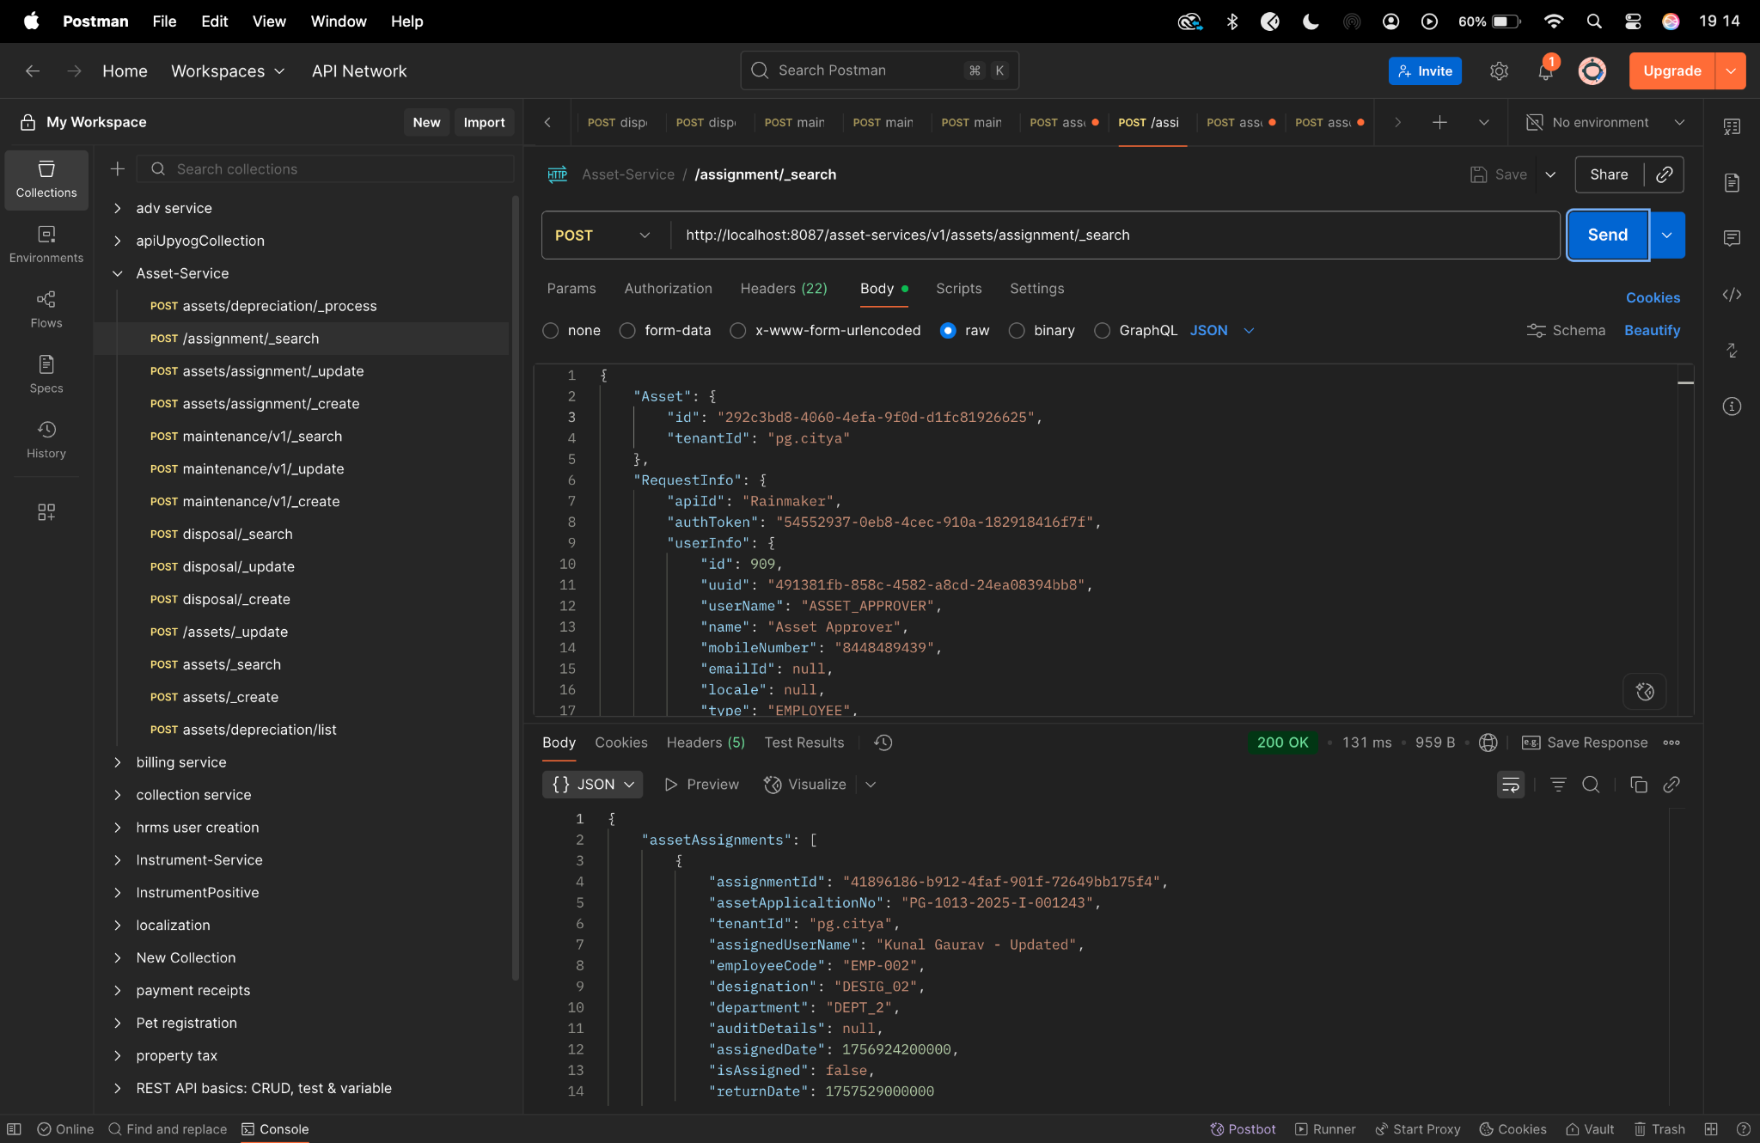

**Diff checker -**

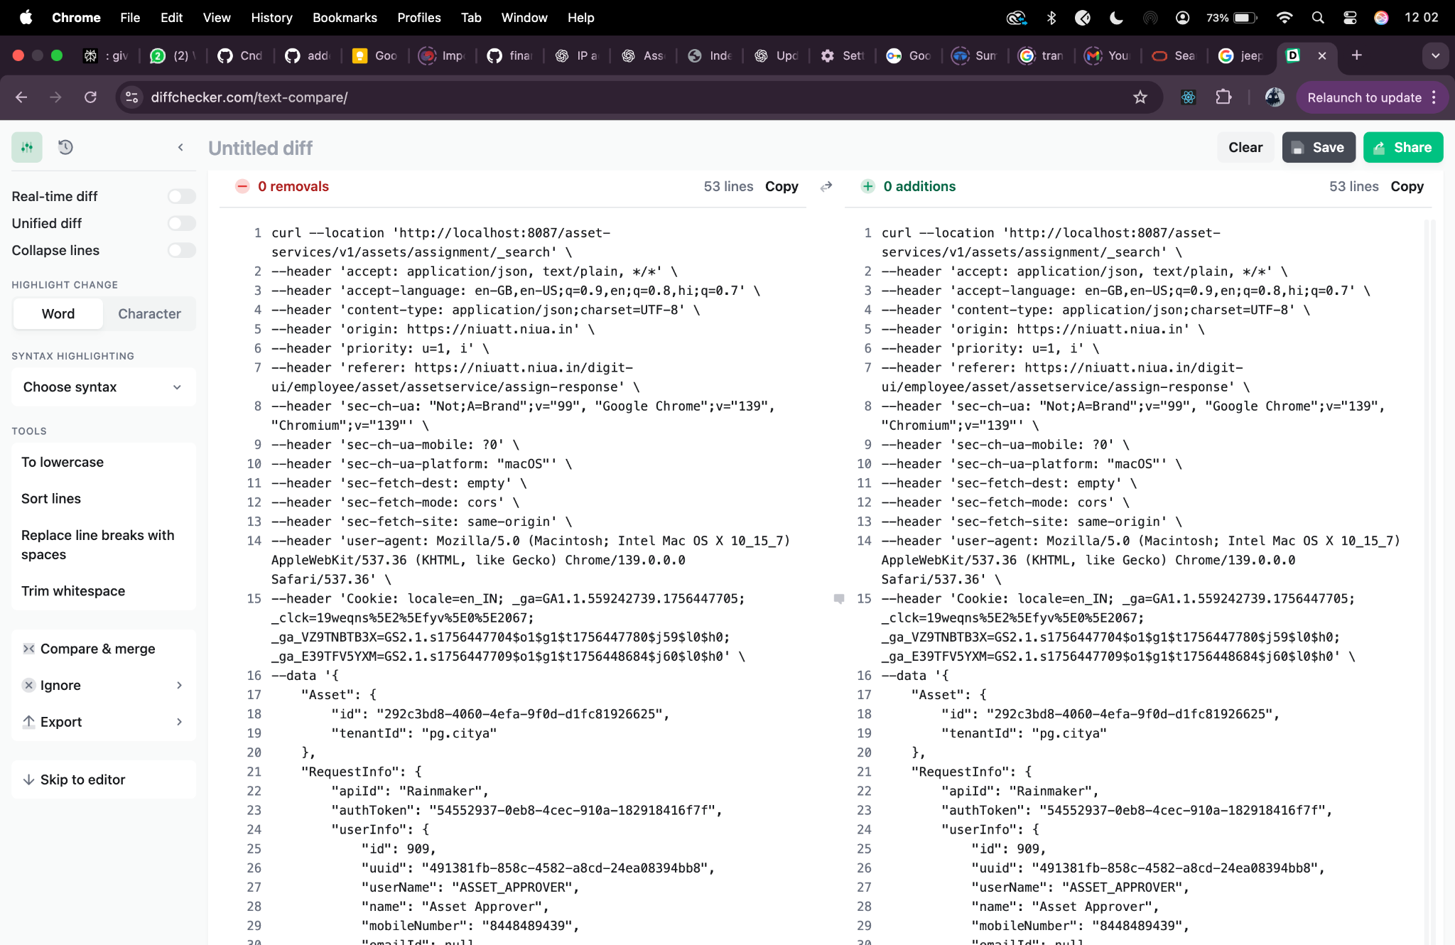

**maintenance/_create -**

curl --location 'http://localhost:8087/asset-services/maintenance/v1/_create' \

--header 'sec-ch-ua-platform: "macOS"' \

--header 'Referer: https://niuatt.niua.in/digit-ui/employee/asset/assetservice/maintenance' \

--header 'User-Agent: Mozilla/5.0 (Macintosh; Intel Mac OS X 10_15_7) AppleWebKit/537.36 (KHTML, like Gecko) Chrome/133.0.0.0 Safari/537.36' \

--header 'Accept: application/json, text/plain, */*' \

--header 'sec-ch-ua: "Not(A:Brand";v="99", "Google Chrome";v="133", "Chromium";v="133"' \

--header 'Content-Type: application/json;charset=UTF-8' \

--header 'sec-ch-ua-mobile: ?0' \

--data '{

"AssetMaintenance": {

"maintenanceId": "",

"assetId": "292c3bd8-4060-4efa-9f0d-d1fc81926625",

"tenantId": "pg.citya",

"warrantyStatus": "IN_AMC",

"assetWarrantyDescription": "sdfdsf",

"amcDetails": "sdfsd",

"assetMaintenanceDate": 1756771200,

"assetNextMaintenanceDate": null,

"maintenanceType": "CORRECTIVE",

"paymentType": "BANK_TRANSFER",

"costOfMaintenance": "",

"description": "warranty",

"vendor": "dsfs",

"maintenanceCycle": "QUARTERLY",

"partsAddedOrReplaced": "sdfsdf",

"preConditionRemarks": "dfsdf",

"postConditionRemarks": "dsfsdf",

"isAMCExpired": true,

"isWarrantyExpired": false,

"isLifeOfAssetAffected": "TRUE",

"assetMaintenanceIncreasedYear": "2",

"documents": [

{

"documentType": "ASSET.MAINTENANCE.DOC3",

"fileStoreId": "16ce3c83-a416-4e60-b6ff-1eaa1a47c278",

"documentUid": "16ce3c83-a416-4e60-b6ff-1eaa1a47c278"

},

{

"documentType": "ASSET.MAINTENANCE.DOC1",

"fileStoreId": "ba1ca218-ca65-438c-9a2e-519acf799f3e",

"documentUid": "ba1ca218-ca65-438c-9a2e-519acf799f3e"

},

{

"documentType": "ASSET.MAINTENANCE.DOC2",

"fileStoreId": "48e2932e-432b-4f83-8b0a-09229f107fbc",

"documentUid": "48e2932e-432b-4f83-8b0a-09229f107fbc"

}

],

"auditDetails": {

"createdBy": "",

"createdTime": "",

"lastModifiedBy": "",

"lastModifiedTime": ""

}

},

"RequestInfo": {

"apiId": "Rainmaker",

"authToken": "54552937-0eb8-4cec-910a-182918416f7f",

"userInfo": {

"id": 909,

"uuid": "491381fb-858c-4582-a8cd-24ea08394bb8",

"userName": "ASSET_APPROVER",

"name": "Asset Approver",

"mobileNumber": "8448489439",

"emailId": null,

"locale": null,

"type": "EMPLOYEE",

"roles": [

{

"name": "Asset Approver",

"code": "ASSET_APPROVER",

"tenantId": "pg.citya"

},

{

"name": "Asset Allocator",

"code": "ASSET_ALLOCATOR",

"tenantId": "pg.citya"

}

],

"active": true,

"tenantId": "pg.citya",

"permanentCity": null

},

"msgId": "1757659710772|en_IN",

"plainAccessRequest": {}

}

}'

**Response -**

{

"ResponseInfo": {

"apiId": "Rainmaker",

"ver": null,

"ts": null,

"resMsgId": "uief87324",

"msgId": "1757659710772|en_IN",

"status": "successful"

},

"AssetMaintenance": [

{

"maintenanceId": "cd7d6de3-d705-4f2c-a1a1-a27d44bd7fc9",

"assetId": "292c3bd8-4060-4efa-9f0d-d1fc81926625",

"tenantId": "pg.citya",

"currentLifeOfAsset": null,

"isWarrantyExpired": false,

"isAMCExpired": true,

"warrantyStatus": "IN_AMC",

"amcDetails": "sdfsd",

"maintenanceType": "CORRECTIVE",

"paymentType": "BANK_TRANSFER",

"costOfMaintenance": null,

"vendor": "dsfs",

"maintenanceCycle": "QUARTERLY",

"partsAddedOrReplaced": "sdfsdf",

"additionalDetails": null,

"postConditionRemarks": "dsfsdf",

"preConditionRemarks": "dfsdf",

"assetMaintenanceStatus": null,

"documents": [

{

"documentId": "d54474db-d5a1-4376-a759-3d6cc9252e61",

"documentType": "ASSET.MAINTENANCE.DOC3",

"fileStoreId": "16ce3c83-a416-4e60-b6ff-1eaa1a47c278",

"documentUid": "5de089ce-6114-4c19-b0e5-41790a65708a",

"docDetails": null

},

{

"documentId": "6c9de3cd-4294-4699-9260-1c2e1c9f6207",

"documentType": "ASSET.MAINTENANCE.DOC1",

"fileStoreId": "ba1ca218-ca65-438c-9a2e-519acf799f3e",

"documentUid": "351aab1f-61d1-41ae-ba52-fba2ab29e6b9",

"docDetails": null

},

{

"documentId": "8a02c38b-fc6e-42d9-b9e3-54f6ad102714",

"documentType": "ASSET.MAINTENANCE.DOC2",

"fileStoreId": "48e2932e-432b-4f83-8b0a-09229f107fbc",

"documentUid": "7277e8eb-d740-4ed0-aad5-57e66b1b8dc3",

"docDetails": null

}

],

"auditDetails": {

"createdBy": "491381fb-858c-4582-a8cd-24ea08394bb8",

"lastModifiedBy": "491381fb-858c-4582-a8cd-24ea08394bb8",

"createdTime": 1757771228926,

"lastModifiedTime": 1757771228926

},

"description": "warranty",

"assetMaintenanceDate": 1756771200,

"assetNextMaintenanceDate": null

}

]

}

**Postman-**

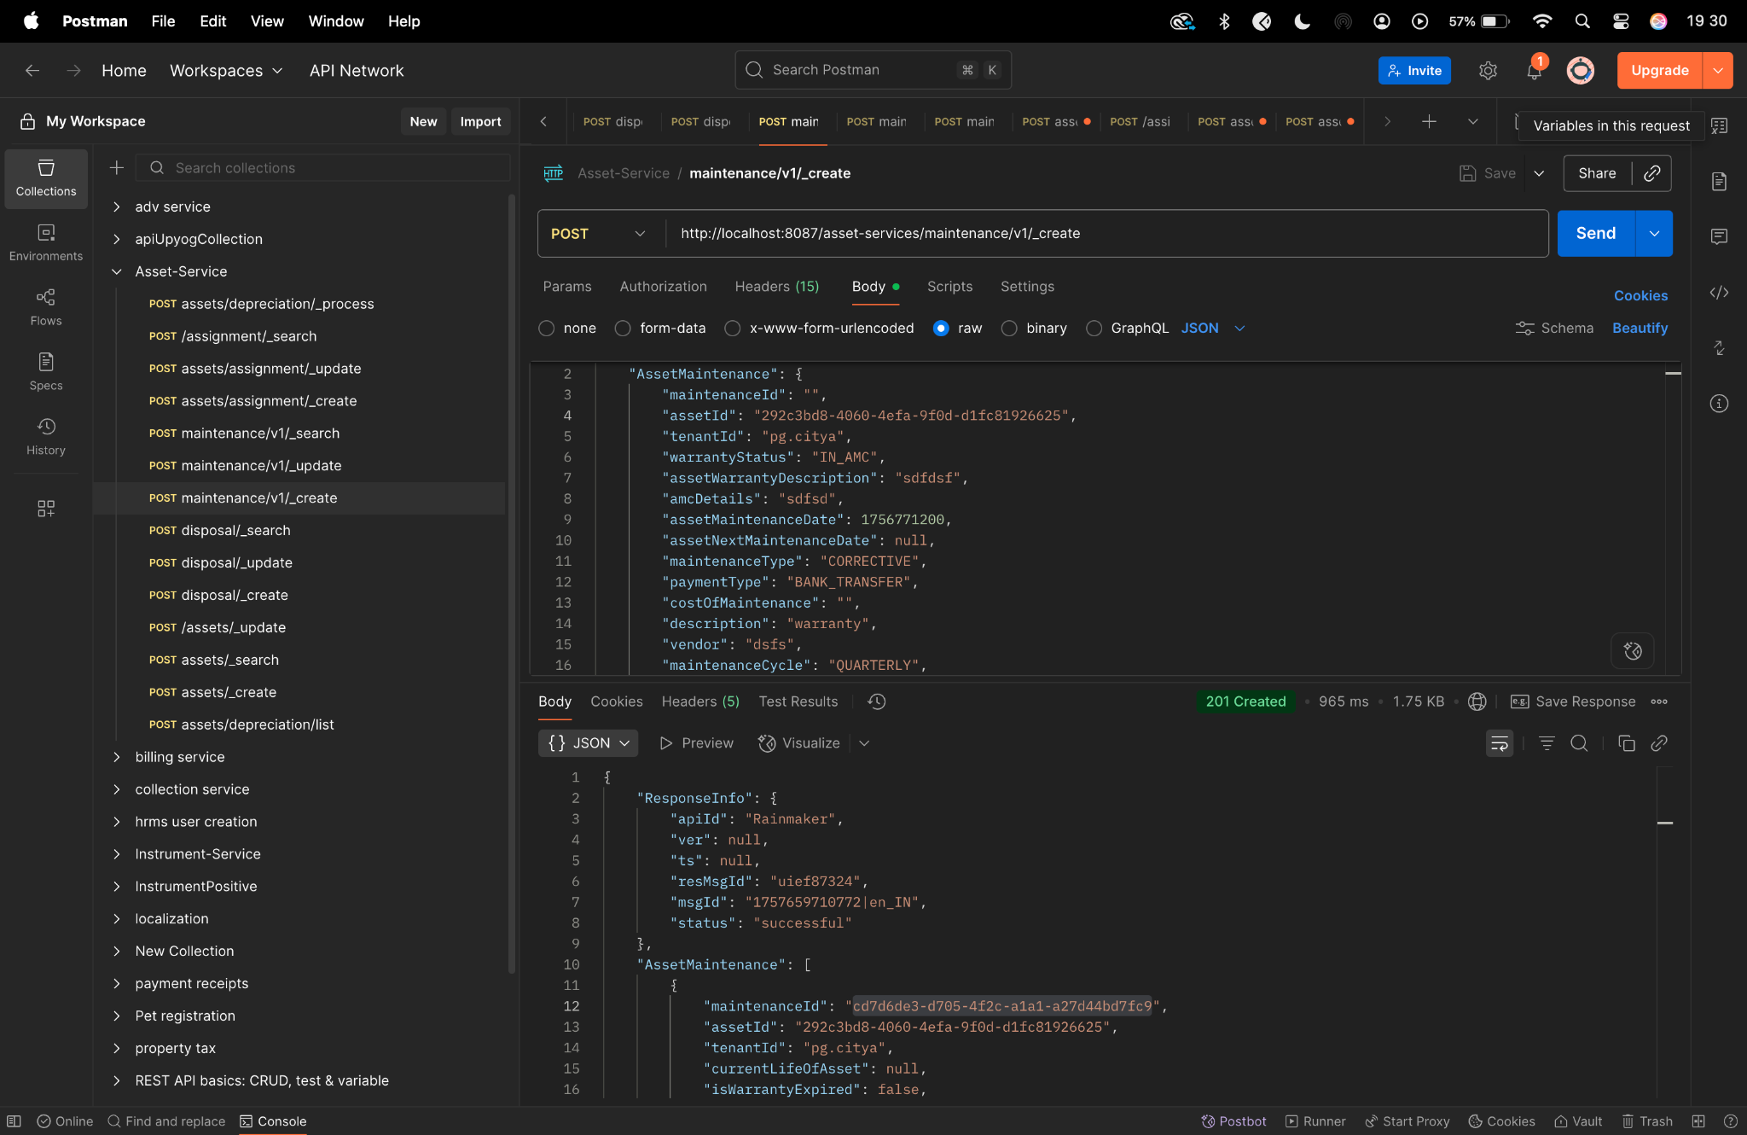

**Diff checker-**

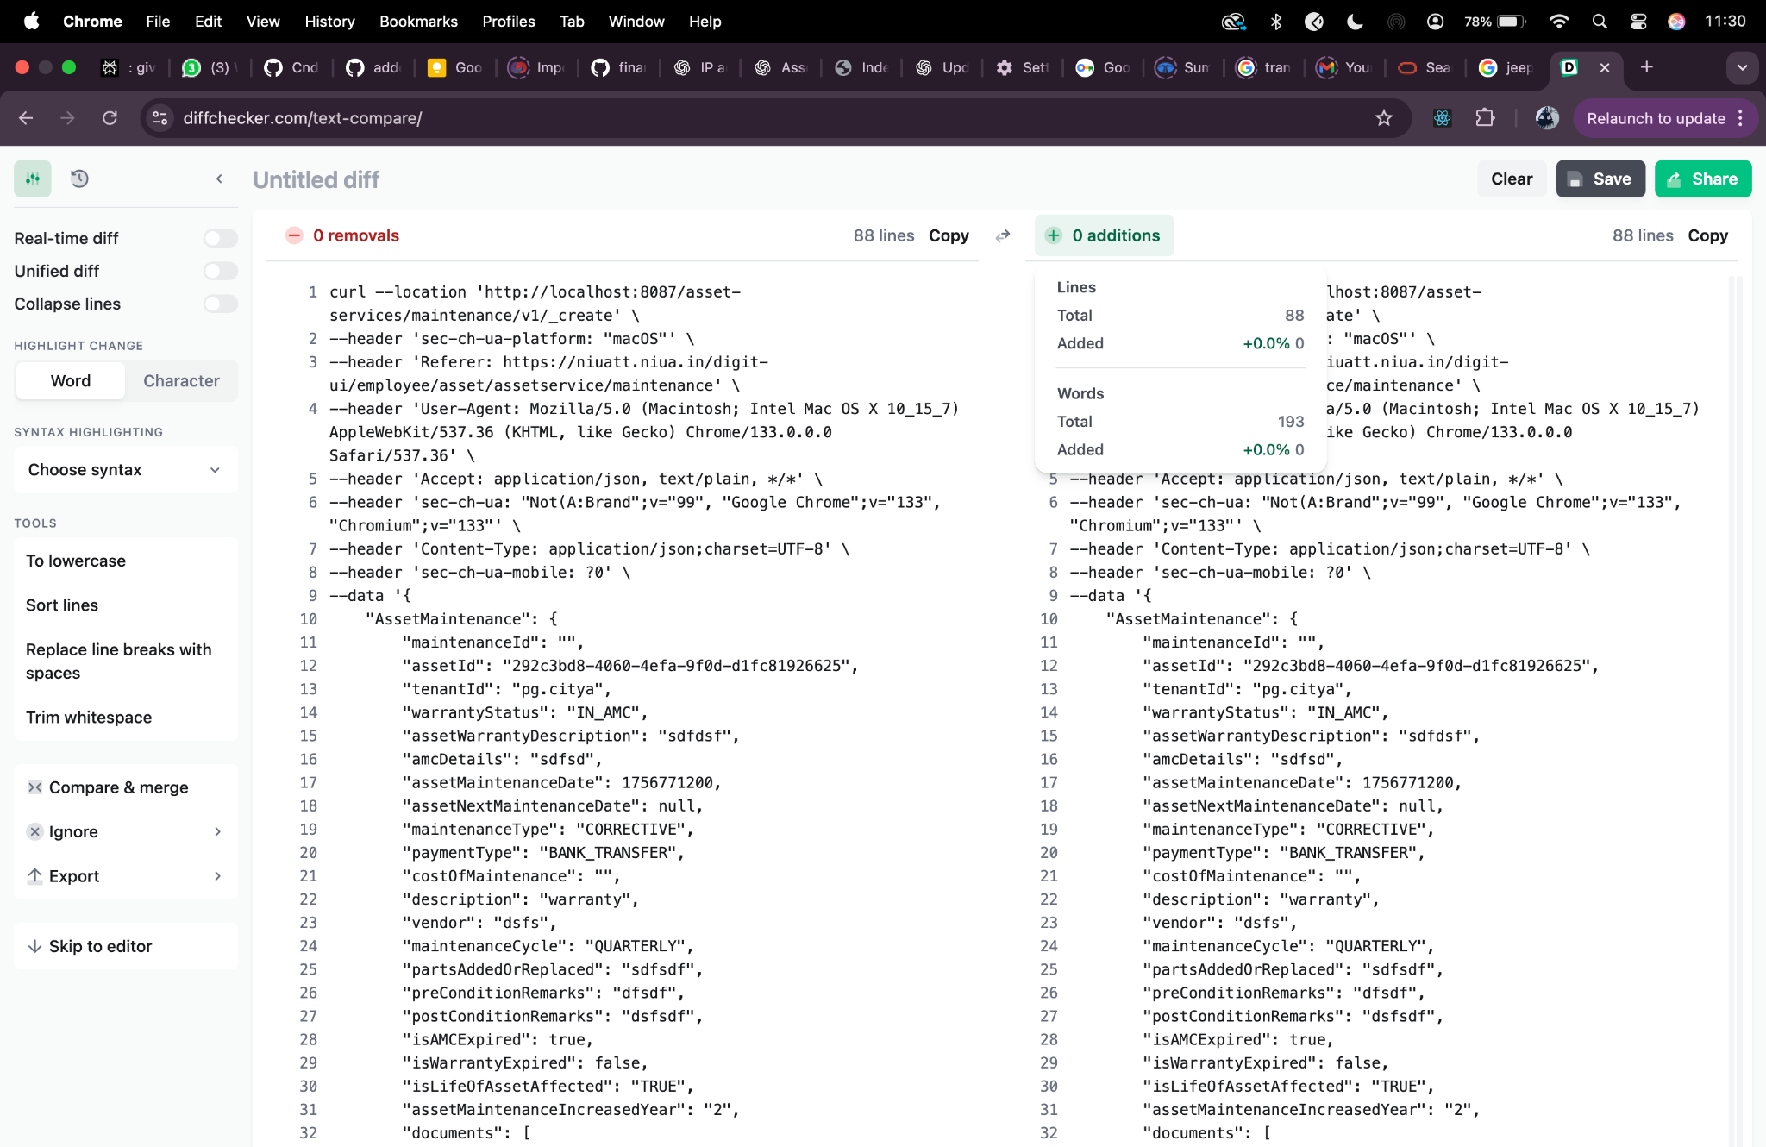

**maintenance/_update-**

curl --location 'http://localhost:8087/asset-services/maintenance/v1/_update' \

--header 'sec-ch-ua-platform: "macOS"' \

--header 'Referer: https://niuatt.niua.in/digit-ui/employee/asset/assetservice/maintenance' \

--header 'User-Agent: Mozilla/5.0 (Macintosh; Intel Mac OS X 10_15_7) AppleWebKit/537.36 (KHTML, like Gecko) Chrome/133.0.0.0 Safari/537.36' \

--header 'Accept: application/json, text/plain, */*' \

--header 'sec-ch-ua: "Not(A:Brand";v="99", "Google Chrome";v="133", "Chromium";v="133"' \

--header 'Content-Type: application/json;charset=UTF-8' \

--header 'sec-ch-ua-mobile: ?0' \

--data '{

"AssetMaintenance": {

"maintenanceId": "cd7d6de3-d705-4f2c-a1a1-a27d44bd7fc9",

"assetId": "292c3bd8-4060-4efa-9f0d-d1fc81926625",

"tenantId": "pg.citya",

"warrantyStatus": "IN_AMC",

"assetWarrantyDescription": "sdfdsf",

"amcDetails": "sdfsd-updated",

"assetMaintenanceDate": 1756771200,

"assetNextMaintenanceDate": null,

"maintenanceType": "CORRECTIVE",

"paymentType": "BANK_TRANSFER",

"costOfMaintenance": "",

"description": "warranty - UPDATED",

"vendor": "Kunal Gaurav",

"maintenanceCycle": "QUARTERLY",

"partsAddedOrReplaced": "sdfsdf",

"preConditionRemarks": "dfsdf",

"postConditionRemarks": "dsfsdf",

"isAMCExpired": true,

"isWarrantyExpired": false,

"isLifeOfAssetAffected": "TRUE",

"assetMaintenanceIncreasedYear": "2",

"documents": [

{

"documentType": "ASSET.MAINTENANCE.DOC3",

"fileStoreId": "16ce3c83-a416-4e60-b6ff-1eaa1a47c278",

"documentUid": "16ce3c83-a416-4e60-b6ff-1eaa1a47c278",

"documentId": "1"

},

{

"documentType": "ASSET.MAINTENANCE.DOC1",

"fileStoreId": "ba1ca218-ca65-438c-9a2e-519acf799f3e",

"documentUid": "ba1ca218-ca65-438c-9a2e-519acf799f3e",

"documentId": "1"

},

{

"documentType": "ASSET.MAINTENANCE.DOC2",

"fileStoreId": "48e2932e-432b-4f83-8b0a-09229f107fbc",

"documentUid": "48e2932e-432b-4f83-8b0a-09229f107fbc",

"documentId": "1"

}

],

"auditDetails": {

"createdBy": "",

"createdTime": "",

"lastModifiedBy": "",

"lastModifiedTime": ""

}

},

"RequestInfo": {

"apiId": "Rainmaker",

"authToken": "54552937-0eb8-4cec-910a-182918416f7f",

"userInfo": {

"id": 909,

"uuid": "491381fb-858c-4582-a8cd-24ea08394bb8",

"userName": "ASSET_APPROVER",

"name": "Asset Approver",

"mobileNumber": "8448489439",

"emailId": null,

"locale": null,

"type": "EMPLOYEE",

"roles": [

{

"name": "Asset Approver",

"code": "ASSET_APPROVER",

"tenantId": "pg.citya"

},

{

"name": "Asset Allocator",

"code": "ASSET_ALLOCATOR",

"tenantId": "pg.citya"

}

],

"active": true,

"tenantId": "pg.citya",

"permanentCity": null

},

"msgId": "1757659710772|en_IN",

"plainAccessRequest": {}

}

}'

**Response -**

{

"ResponseInfo": {

"apiId": "Rainmaker",

"ver": null,

"ts": null,

"resMsgId": "uief87324",

"msgId": "1757659710772|en_IN",

"status": "successful"

},

"AssetMaintenance": [

{

"maintenanceId": "cd7d6de3-d705-4f2c-a1a1-a27d44bd7fc9",

"assetId": "292c3bd8-4060-4efa-9f0d-d1fc81926625",

"tenantId": "pg.citya",

"currentLifeOfAsset": null,

"isWarrantyExpired": false,

"isAMCExpired": true,

"warrantyStatus": "IN_AMC",

"amcDetails": "sdfsd-updated",

"maintenanceType": "CORRECTIVE",

"paymentType": "BANK_TRANSFER",

"costOfMaintenance": null,

"vendor": "Kunal Gaurav",

"maintenanceCycle": "QUARTERLY",

"partsAddedOrReplaced": "sdfsdf",

"additionalDetails": null,

"postConditionRemarks": "dsfsdf",

"preConditionRemarks": "dfsdf",

"assetMaintenanceStatus": null,

"documents": [

{

"documentId": "1",

"documentType": "ASSET.MAINTENANCE.DOC3",

"fileStoreId": "16ce3c83-a416-4e60-b6ff-1eaa1a47c278",

"documentUid": "16ce3c83-a416-4e60-b6ff-1eaa1a47c278",

"docDetails": null

},

{

"documentId": "1",

"documentType": "ASSET.MAINTENANCE.DOC1",

"fileStoreId": "ba1ca218-ca65-438c-9a2e-519acf799f3e",

"documentUid": "ba1ca218-ca65-438c-9a2e-519acf799f3e",

"docDetails": null

},

{

"documentId": "1",

"documentType": "ASSET.MAINTENANCE.DOC2",

"fileStoreId": "48e2932e-432b-4f83-8b0a-09229f107fbc",

"documentUid": "48e2932e-432b-4f83-8b0a-09229f107fbc",

"docDetails": null

}

],

"auditDetails": {

"createdBy": null,

"lastModifiedBy": "491381fb-858c-4582-a8cd-24ea08394bb8",

"createdTime": null,

"lastModifiedTime": 1757772477342

},

"description": "warranty - UPDATED",

"assetMaintenanceDate": 1756771200,

"assetNextMaintenanceDate": null

}

]

}

**Postman-**

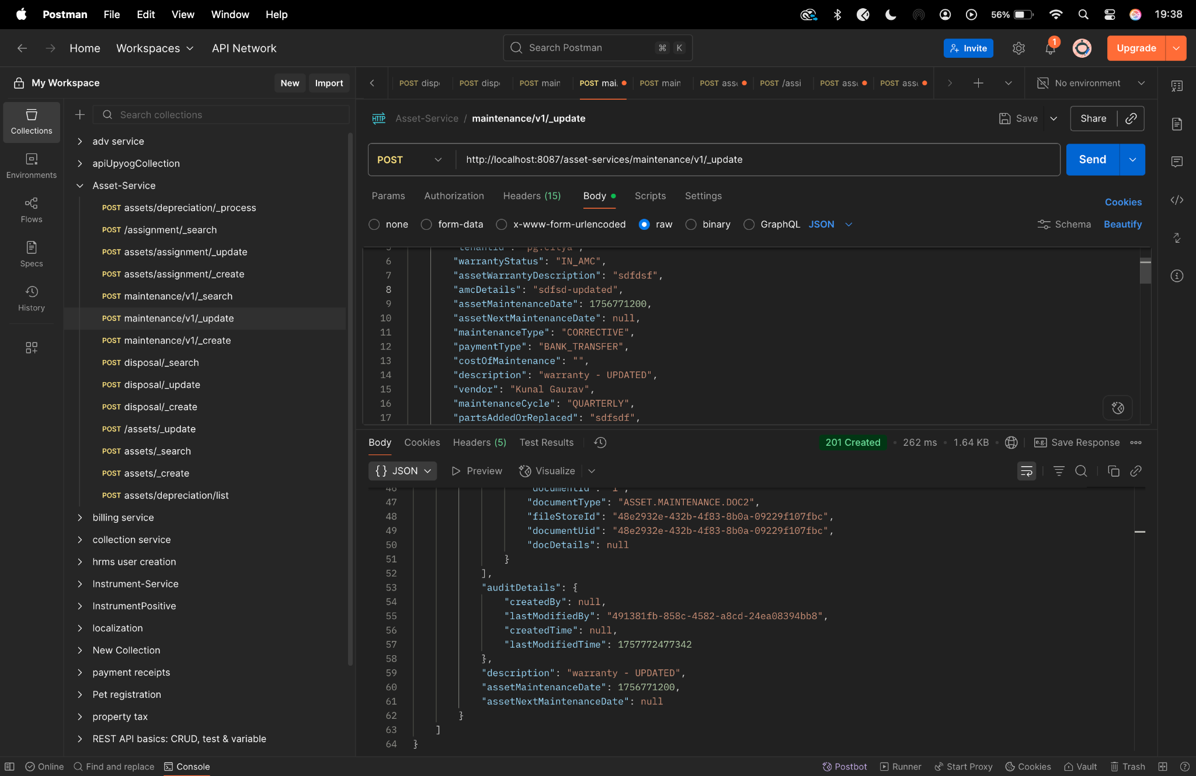

**Diff checker-**

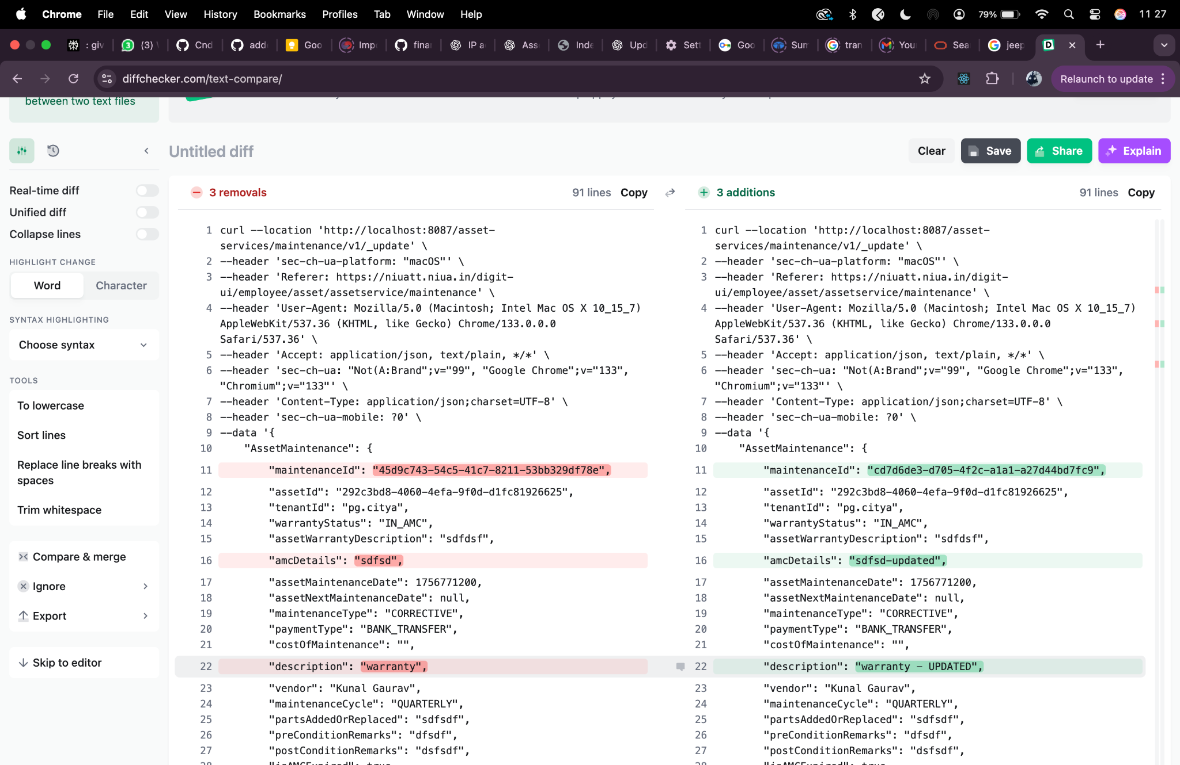

**maintenance/_search-**

curl --location 'http://localhost:8087/asset-services/maintenance/v1/_search' \

--header 'sec-ch-ua-platform: "macOS"' \

--header 'Referer: https://niuatt.niua.in/digit-ui/employee/asset/assetservice/maintenance' \

--header 'User-Agent: Mozilla/5.0 (Macintosh; Intel Mac OS X 10_15_7) AppleWebKit/537.36 (KHTML, like Gecko) Chrome/133.0.0.0 Safari/537.36' \

--header 'Accept: application/json, text/plain, */*' \

--header 'sec-ch-ua: "Not(A:Brand";v="99", "Google Chrome";v="133", "Chromium";v="133"' \

--header 'Content-Type: application/json;charset=UTF-8' \

--header 'sec-ch-ua-mobile: ?0' \

--data '{

"AssetMaintenanceSearchCriteria": {

"tenantId": "pg.citya",

"assetId": "292c3bd8-4060-4efa-9f0d-d1fc81926625",

"maintenanceId": "cd7d6de3-d705-4f2c-a1a1-a27d44bd7fc9",

"maintenanceType": "CORRECTIVE",

"offset": 0,

"limit": 10

},

"RequestInfo": {

"apiId": "Rainmaker",

"authToken": "54552937-0eb8-4cec-910a-182918416f7f",

"userInfo": {

"id": 909,

"uuid": "491381fb-858c-4582-a8cd-24ea08394bb8",

"userName": "ASSET_APPROVER",

"name": "Asset Approver",

"mobileNumber": "8448489439",

"emailId": null,

"locale": null,

"type": "EMPLOYEE",

"roles": [

{

"name": "Asset Approver",

"code": "ASSET_APPROVER",

"tenantId": "pg.citya"

},

{

"name": "Asset Allocator",

"code": "ASSET_ALLOCATOR",

"tenantId": "pg.citya"

}

],

"active": true,

"tenantId": "pg.citya",

"permanentCity": null

},

"msgId": "1757659710772|en_IN",

"plainAccessRequest": {}

}

}'

**Response-**

{

"ResponseInfo": {

"apiId": "",

"ver": "",

"ts": null,

"resMsgId": "uief87324",

"msgId": "",

"status": "successful"

},

"AssetMaintenance": [

{

"maintenanceId": "cd7d6de3-d705-4f2c-a1a1-a27d44bd7fc9",

"assetId": "292c3bd8-4060-4efa-9f0d-d1fc81926625",

"tenantId": null,

"currentLifeOfAsset": null,

"isWarrantyExpired": false,

"isAMCExpired": true,

"warrantyStatus": "IN_AMC",

"amcDetails": "sdfsd-updated",

"maintenanceType": "CORRECTIVE",

"paymentType": "BANK_TRANSFER",

"costOfMaintenance": 0.0,

"vendor": "Kunal Gaurav",

"maintenanceCycle": "QUARTERLY",

"partsAddedOrReplaced": "sdfsdf",

"additionalDetails": null,

"postConditionRemarks": "dsfsdf",

"preConditionRemarks": "dfsdf",

"assetMaintenanceStatus": null,

"documents": [

{

"documentId": "8a02c38b-fc6e-42d9-b9e3-54f6ad102714",

"documentType": "ASSET.MAINTENANCE.DOC2",

"fileStoreId": "48e2932e-432b-4f83-8b0a-09229f107fbc",

"documentUid": "7277e8eb-d740-4ed0-aad5-57e66b1b8dc3",

"docDetails": null

},

{

"documentId": "6c9de3cd-4294-4699-9260-1c2e1c9f6207",

"documentType": "ASSET.MAINTENANCE.DOC1",

"fileStoreId": "ba1ca218-ca65-438c-9a2e-519acf799f3e",

"documentUid": "351aab1f-61d1-41ae-ba52-fba2ab29e6b9",

"docDetails": null

},

{

"documentId": "d54474db-d5a1-4376-a759-3d6cc9252e61",

"documentType": "ASSET.MAINTENANCE.DOC3",

"fileStoreId": "16ce3c83-a416-4e60-b6ff-1eaa1a47c278",

"documentUid": "5de089ce-6114-4c19-b0e5-41790a65708a",

"docDetails": null

}

],

"auditDetails": {

"createdBy": "491381fb-858c-4582-a8cd-24ea08394bb8",

"lastModifiedBy": "491381fb-858c-4582-a8cd-24ea08394bb8",

"createdTime": 1757771228926,

"lastModifiedTime": 1757772477342

},

"description": "warranty - UPDATED",

"assetMaintenanceDate": 1756771200,

"assetNextMaintenanceDate": 0

},

{

"maintenanceId": "03646cec-498d-4757-a411-b458a7478845",

"assetId": "292c3bd8-4060-4efa-9f0d-d1fc81926625",

"tenantId": null,

"currentLifeOfAsset": null,

"isWarrantyExpired": false,

"isAMCExpired": true,

"warrantyStatus": "IN_AMC",

"amcDetails": "sdfsd",

"maintenanceType": "CORRECTIVE",

"paymentType": "BANK_TRANSFER",

"costOfMaintenance": 0.0,

"vendor": "dsfs",

"maintenanceCycle": "QUARTERLY",

"partsAddedOrReplaced": "sdfsdf",

"additionalDetails": null,

"postConditionRemarks": "dsfsdf",

"preConditionRemarks": "dfsdf",

"assetMaintenanceStatus": null,

"documents": [

{

"documentId": "772a45df-4a70-479b-96be-69290eef2183",

"documentType": "ASSET.MAINTENANCE.DOC1",

"fileStoreId": "ba1ca218-ca65-438c-9a2e-519acf799f3e",

"documentUid": "8a237d7e-7a5a-4f98-9cfd-8744d9fdb5a5",

"docDetails": null

},

{

"documentId": "68467009-aad1-425f-b377-0de95d762c29",

"documentType": "ASSET.MAINTENANCE.DOC2",

"fileStoreId": "48e2932e-432b-4f83-8b0a-09229f107fbc",

"documentUid": "cf91ad54-b1bf-4583-859a-3b233e61e53f",

"docDetails": null

},

{

"documentId": "44544ae4-9548-4a52-8f2e-3ee8cd1fe368",

"documentType": "ASSET.MAINTENANCE.DOC3",

"fileStoreId": "16ce3c83-a416-4e60-b6ff-1eaa1a47c278",

"documentUid": "84d2cce6-178d-4e86-a12b-b9b00cf1ba12",

"docDetails": null

}

],

"auditDetails": {

"createdBy": "491381fb-858c-4582-a8cd-24ea08394bb8",

"lastModifiedBy": "491381fb-858c-4582-a8cd-24ea08394bb8",

"createdTime": 1757661737186,

"lastModifiedTime": 1757661737186

},

"description": "warranty",

"assetMaintenanceDate": 1756771200,

"assetNextMaintenanceDate": 0

},

{

"maintenanceId": "f8c41d3d-b308-4c64-b801-a960ea8f9396",

"assetId": "292c3bd8-4060-4efa-9f0d-d1fc81926625",

"tenantId": null,

"currentLifeOfAsset": null,

"isWarrantyExpired": false,

"isAMCExpired": true,

"warrantyStatus": "IN_AMC",

"amcDetails": "sdfsd",

"maintenanceType": "CORRECTIVE",

"paymentType": "BANK_TRANSFER",

"costOfMaintenance": 0.0,

"vendor": "dsfs",

"maintenanceCycle": "QUARTERLY",

"partsAddedOrReplaced": "sdfsdf",

"additionalDetails": null,

"postConditionRemarks": "dsfsdf",

"preConditionRemarks": "dfsdf",

"assetMaintenanceStatus": null,

"documents": [

{

"documentId": null,

"documentType": null,

"fileStoreId": null,

"documentUid": null,

"docDetails": null

}

],

"auditDetails": {

"createdBy": "491381fb-858c-4582-a8cd-24ea08394bb8",

"lastModifiedBy": "491381fb-858c-4582-a8cd-24ea08394bb8",

"createdTime": 1757660688539,

"lastModifiedTime": 1757660688539

},

"description": "warranty",

"assetMaintenanceDate": 1756771200,

"assetNextMaintenanceDate": 0

},

{

"maintenanceId": "3a036056-e533-4794-bedb-7893d152bcec",

"assetId": "292c3bd8-4060-4efa-9f0d-d1fc81926625",

"tenantId": null,

"currentLifeOfAsset": null,

"isWarrantyExpired": false,

"isAMCExpired": true,

"warrantyStatus": "IN_AMC",

"amcDetails": "sdfsd",

"maintenanceType": "CORRECTIVE",

"paymentType": "BANK_TRANSFER",

"costOfMaintenance": 0.0,

"vendor": "dsfs",

"maintenanceCycle": "QUARTERLY",

"partsAddedOrReplaced": "sdfsdf",

"additionalDetails": null,

"postConditionRemarks": "dsfsdf",

"preConditionRemarks": "dfsdf",

"assetMaintenanceStatus": null,

"documents": [

{

"documentId": "e3f4b94c-28d0-44a2-964d-ac778b32f191",

"documentType": "ASSET.MAINTENANCE.DOC2",

"fileStoreId": "48e2932e-432b-4f83-8b0a-09229f107fbc",

"documentUid": "dca099f3-1be6-47bf-9cb7-1c0420223837",

"docDetails": null

},

{

"documentId": "fdff5c18-4a05-4387-a38a-936c0ee79c4a",

"documentType": "ASSET.MAINTENANCE.DOC3",

"fileStoreId": "16ce3c83-a416-4e60-b6ff-1eaa1a47c278",

"documentUid": "fa4edde5-15dd-48ec-abf7-fbbdf305e1ca",

"docDetails": null

},

{

"documentId": "821e3411-bb64-4842-b7d7-6a4089df5d75",

"documentType": "ASSET.MAINTENANCE.DOC1",

"fileStoreId": "ba1ca218-ca65-438c-9a2e-519acf799f3e",

"documentUid": "53185eaf-6fc1-4c1e-9471-3296c78044bd",

"docDetails": null

}

],

"auditDetails": {

"createdBy": "491381fb-858c-4582-a8cd-24ea08394bb8",

"lastModifiedBy": "491381fb-858c-4582-a8cd-24ea08394bb8",

"createdTime": 1757660534192,

"lastModifiedTime": 1757660534192

},

"description": "warranty",

"assetMaintenanceDate": 1756771200,

"assetNextMaintenanceDate": 0

},

{

"maintenanceId": "45d9c743-54c5-41c7-8211-53bb329df78e",

"assetId": "292c3bd8-4060-4efa-9f0d-d1fc81926625",

"tenantId": null,

"currentLifeOfAsset": null,

"isWarrantyExpired": false,

"isAMCExpired": true,

"warrantyStatus": "IN_AMC",

"amcDetails": "sdfsd",

"maintenanceType": "CORRECTIVE",

"paymentType": "BANK_TRANSFER",

"costOfMaintenance": 0.0,

"vendor": "Kunal Gaurav",

"maintenanceCycle": "QUARTERLY",

"partsAddedOrReplaced": "sdfsdf",

"additionalDetails": null,

"postConditionRemarks": "dsfsdf",

"preConditionRemarks": "dfsdf",

"assetMaintenanceStatus": null,

"documents": [

{

"documentId": "b3659e8b-fe32-4353-96c8-5fcb03dbe95c",

"documentType": "ASSET.MAINTENANCE.DOC1",

"fileStoreId": "ba1ca218-ca65-438c-9a2e-519acf799f3e",

"documentUid": "4edea342-d4a9-49ce-b570-50ac303252d7",

"docDetails": null

},

{

"documentId": "1",

"documentType": "ASSET.MAINTENANCE.DOC2",

"fileStoreId": "48e2932e-432b-4f83-8b0a-09229f107fbc",

"documentUid": "48e2932e-432b-4f83-8b0a-09229f107fbc",

"docDetails": null

},

{

"documentId": "21020b2b-d921-4744-95f6-e0add0a8e67f",

"documentType": "ASSET.MAINTENANCE.DOC2",

"fileStoreId": "48e2932e-432b-4f83-8b0a-09229f107fbc",

"documentUid": "bc1f1b0a-e187-4884-9f1b-79d0e3ad39b7",

"docDetails": null

},

{

"documentId": "c996c42e-184d-4e12-8ce5-22c08f0ff8e4",

"documentType": "ASSET.MAINTENANCE.DOC3",

"fileStoreId": "16ce3c83-a416-4e60-b6ff-1eaa1a47c278",

"documentUid": "b9791a91-b5c7-4d5c-9592-f5055121afc0",

"docDetails": null

}

],

"auditDetails": {

"createdBy": "491381fb-858c-4582-a8cd-24ea08394bb8",

"lastModifiedBy": "491381fb-858c-4582-a8cd-24ea08394bb8",

"createdTime": 1757660055007,

"lastModifiedTime": 1757666300505

},

"description": "warranty",

"assetMaintenanceDate": 1756771200,

"assetNextMaintenanceDate": 0

},

{

"maintenanceId": "1c30ac12-6f52-446a-89ab-227c4a8d2744",

"assetId": "292c3bd8-4060-4efa-9f0d-d1fc81926625",

"tenantId": null,

"currentLifeOfAsset": null,

"isWarrantyExpired": false,

"isAMCExpired": true,

"warrantyStatus": "IN_AMC",

"amcDetails": "sdfsd",

"maintenanceType": "CORRECTIVE",

"paymentType": "BANK_TRANSFER",

"costOfMaintenance": 0.0,

"vendor": "dsfs",

"maintenanceCycle": "QUARTERLY",

"partsAddedOrReplaced": "sdfsdf",

"additionalDetails": null,

"postConditionRemarks": "dsfsdf",

"preConditionRemarks": "dfsdf",

"assetMaintenanceStatus": null,

"documents": [

{

"documentId": "32790ea6-fcfa-405d-a6e7-ed5007d1b047",

"documentType": "ASSET.MAINTENANCE.DOC1",

"fileStoreId": "ba1ca218-ca65-438c-9a2e-519acf799f3e",

"documentUid": "1d9a6c45-77fe-428b-96ce-e20e85359db6",

"docDetails": null

},

{

"documentId": "911e086a-224b-4ead-abe0-17e03dac30d5",

"documentType": "ASSET.MAINTENANCE.DOC2",

"fileStoreId": "48e2932e-432b-4f83-8b0a-09229f107fbc",

"documentUid": "a7a2aa11-3d0d-4222-be92-ca550531c3eb",

"docDetails": null

},

{

"documentId": "868adea6-9071-4a9c-b944-776d3a1bc64b",

"documentType": "ASSET.MAINTENANCE.DOC3",

"fileStoreId": "16ce3c83-a416-4e60-b6ff-1eaa1a47c278",

"documentUid": "bd448679-fc5e-4cd8-a135-eb9484b66a4c",

"docDetails": null

}

],

"auditDetails": {

"createdBy": "491381fb-858c-4582-a8cd-24ea08394bb8",

"lastModifiedBy": "491381fb-858c-4582-a8cd-24ea08394bb8",

"createdTime": 1757659711964,

"lastModifiedTime": 1757659711964

},

"description": "sdfsdf",

"assetMaintenanceDate": 1756771200,

"assetNextMaintenanceDate": 0

},

{

"maintenanceId": "c18721c6-bfa4-4e8e-bf8f-0dc35d1fb52a",

"assetId": "f9c7697d-16e9-480e-98ea-778f75281efc",

"tenantId": null,

"currentLifeOfAsset": null,

"isWarrantyExpired": true,

"isAMCExpired": false,

"warrantyStatus": "IN_WARRANTY",

"amcDetails": "",

"maintenanceType": "PREVENTIVE",

"paymentType": "BANK_TRANSFER",

"costOfMaintenance": 0.0,

"vendor": "Pradeep",

"maintenanceCycle": "MONTHLY",

"partsAddedOrReplaced": "Parts to be added",

"additionalDetails": null,

"postConditionRemarks": "Post Condition Description",

"preConditionRemarks": "Pre Condition Description",

"assetMaintenanceStatus": null,

"documents": [

{

"documentId": "d872343a-e3a3-4a9f-9c11-3120c82c9685",

"documentType": "ASSET.MAINTENANCE.DOC1",

"fileStoreId": "0d5ef23f-aaef-462d-85c7-8dac467ad182",

"documentUid": "6205c868-d834-4059-b401-6878532b8ae9",

"docDetails": null

},

{

"documentId": "d38bc4ed-a504-4f9b-a052-030018a81634",

"documentType": "ASSET.MAINTENANCE.DOC2",

"fileStoreId": "1e5cc808-b548-448f-849a-af66f052af7f",

"documentUid": "0c66a9e4-9127-49d5-8d85-d803b3285ec7",

"docDetails": null

},

{

"documentId": "cab920cb-ff54-42c5-a8c4-3ec474f2d6d0",

"documentType": "ASSET.MAINTENANCE.DOC3",

"fileStoreId": "fdf9743e-4f67-4243-809f-c108e7d289a3",

"documentUid": "cb1ecbac-434a-4d7d-a8cc-4de3ec42df28",

"docDetails": null

}

],

"auditDetails": {

"createdBy": "491381fb-858c-4582-a8cd-24ea08394bb8",

"lastModifiedBy": "491381fb-858c-4582-a8cd-24ea08394bb8",

"createdTime": 1756118965461,

"lastModifiedTime": 1756118965461

},

"description": "Maintenance Description",

"assetMaintenanceDate": 1641340800,

"assetNextMaintenanceDate": 1644019200

},

{

"maintenanceId": "c7bf6092-ce1c-4c0a-9a16-6069795539f5",

"assetId": "7c9fdf54-0569-4f0d-ab84-2443848bf3cc",

"tenantId": null,

"currentLifeOfAsset": null,

"isWarrantyExpired": false,

"isAMCExpired": true,

"warrantyStatus": "IN_AMC",

"amcDetails": "DSFSDF",

"maintenanceType": "PREVENTIVE",

"paymentType": "BANK_TRANSFER",

"costOfMaintenance": 0.0,

"vendor": "SDFD",

"maintenanceCycle": "QUARTERLY",

"partsAddedOrReplaced": "SDF",

"additionalDetails": null,

"postConditionRemarks": "SDFDS",

"preConditionRemarks": "DFSDFSF",

"assetMaintenanceStatus": null,

"documents": [

{

"documentId": "70c9d37a-d3de-49c2-bd0e-daadcd1562c6",

"documentType": "ASSET.MAINTENANCE.DOC1",

"fileStoreId": "5b13e544-bc40-43a4-9a54-6e112d9359ce",

"documentUid": "fe468ecf-bcd6-4068-a08d-8b1c8275d76b",

"docDetails": null

},

{

"documentId": "704ee6ab-5c15-44f5-a1d3-999803ab23c5",

"documentType": "ASSET.MAINTENANCE.DOC2",

"fileStoreId": "a0a48e97-8435-478f-8d5e-7858ecc20978",

"documentUid": "ae895faf-0733-4143-8634-756e0dcd3c70",

"docDetails": null

},

{

"documentId": "d15e8d04-92f6-4aad-a45d-1288e0392051",

"documentType": "ASSET.MAINTENANCE.DOC3",

"fileStoreId": "772fb1c3-c148-4c70-b739-f64bba970a40",

"documentUid": "9032eff2-4464-4f79-94f1-34ad6bc07f5a",

"docDetails": null

}

],

"auditDetails": {

"createdBy": "491381fb-858c-4582-a8cd-24ea08394bb8",

"lastModifiedBy": "491381fb-858c-4582-a8cd-24ea08394bb8",

"createdTime": 1756118401276,

"lastModifiedTime": 1756118401276

},

"description": "SDFS",

"assetMaintenanceDate": 1754870400,

"assetNextMaintenanceDate": 1762819200

},

{

"maintenanceId": "d5c79ac9-bbb8-4124-ac60-9418d361e32a",

"assetId": "e664a95e-1cde-4b79-acbb-449142522e56",

"tenantId": null,

"currentLifeOfAsset": null,

"isWarrantyExpired": false,

"isAMCExpired": false,

"warrantyStatus": "NA",

"amcDetails": "",

"maintenanceType": "PREVENTIVE",

"paymentType": "BANK_TRANSFER",

"costOfMaintenance": 0.0,

"vendor": "Mac IOS",

"maintenanceCycle": "HALF_YEARLY",

"partsAddedOrReplaced": "Lorem ipsum",

"additionalDetails": null,

"postConditionRemarks": "dfsdf",

"preConditionRemarks": "pre Condition",

"assetMaintenanceStatus": null,

"documents": [

{

"documentId": "54b93aa1-7576-4659-9011-b26f73ed0a3c",

"documentType": "ASSET.MAINTENANCE.DOC2",

"fileStoreId": "9ed9b20c-4f8b-4615-a33b-943bff94f7f7",

"documentUid": "3d4b4b58-0f4e-48be-82ae-fd8c89b891e1",

"docDetails": null

},

{

"documentId": "70da1c9d-8228-4279-908e-e76215cc106b",

"documentType": "ASSET.MAINTENANCE.DOC1",

"fileStoreId": "0c9b9b61-b59a-4405-a4f7-089a8d00a1b8",

"documentUid": "f701cee4-b79a-4942-b429-50ea9cd7049d",

"docDetails": null

},

{

"documentId": "188db84f-a7b0-4eb6-bdba-eb9c3134ab25",

"documentType": "ASSET.MAINTENANCE.DOC3",

"fileStoreId": "e4019867-8abe-4d0a-b01c-f0b6c1927dea",

"documentUid": "759baed6-3e35-4f53-97ec-852f17650c05",

"docDetails": null

}

],

"auditDetails": {

"createdBy": "491381fb-858c-4582-a8cd-24ea08394bb8",

"lastModifiedBy": "491381fb-858c-4582-a8cd-24ea08394bb8",

"createdTime": 1755424538582,

"lastModifiedTime": 1755424538582

},

"description": "Maintenance Description",

"assetMaintenanceDate": 1609718400,

"assetNextMaintenanceDate": 1625356800

},

{

"maintenanceId": "ef29d243-7c95-46c0-a774-94ef60f26626",

"assetId": "e664a95e-1cde-4b79-acbb-449142522e56",

"tenantId": null,

"currentLifeOfAsset": null,

"isWarrantyExpired": false,

"isAMCExpired": false,

"warrantyStatus": null,

"amcDetails": "",

"maintenanceType": "CORRECTIVE",

"paymentType": "BANK_TRANSFER",

"costOfMaintenance": 0.0,

"vendor": "ewrewr",

"maintenanceCycle": "MONTHLY",

"partsAddedOrReplaced": "ewr",

"additionalDetails": null,

"postConditionRemarks": "ewrewr",

"preConditionRemarks": "ewrwer",

"assetMaintenanceStatus": null,

"documents": [

{

"documentId": "ef0fdbc8-f91f-4bad-8e89-ff7e0c2cdd65",

"documentType": "ASSET.MAINTENANCE.DOC3",

"fileStoreId": "6d217938-afcc-47d3-a614-362437546e7f",

"documentUid": "64f615a6-1f7a-4427-a8f2-f98658531aef",

"docDetails": null

},

{

"documentId": "667284c5-c7bc-4d48-a69c-f8d502e75b5a",

"documentType": "ASSET.MAINTENANCE.DOC2",

"fileStoreId": "1c331d31-502a-4a50-9b20-55efc5cb6053",

"documentUid": "4a4a0391-3ba9-47ab-9687-74b7effc82da",

"docDetails": null

},

{

"documentId": "18321c86-c45b-4175-93cd-55d54834bf4b",

"documentType": "ASSET.MAINTENANCE.DOC1",

"fileStoreId": "a7e3381c-2955-4095-83da-bc3d9b1c9894",

"documentUid": "f2845a01-8aba-4959-b939-a9103fe9b017",

"docDetails": null

}

],

"auditDetails": {

"createdBy": "491381fb-858c-4582-a8cd-24ea08394bb8",

"lastModifiedBy": "491381fb-858c-4582-a8cd-24ea08394bb8",

"createdTime": 1755424409146,

"lastModifiedTime": 1755424409146

},

"description": "ewrwe4r",

"assetMaintenanceDate": 1609977600,

"assetNextMaintenanceDate": 1612656000

}

]

}

**Postman-**

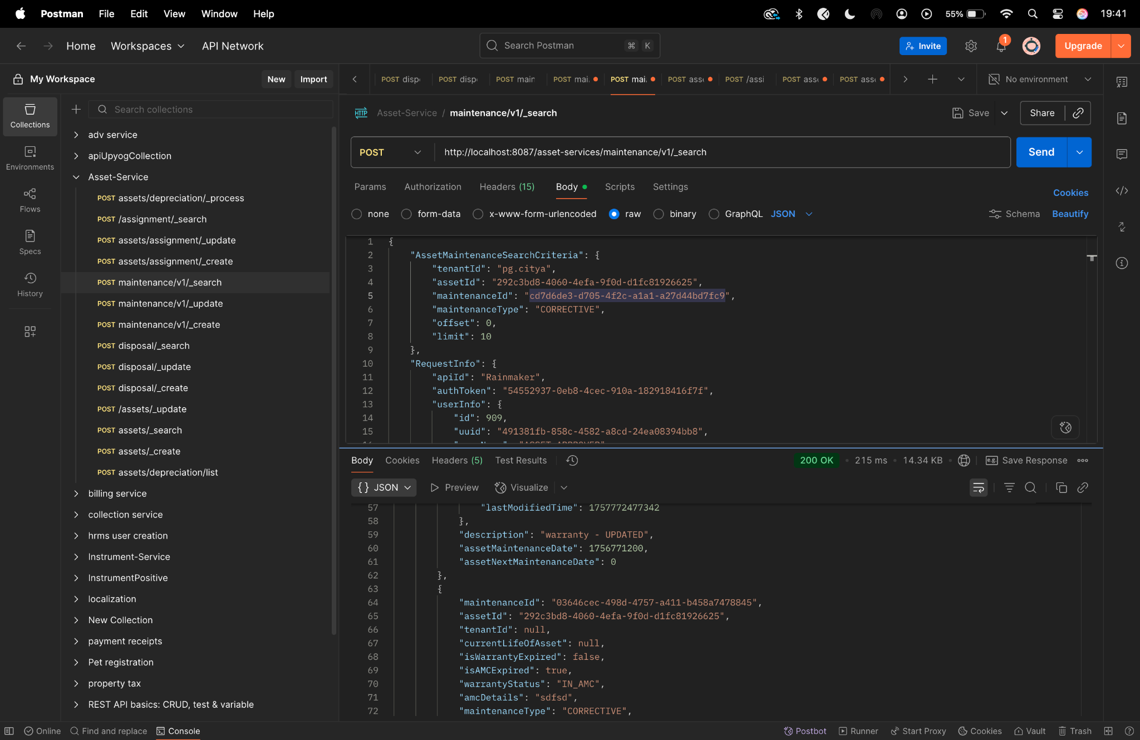

**Diff checker-**

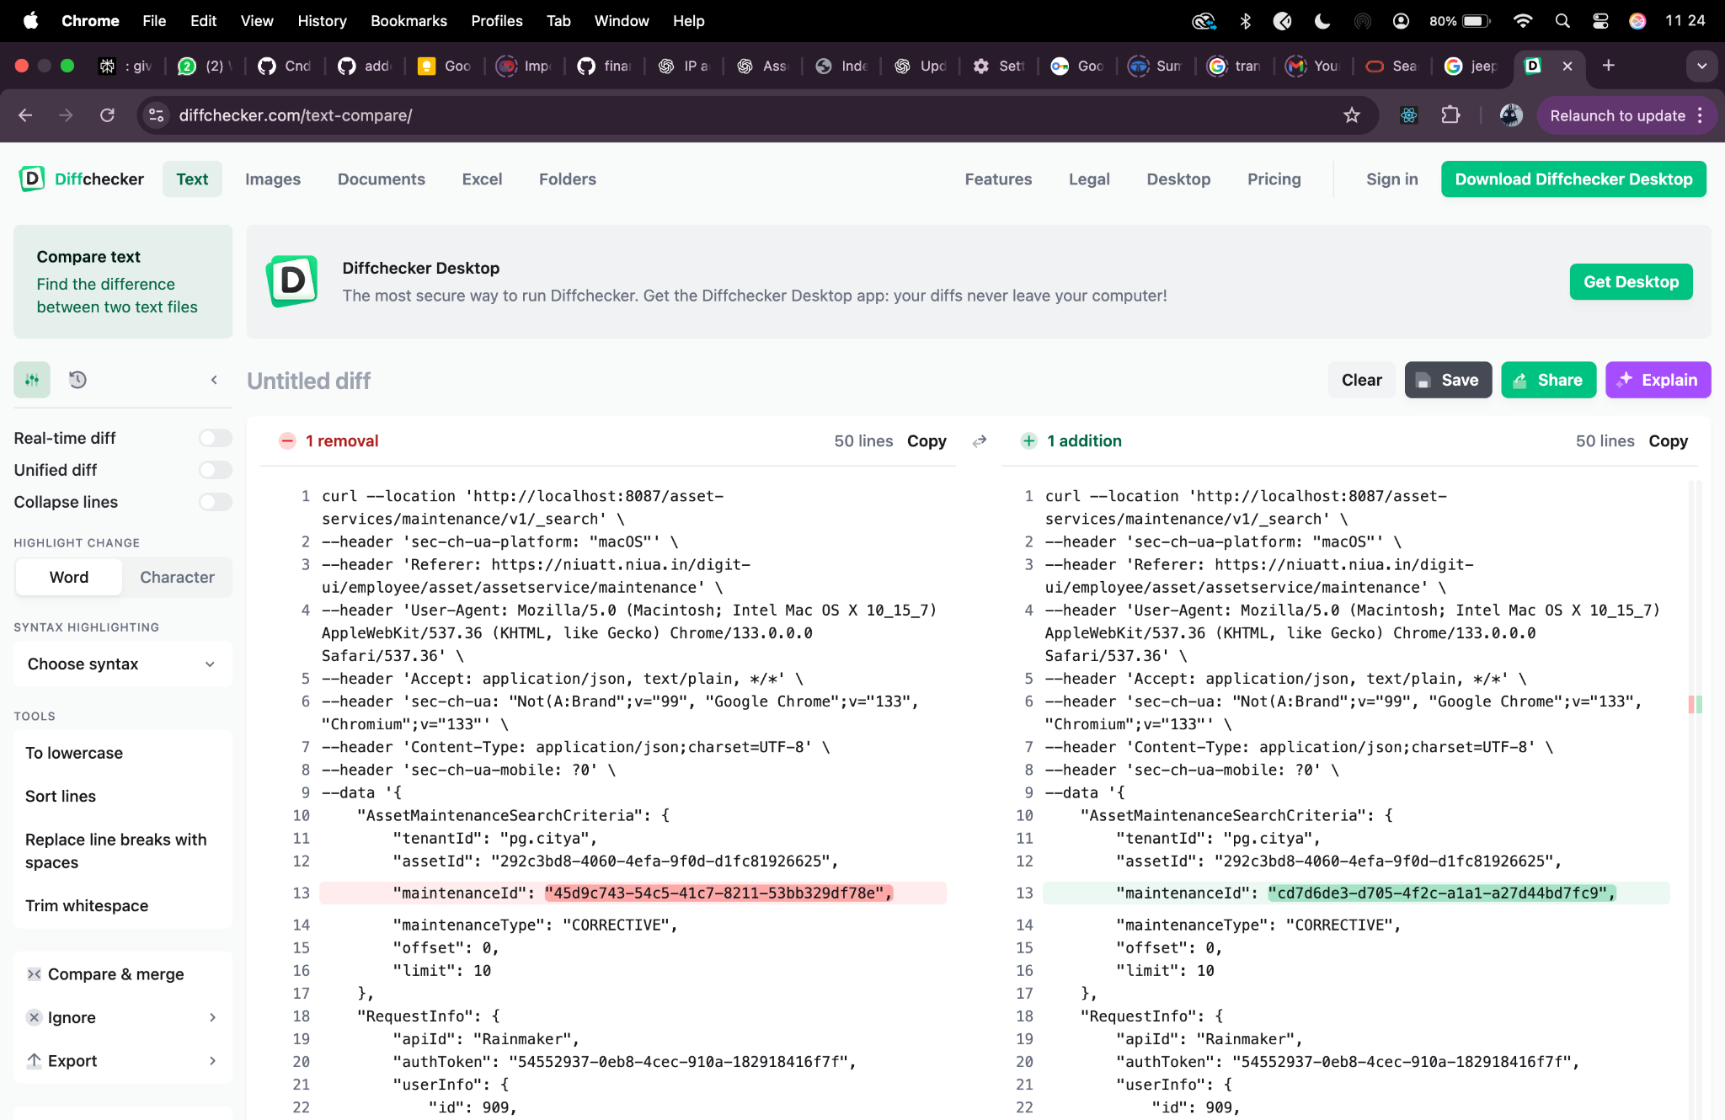

**desposl/_create-**

curl --location 'http://localhost:8087/asset-services/v1/disposal/_create' \

--header 'accept: application/json, text/plain, */*' \

--header 'accept-language: en-GB,en-US;q=0.9,en;q=0.8,hi;q=0.7' \

--header 'content-type: application/json;charset=UTF-8' \

--header 'origin: https://niuatt.niua.in' \

--header 'priority: u=1, i' \

--header 'referer: https://niuatt.niua.in/upyog-ui/employee/asset/assetservice/dispose-assets/PG-1013-2025-I-001236' \

--header 'sec-ch-ua: "Not;A=Brand";v="99", "Google Chrome";v="139", "Chromium";v="139"' \

--header 'sec-ch-ua-mobile: ?0' \

--header 'sec-ch-ua-platform: "macOS"' \

--header 'sec-fetch-dest: empty' \

--header 'sec-fetch-mode: cors' \

--header 'sec-fetch-site: same-origin' \

--header 'user-agent: Mozilla/5.0 (Macintosh; Intel Mac OS X 10_15_7) AppleWebKit/537.36 (KHTML, like Gecko) Chrome/139.0.0.0 Safari/537.36' \

--header 'Cookie: locale=en_IN; _ga=GA1.1.559242739.1756447705; _clck=19weqns%5E2%5Efyv%5E0%5E2067; _ga_VZ9TNBTB3X=GS2.1.s1756447704$o1$g1$t1756447780$j59$l0$h0; _ga_E39TFV5YXM=GS2.1.s1756447709$o1$g1$t1756448684$j60$l0$h0' \

--data '{

"AssetDisposal": {

"disposalId": "",

"assetId": "292c3bd8-4060-4efa-9f0d-d1fc81926625",

"tenantId": "pg.citya",

"lifeOfAsset": "5",

"isAssetDisposedInFacility": true,

"currentAgeOfAsset": 2,

"disposalDate": 1756924200000,

"reasonForDisposal": "Others",

"amountReceived": 500,

"purchaserName": "",

"paymentMode": "",

"comments": "for assest",

"glCode": "111111",

"assetDisposalStatus": "DISPOSED",

"additionalDetails": {

"approvalNumber": "APPROVAL-2020",

"disposedBy": "Kunal Gaurav"

},

"auditDetail": {

"createdBy": "admin",

"createdTime": 1672531200000,

"lastModifiedBy": "admin",

"lastModifiedTime": 1672534800000

},

"documents": [

{

"documentType": "OWNER.RECIEPTPHOTO",

"fileStoreId": "ba740edc-006d-4a34-98d7-96dd2947c795",

"documentUid": "ba740edc-006d-4a34-98d7-96dd2947c795",

"latitude": null,

"longitude": null

}

]

},

"RequestInfo": {

"apiId": "Rainmaker",

"authToken": "54552937-0eb8-4cec-910a-182918416f7f",

"userInfo": {

"id": 909,

"uuid": "491381fb-858c-4582-a8cd-24ea08394bb8",

"userName": "ASSET_APPROVER",

"name": "Asset Approver",

"mobileNumber": "8448489439",

"emailId": null,

"locale": null,

"type": "EMPLOYEE",

"roles": [

{

"name": "Asset Approver",

"code": "ASSET_APPROVER",

"tenantId": "pg.citya"

},

{

"name": "Asset Allocator",

"code": "ASSET_ALLOCATOR",

"tenantId": "pg.citya"

}

],

"active": true,

"tenantId": "pg.citya",

"permanentCity": null

},

"msgId": "1757656020981|en_IN",

"plainAccessRequest": {}

}

}'

**Response -**

{

"ResponseInfo": {

"apiId": "Rainmaker",

"ver": null,

"ts": null,

"resMsgId": "uief87324",

"msgId": "1757656020981|en_IN",

"status": "successful"

},

"AssetDisposals": [

{

"disposalId": "2e093a11-4ba2-4e7c-90ba-fa0331ded0eb",

"assetId": "292c3bd8-4060-4efa-9f0d-d1fc81926625",

"tenantId": "pg.citya",

"lifeOfAsset": 5,

"currentAgeOfAsset": 2,

"isAssetDisposedInFacility": true,

"disposalDate": 1756924200000,

"reasonForDisposal": "Others",

"amountReceived": 500.0,

"purchaserName": "",

"paymentMode": "",

"receiptNumber": null,

"comments": "for assest",

"glCode": "111111",

"assetDisposalStatus": "DISPOSED",

"additionalDetails": {

"approvalNumber": "APPROVAL-2020",

"disposedBy": "Kunal Gaurav"

},

"documents": [

{

"documentId": "ea772419-7e00-436a-b757-4d38c2098f5d",

"documentType": "OWNER.RECIEPTPHOTO",

"fileStoreId": "ba740edc-006d-4a34-98d7-96dd2947c795",

"documentUid": "f9b78727-b042-4782-b528-a62afcecfb64",

"docDetails": null

}

],

"auditDetails": {

"createdBy": "491381fb-858c-4582-a8cd-24ea08394bb8",

"lastModifiedBy": "491381fb-858c-4582-a8cd-24ea08394bb8",

"createdTime": 1757909565458,

"lastModifiedTime": 1757909565458

}

}

]

}

**Postman-**

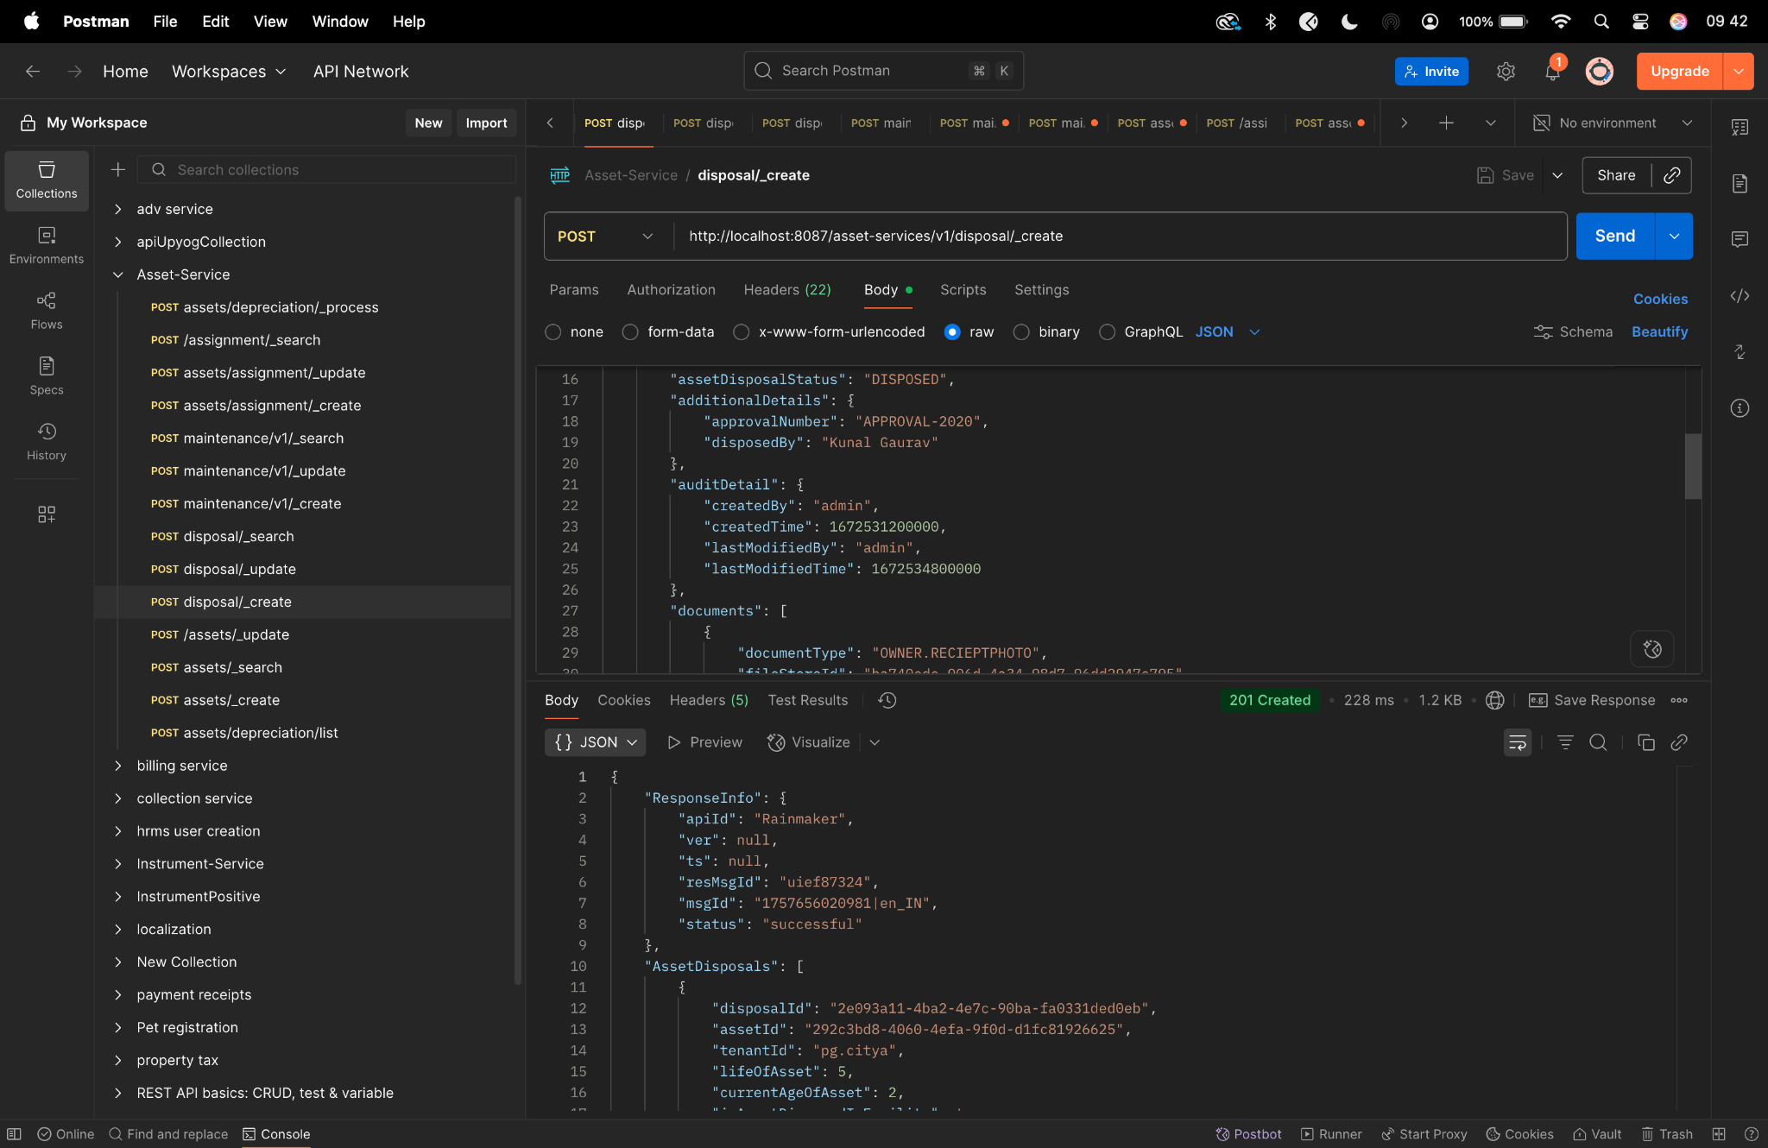

**Diff checker-**

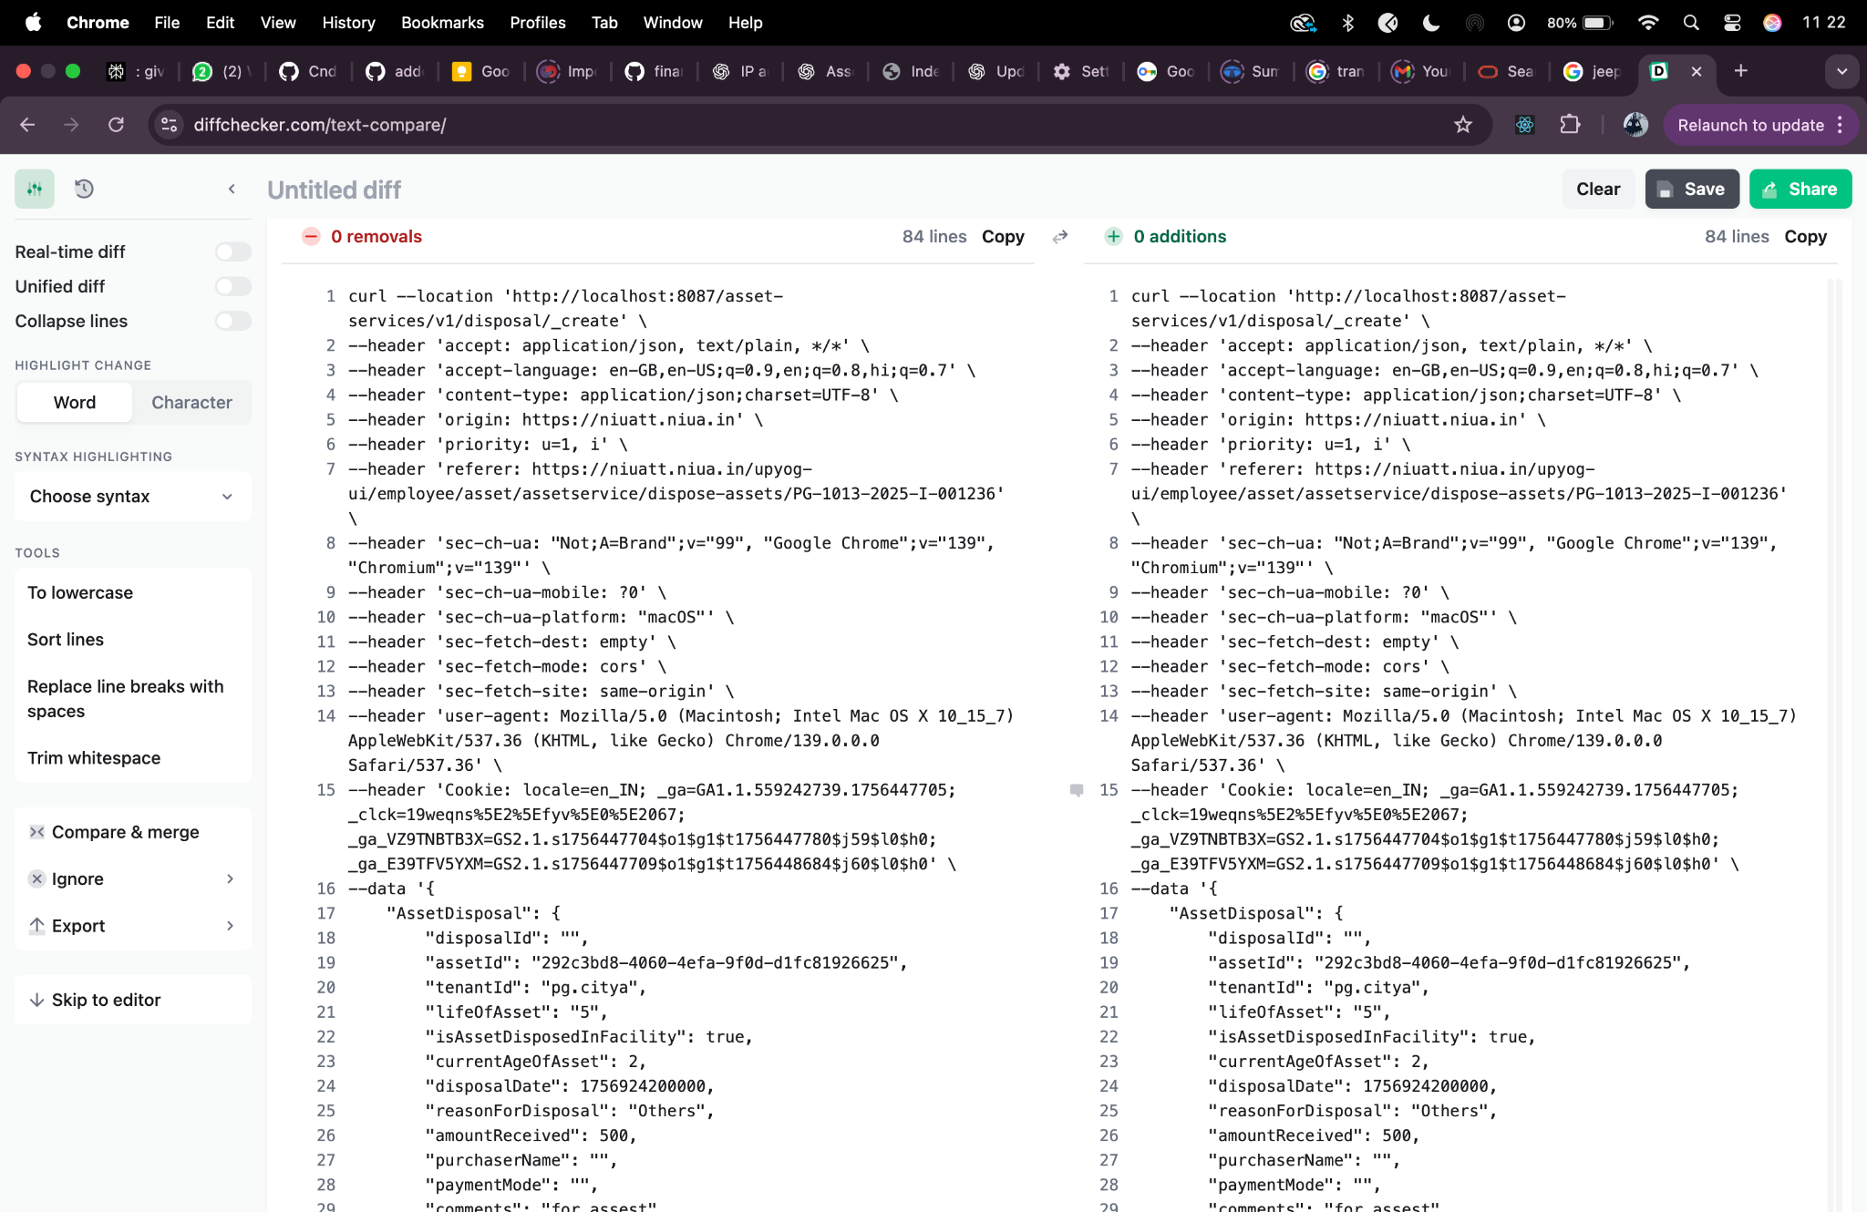

**disposal/_search-**

curl --location 'http://localhost:8087/asset-services/v1/disposal/_search' \

--header 'accept: application/json, text/plain, */*' \

--header 'accept-language: en-GB,en-US;q=0.9,en;q=0.8,hi;q=0.7' \

--header 'content-type: application/json;charset=UTF-8' \

--header 'origin: https://niuatt.niua.in' \

--header 'priority: u=1, i' \

--header 'referer: https://niuatt.niua.in/upyog-ui/employee/asset/assetservice/dispose-assets/' \

--header 'sec-ch-ua: "Not;A=Brand";v="99", "Google Chrome";v="139", "Chromium";v="139"' \

--header 'sec-ch-ua-mobile: ?0' \

--header 'sec-ch-ua-platform: "macOS"' \

--header 'sec-fetch-dest: empty' \

--header 'sec-fetch-mode: cors' \

--header 'sec-fetch-site: same-origin' \

--header 'user-agent: Mozilla/5.0 (Macintosh; Intel Mac OS X 10_15_7) AppleWebKit/537.36 (KHTML, like Gecko) Chrome/139.0.0.0 Safari/537.36' \

--header 'Cookie: locale=en_IN; _ga=GA1.1.559242739.1756447705; _clck=19weqns%5E2%5Efyv%5E0%5E2067; _ga_VZ9TNBTB3X=GS2.1.s1756447704$o1$g1$t1756447780$j59$l0$h0; _ga_E39TFV5YXM=GS2.1.s1756447709$o1$g1$t1756448684$j60$l0$h0' \

--data '{

"searchCriteria": {

"tenantId": "pg.citya",

"assetId": "292c3bd8-4060-4efa-9f0d-d1fc81926625",

"assetDisposalStatus": "DISPOSED",

"offset": 0,

"limit": 10

},

"RequestInfo": {

"apiId": "Rainmaker",

"authToken": "54552937-0eb8-4cec-910a-182918416f7f",

"userInfo": {

"id": 909,

"uuid": "491381fb-858c-4582-a8cd-24ea08394bb8",

"userName": "ASSET_APPROVER",

"name": "Asset Approver",

"mobileNumber": "8448489439",

"emailId": null,

"locale": null,

"type": "EMPLOYEE",

"roles": [

{

"name": "Asset Approver",

"code": "ASSET_APPROVER",

"tenantId": "pg.citya"

},

{

"name": "Asset Allocator",

"code": "ASSET_ALLOCATOR",

"tenantId": "pg.citya"

}

],

"active": true,

"tenantId": "pg.citya",

"permanentCity": null

},

"msgId": "1757656020981|en_IN",

"plainAccessRequest": {}

}

}'

**Response -**

{

"ResponseInfo": {

"apiId": "",

"ver": "",

"ts": null,

"resMsgId": "uief87324",

"msgId": "",

"status": "successful"

},

"AssetDisposals": [

{

"disposalId": "2e093a11-4ba2-4e7c-90ba-fa0331ded0eb",

"assetId": "292c3bd8-4060-4efa-9f0d-d1fc81926625",

"tenantId": "pg.citya",

"lifeOfAsset": 5,

"currentAgeOfAsset": 2,

"isAssetDisposedInFacility": true,

"disposalDate": 1756924200000,

"reasonForDisposal": "Others",

"amountReceived": 500.0,

"purchaserName": "",

"paymentMode": "",

"receiptNumber": null,

"comments": "for assest",

"glCode": "111111",

"assetDisposalStatus": "DISPOSED",

"additionalDetails": {

"disposedBy": "Kunal Gaurav",

"approvalNumber": "APPROVAL-2020"

},

"documents": [

{

"documentId": "ea772419-7e00-436a-b757-4d38c2098f5d",

"documentType": "OWNER.RECIEPTPHOTO",

"fileStoreId": "ba740edc-006d-4a34-98d7-96dd2947c795",

"documentUid": "f9b78727-b042-4782-b528-a62afcecfb64",

"docDetails": null

}

],

"auditDetails": {

"createdBy": "491381fb-858c-4582-a8cd-24ea08394bb8",

"lastModifiedBy": "491381fb-858c-4582-a8cd-24ea08394bb8",

"createdTime": 1757909565458,

"lastModifiedTime": 1757909565458

}

},

{

"disposalId": "c0896a34-a2df-4723-b3c2-6f676174c2ce",

"assetId": "1163afaf-b0a1-4929-b5f1-aaaa20e2070d",

"tenantId": "pg.citya",

"lifeOfAsset": 5,

"currentAgeOfAsset": 2,

"isAssetDisposedInFacility": true,

"disposalDate": 1756924200000,

"reasonForDisposal": "Others",

"amountReceived": 500.0,

"purchaserName": "",

"paymentMode": "",

"receiptNumber": null,

"comments": "for assest",

"glCode": "111111",

"assetDisposalStatus": "DISPOSED",

"additionalDetails": {

"disposedBy": "Kunal Gaurav",

"approvalNumber": "APPROVAL-2020"

},

"documents": [

{

"documentId": "b2aee7e4-0223-433f-9f72-b5da9ffb9b7f",

"documentType": "OWNER.RECIEPTPHOTO",

"fileStoreId": "ba740edc-006d-4a34-98d7-96dd2947c795",

"documentUid": "e74db517-601e-4cba-919a-a23049977972",

"docDetails": null

}

],

"auditDetails": {

"createdBy": "491381fb-858c-4582-a8cd-24ea08394bb8",

"lastModifiedBy": "491381fb-858c-4582-a8cd-24ea08394bb8",

"createdTime": 1757657906528,

"lastModifiedTime": 1757657906528

}

},

{

"disposalId": "a29c1018-f2b2-4cf5-9714-671b581aaf07",

"assetId": "f9c7697d-16e9-480e-98ea-778f75281efc",

"tenantId": "pg.citya",

"lifeOfAsset": 6,

"currentAgeOfAsset": 1695,

"isAssetDisposedInFacility": true,

"disposalDate": 1754332200000,

"reasonForDisposal": "DISPOSED_AND_SOLD",

"amountReceived": 20001.0,

"purchaserName": "Dinesh ",

"paymentMode": "Offline",

"receiptNumber": "yes",

"comments": "dhjhdsalfjsd",

"glCode": "111111",

"assetDisposalStatus": "DISPOSED",

"additionalDetails": {

"disposedBy": "Jane Smith",

"approvalNumber": "APPROVAL202501"

},

"documents": [

{

"documentId": "c2df6db1-1835-44fc-b981-0d3c656958f4",

"documentType": "ASSET.DISPOSE.DOC1",

"fileStoreId": null,

"documentUid": "6d388690-2a15-4924-b8c3-87f9ae4ea2d7",

"docDetails": null

}

],

"auditDetails": {

"createdBy": "491381fb-858c-4582-a8cd-24ea08394bb8",

"lastModifiedBy": "491381fb-858c-4582-a8cd-24ea08394bb8",

"createdTime": 1756119041208,

"lastModifiedTime": 1756119041208

}

},

{

"disposalId": "bd60611d-0e83-4d69-a6f4-726de10c7ae2",

"assetId": "7c9fdf54-0569-4f0d-ab84-2443848bf3cc",

"tenantId": "pg.citya",

"lifeOfAsset": 4,

"currentAgeOfAsset": 1697,

"isAssetDisposedInFacility": true,

"disposalDate": 1612204200000,

"reasonForDisposal": "DISPOSED",

"amountReceived": 2340.0,

"purchaserName": "PARVESH",

"paymentMode": "ONLINE",

"receiptNumber": "YES RECIPT",

"comments": "DFGHJKL",

"glCode": "111111",

"assetDisposalStatus": "DISPOSED",

"additionalDetails": {

"disposedBy": "Jane Smith",

"approvalNumber": "APPROVAL202501"

},

"documents": [

{

"documentId": "93c36bf2-43f8-407e-acac-190312cbe981",

"documentType": "ASSET.DISPOSE.DOC1",

"fileStoreId": "7e700a97-6c89-4d44-8122-16171e5ada04",

"documentUid": "fb7423db-cd32-4a13-a214-5b47c4a4c884",

"docDetails": null

}

],

"auditDetails": {

"createdBy": "491381fb-858c-4582-a8cd-24ea08394bb8",

"lastModifiedBy": "491381fb-858c-4582-a8cd-24ea08394bb8",

"createdTime": 1756118697660,

"lastModifiedTime": 1756118697660

}

},

{

"disposalId": "41a076dc-13b2-4897-a1af-d6393db0de7c",

"assetId": "9086cc20-67b8-4248-af35-8064694262d6",

"tenantId": "pg.citya",

"lifeOfAsset": 1,

"currentAgeOfAsset": 16,

"isAssetDisposedInFacility": true,

"disposalDate": 1754332200000,

"reasonForDisposal": "DISPOSED_AND_SOLD",

"amountReceived": 2345.0,

"purchaserName": "gfjhgkh",

"paymentMode": "hgj",

"receiptNumber": "g",

"comments": "ygtgk",

"glCode": "111111",

"assetDisposalStatus": "DISPOSED",

"additionalDetails": {

"disposedBy": "Jane Smith",

"approvalNumber": "APPROVAL202501"

},

"documents": [

{

"documentId": "d5ad83c1-5af8-4d68-b048-0ffbcc20c0f8",

"documentType": "ASSET.DISPOSE.DOC1",

"fileStoreId": null,

"documentUid": "3fc354e9-2990-4896-9208-b5dc36dbcea3",

"docDetails": null

}

],

"auditDetails": {

"createdBy": "491381fb-858c-4582-a8cd-24ea08394bb8",

"lastModifiedBy": "491381fb-858c-4582-a8cd-24ea08394bb8",

"createdTime": 1755425097891,

"lastModifiedTime": 1755425097891

}

},

{

"disposalId": "7b1946f2-f3ec-4230-801f-4e67d242a4da",

"assetId": "60a8fc3a-f127-4ebd-a4d5-8e3573c18b87",

"tenantId": "pg.citya",

"lifeOfAsset": 21,

"currentAgeOfAsset": 31,

"isAssetDisposedInFacility": true,

"disposalDate": 1748802600000,

"reasonForDisposal": "DISPOSED_AND_SOLD",

"amountReceived": 2000.0,

"purchaserName": "",

"paymentMode": "",

"receiptNumber": null,

"comments": "ok ",

"glCode": "111111",

"assetDisposalStatus": "DISPOSED",

"additionalDetails": {

"disposedBy": "Jane Smith",

"approvalNumber": "APPROVAL202501"

},

"documents": [

{

"documentId": "9a7528ee-abcb-41d9-b292-f091e5f62ee4",

"documentType": "ASSET.DISPOSE.DOC1",

"fileStoreId": null,

"documentUid": "37e5bbe6-7396-4020-ad91-b3fb593d4b19",

"docDetails": null

}

],

"auditDetails": {

"createdBy": "491381fb-858c-4582-a8cd-24ea08394bb8",

"lastModifiedBy": "491381fb-858c-4582-a8cd-24ea08394bb8",

"createdTime": 1748840312789,

"lastModifiedTime": 1748840312789

}

},

{

"disposalId": "593be013-95b7-441a-91f0-2ff7e6e82444",

"assetId": "6afce2b0-4fa7-4ceb-8810-9bbf744bcbd9",

"tenantId": "pg.citya",

"lifeOfAsset": 10,

"currentAgeOfAsset": 477,

"isAssetDisposedInFacility": true,

"disposalDate": 1746988200000,

"reasonForDisposal": "DISPOSED",

"amountReceived": 6098.0,

"purchaserName": "",

"paymentMode": "",

"receiptNumber": null,

"comments": "Asset Disposed",

"glCode": "111111",

"assetDisposalStatus": "DISPOSED",

"additionalDetails": {

"disposedBy": "Jane Smith",

"approvalNumber": "APPROVAL202501"

},

"documents": [

{

"documentId": "483273af-59e0-4c73-8994-6958c67a5305",

"documentType": "ASSET.DISPOSE.DOC1",

"fileStoreId": null,

"documentUid": "93c0c3f0-f89d-44fa-a6cf-8bbcde0113f9",

"docDetails": null

}

],

"auditDetails": {

"createdBy": "491381fb-858c-4582-a8cd-24ea08394bb8",

"lastModifiedBy": "491381fb-858c-4582-a8cd-24ea08394bb8",

"createdTime": 1748492511326,

"lastModifiedTime": 1748492511326

}

},

{

"disposalId": "b16745f5-2f2f-428f-b3ff-813cee1146f5",

"assetId": "cce3ca2a-6b8a-4131-8658-cf38677cb83d",

"tenantId": "pg.citya",

"lifeOfAsset": 5,

"currentAgeOfAsset": 1538,

"isAssetDisposedInFacility": true,

"disposalDate": 1738348200000,

"reasonForDisposal": "DISPOSED",

"amountReceived": 5000.0,

"purchaserName": "Mohin",

"paymentMode": "online",

"receiptNumber": "lorem",

"comments": "lorem",

"glCode": "111111",

"assetDisposalStatus": "DISPOSED",

"additionalDetails": {

"disposedBy": "Jane Smith",

"approvalNumber": "APPROVAL202501"

},

"documents": [

{

"documentId": "9fcc16c3-dfea-446e-ade2-758091e48a7d",

"documentType": "ASSET.DISPOSE.DOC1",

"fileStoreId": "3416ef31-e7c6-4e93-92c3-ea0d8e7e54c6",

"documentUid": "f77a73a2-7f41-44a9-8823-e06d62f1ecbe",

"docDetails": null

}

],

"auditDetails": {

"createdBy": "6e6585c8-83d7-4170-850a-fec8316f81a2",

"lastModifiedBy": "6e6585c8-83d7-4170-850a-fec8316f81a2",

"createdTime": 1742368116292,

"lastModifiedTime": 1742368116292

}

},

{

"disposalId": "85721148-8002-44bb-862e-5c2e0d6f3d32",

"assetId": "877e53fb-5ebc-4b11-8c02-2680986c1a62",

"tenantId": "pg.citya",

"lifeOfAsset": 5,

"currentAgeOfAsset": 1538,

"isAssetDisposedInFacility": true,

"disposalDate": 1740767400000,

"reasonForDisposal": "DISPOSED",

"amountReceived": 10000.0,

"purchaserName": "deepak",

"paymentMode": "cash",

"receiptNumber": "345678",

"comments": "dfsfd",

"glCode": "111111",

"assetDisposalStatus": "DISPOSED",

"additionalDetails": {

"disposedBy": "Jane Smith",

"approvalNumber": "APPROVAL202501"

},

"documents": [

{

"documentId": "c77662e8-274c-4d37-8d59-5d13467ab2a2",

"documentType": "ASSET.DISPOSE.DOC1",

"fileStoreId": null,

"documentUid": "77f9e52b-4fb6-4885-9055-ed974e359e9e",

"docDetails": null

}

],

"auditDetails": {

"createdBy": "6e6585c8-83d7-4170-850a-fec8316f81a2",

"lastModifiedBy": "6e6585c8-83d7-4170-850a-fec8316f81a2",

"createdTime": 1742363096245,

"lastModifiedTime": 1742363096245

}

},

{

"disposalId": "29d25169-a98c-4d2d-ba73-441786ee95ad",

"assetId": "e8d7df41-e6bc-404f-a4f1-ffa0b4269d92",

"tenantId": "pg.citya",

"lifeOfAsset": 5,

"currentAgeOfAsset": 1311,

"isAssetDisposedInFacility": true,

"disposalDate": 1733337000000,

"reasonForDisposal": "DISPOSED_AND_SOLD",

"amountReceived": 2332.0,

"purchaserName": "",

"paymentMode": "",

"receiptNumber": null,

"comments": "dsfasdf",

"glCode": "111111",

"assetDisposalStatus": "DISPOSED",

"additionalDetails": {

"disposedBy": "Jane Smith",

"approvalNumber": "APPROVAL202501"

},

"documents": [

{

"documentId": "e4048269-ec98-457a-af9b-44caed456514",

"documentType": "ASSET.DISPOSE.DOC1",

"fileStoreId": "ea4ba943-a933-4f7d-a745-b42be381235b",

"documentUid": "4f35e0c9-3186-49a5-bd2e-dd6258584903",

"docDetails": null

}

],

"auditDetails": {

"createdBy": "16ac4a3c-115d-4ab7-8b7e-57d2396c1e38",

"lastModifiedBy": "16ac4a3c-115d-4ab7-8b7e-57d2396c1e38",

"createdTime": 1738942240366,

"lastModifiedTime": 1738942240366

}

}

]

}

**Postman-**

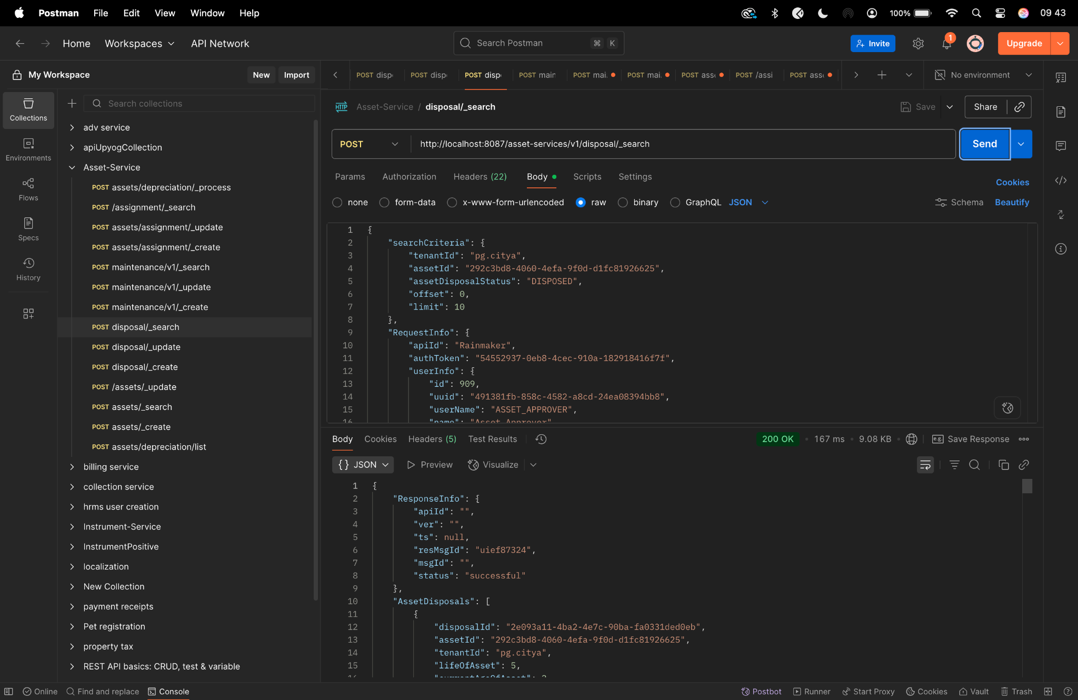

**Diff checker-**

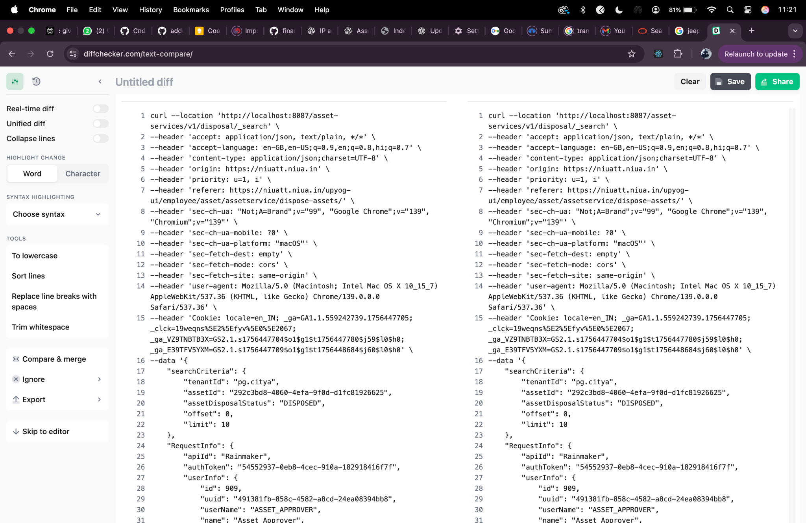

**disposal/_update-**

curl --location 'http://localhost:8087/asset-services/v1/disposal/_update' \

--header 'accept: application/json, text/plain, */*' \

--header 'accept-language: en-GB,en-US;q=0.9,en;q=0.8,hi;q=0.7' \

--header 'content-type: application/json;charset=UTF-8' \

--header 'origin: https://niuatt.niua.in' \

--header 'priority: u=1, i' \

--header 'referer: https://niuatt.niua.in/upyog-ui/employee/asset/assetservice/dispose-assets/PG-1013-2025-I-001236' \

--header 'sec-ch-ua: "Not;A=Brand";v="99", "Google Chrome";v="139", "Chromium";v="139"' \

--header 'sec-ch-ua-mobile: ?0' \

--header 'sec-ch-ua-platform: "macOS"' \

--header 'sec-fetch-dest: empty' \

--header 'sec-fetch-mode: cors' \

--header 'sec-fetch-site: same-origin' \

--header 'user-agent: Mozilla/5.0 (Macintosh; Intel Mac OS X 10_15_7) AppleWebKit/537.36 (KHTML, like Gecko) Chrome/139.0.0.0 Safari/537.36' \

--header 'Cookie: locale=en_IN; _ga=GA1.1.559242739.1756447705; _clck=19weqns%5E2%5Efyv%5E0%5E2067; _ga_VZ9TNBTB3X=GS2.1.s1756447704$o1$g1$t1756447780$j59$l0$h0; _ga_E39TFV5YXM=GS2.1.s1756447709$o1$g1$t1756448684$j60$l0$h0' \

--data '{

"AssetDisposal": {

"disposalId": "2e093a11-4ba2-4e7c-90ba-fa0331ded0eb",

"assetId": "292c3bd8-4060-4efa-9f0d-d1fc81926625",

"tenantId": "pg.citya",

"lifeOfAsset": "6",

"isAssetDisposedInFacility": true,

"currentAgeOfAsset": 2,

"disposalDate": 1756924200000,

"reasonForDisposal": "Others",

"amountReceived": 500,

"purchaserName": "",

"paymentMode": "",

"comments": "ertwrtwe-UPDATED",

"glCode": "111111",

"assetDisposalStatus": "DISPOSED",

"additionalDetails": {

"approvalNumber": "APPROVAL202501",

"disposedBy": "Jane Smith"

},

"auditDetail": {

"createdBy": "admin",

"createdTime": 1672531200000,

"lastModifiedBy": "admin",

"lastModifiedTime": 1672534800000

},

"documents": [

{

"documentType": "OWNER.RECIEPTPHOTO",

"fileStoreId": "ba740edc-006d-4a34-98d7-96dd2947c795",

"documentUid": "ba740edc-006d-4a34-98d7-96dd2947c795",

"latitude": null,

"longitude": null

}

]

},

"RequestInfo": {

"apiId": "Rainmaker",

"authToken": "54552937-0eb8-4cec-910a-182918416f7f",

"userInfo": {

"id": 909,

"uuid": "491381fb-858c-4582-a8cd-24ea08394bb8",

"userName": "ASSET_APPROVER",

"name": "Asset Approver",

"mobileNumber": "8448489439",

"emailId": null,

"locale": null,

"type": "EMPLOYEE",

"roles": [

{

"name": "Asset Approver",

"code": "ASSET_APPROVER",

"tenantId": "pg.citya"

},

{

"name": "Asset Allocator",

"code": "ASSET_ALLOCATOR",

"tenantId": "pg.citya"

}

],

"active": true,

"tenantId": "pg.citya",

"permanentCity": null

},

"msgId": "1757656020981|en_IN",

"plainAccessRequest": {}

}

}'

**Response-**

{

"ResponseInfo": {

"apiId": "Rainmaker",

"ver": null,

"ts": null,

"resMsgId": "uief87324",

"msgId": "1757656020981|en_IN",

"status": "successful"

},

"AssetDisposals": [

{

"disposalId": "2e093a11-4ba2-4e7c-90ba-fa0331ded0eb",

"assetId": "292c3bd8-4060-4efa-9f0d-d1fc81926625",

"tenantId": "pg.citya",

"lifeOfAsset": 6,

"currentAgeOfAsset": 2,

"isAssetDisposedInFacility": true,

"disposalDate": 1756924200000,

"reasonForDisposal": "Others",

"amountReceived": 500.0,

"purchaserName": "",

"paymentMode": "",

"receiptNumber": null,

"comments": "ertwrtwe-UPDATED",

"glCode": "111111",

"assetDisposalStatus": "DISPOSED",

"additionalDetails": {

"approvalNumber": "APPROVAL202501",

"disposedBy": "Jane Smith"

},

"documents": [

{

"documentId": "450356eb-e775-49e1-9fe3-1b0b24718452",

"documentType": "OWNER.RECIEPTPHOTO",

"fileStoreId": "ba740edc-006d-4a34-98d7-96dd2947c795",

"documentUid": "01f47b2b-834f-4439-9d52-cb9fe2124022",

"docDetails": null

}

],

"auditDetails": {

"createdBy": null,

"lastModifiedBy": "491381fb-858c-4582-a8cd-24ea08394bb8",

"createdTime": null,

"lastModifiedTime": 1757909815407

}

}

]

}

**Postman-**

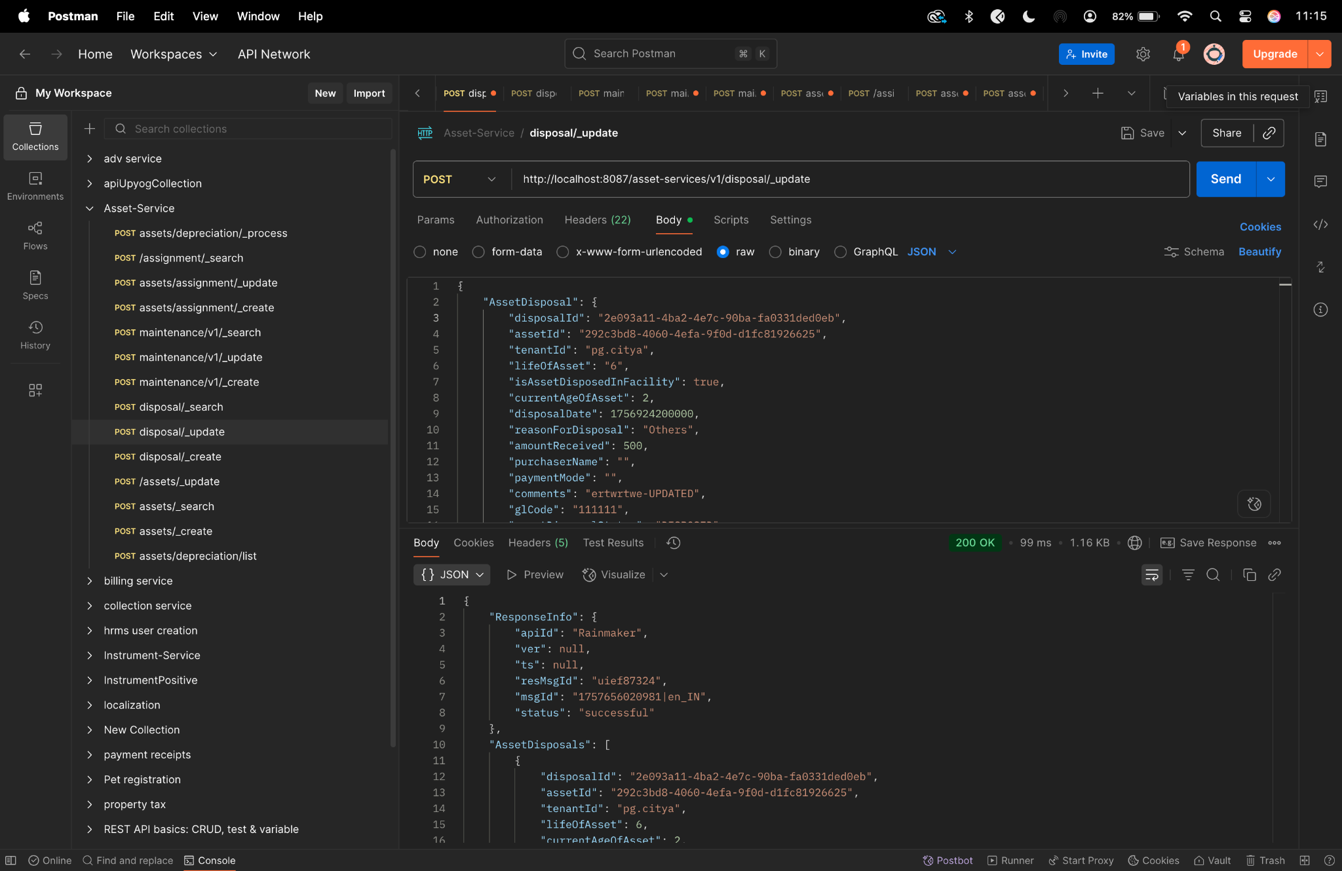

**Diff checker-**

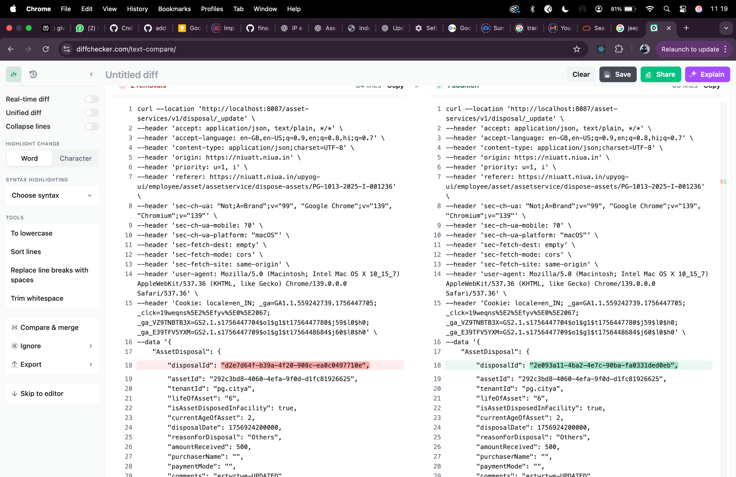

**Depreciation/_process-**

curl --location 'http://localhost:8087/asset-services/v1/assets/depreciation/_process' \

--header 'accept: application/json, text/plain, */*' \

--header 'accept-language: en-GB,en-US;q=0.9,en;q=0.8,hi;q=0.7' \

--header 'content-type: application/json;charset=UTF-8' \

--header 'origin: https://niuatt.niua.in' \

--header 'priority: u=1, i' \

--header 'referer: https://niuatt.niua.in/digit-ui/employee/asset/assetservice/my-asset' \

--header 'sec-ch-ua: "Not;A=Brand";v="99", "Google Chrome";v="139", "Chromium";v="139"' \

--header 'sec-ch-ua-mobile: ?0' \

--header 'sec-ch-ua-platform: "macOS"' \

--header 'sec-fetch-dest: empty' \

--header 'sec-fetch-mode: cors' \

--header 'sec-fetch-site: same-origin' \

--header 'user-agent: Mozilla/5.0 (Macintosh; Intel Mac OS X 10_15_7) AppleWebKit/537.36 (KHTML, like Gecko) Chrome/139.0.0.0 Safari/537.36' \

--header 'Cookie: locale=en_IN; _ga=GA1.1.559242739.1756447705; _clck=19weqns%5E2%5Efyv%5E0%5E2067; _ga_VZ9TNBTB3X=GS2.1.s1756447704$o1$g1$t1756447780$j59$l0$h0; _ga_E39TFV5YXM=GS2.1.s1756447709$o1$g1$t1756448684$j60$l0$h0' \

--data '{

"Asset": {

"tenantId": "pg.citya",

"id": "9e5f98a5-a56b-4982-8027-b011b005289a",

"accountId": ""

},

"RequestInfo": {

"apiId": "Rainmaker",

"authToken": "54552937-0eb8-4cec-910a-182918416f7f",

"userInfo": {

"id": 909,

"uuid": "491381fb-858c-4582-a8cd-24ea08394bb8",

"userName": "ASSET_APPROVER",

"name": "Asset Approver",

"mobileNumber": "8448489439",

"emailId": null,

"locale": null,

"type": "EMPLOYEE",

"roles": [

{

"name": "Asset Approver",

"code": "ASSET_APPROVER",

"tenantId": "pg.citya"

},

{

"name": "Asset Allocator",

"code": "ASSET_ALLOCATOR",

"tenantId": "pg.citya"

}

],

"active": true,

"tenantId": "pg.citya",

"permanentCity": null

},

"msgId": "1757669988361|en_IN",

"plainAccessRequest": {}

}

}'

**Response -**

{

"ResponseInfo": {

"apiId": "Rainmaker",

"ver": null,

"ts": null,

"resMsgId": "uief87324",

"msgId": "1757669988361|en_IN",

"status": "successful"

},

"Message": "Depreciation calculated successfully "

}

**Postman-**

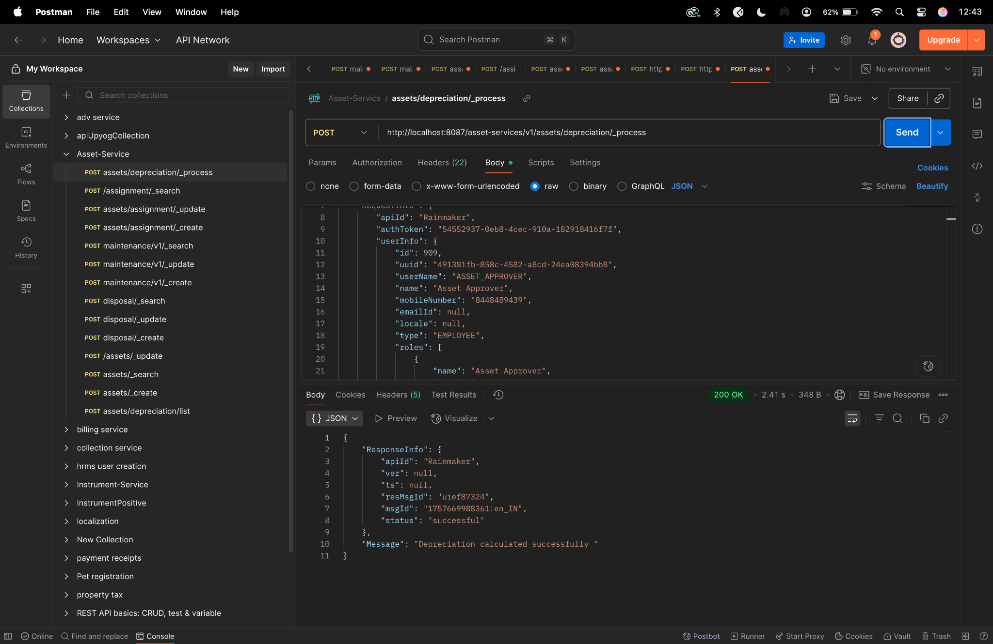

**Diff checker -**

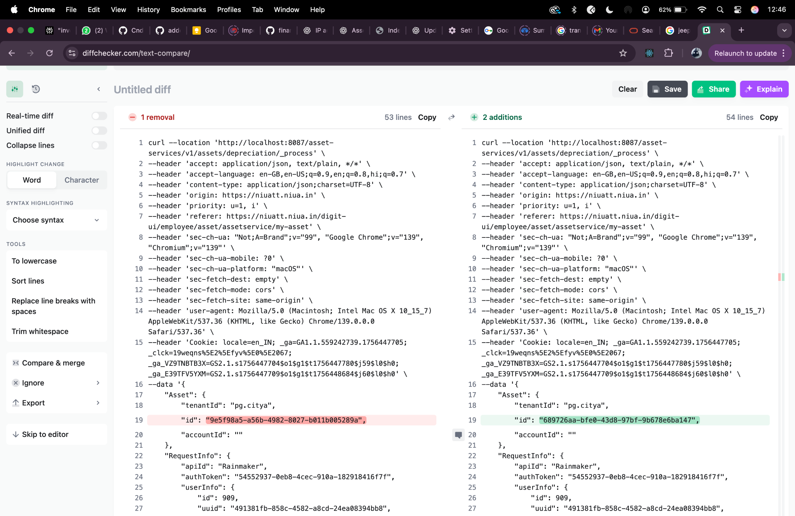

**Depreciation/list-**

curl --location 'http://localhost:8087/asset-services/v1/assets/depreciation/list' \

--header 'accept: application/json, text/plain, */*' \

--header 'accept-language: en-GB,en-US;q=0.9,en;q=0.8,hi;q=0.7' \

--header 'content-type: application/json;charset=UTF-8' \

--header 'origin: https://niuatt.niua.in' \

--header 'priority: u=1, i' \

--header 'referer: https://niuatt.niua.in/digit-ui/employee/asset/assetservice/applicationsearch/application-details/PG-1013-2025-I-001237' \

--header 'sec-ch-ua: "Not;A=Brand";v="99", "Google Chrome";v="139", "Chromium";v="139"' \

--header 'sec-ch-ua-mobile: ?0' \

--header 'sec-ch-ua-platform: "macOS"' \

--header 'sec-fetch-dest: empty' \

--header 'sec-fetch-mode: cors' \

--header 'sec-fetch-site: same-origin' \

--header 'user-agent: Mozilla/5.0 (Macintosh; Intel Mac OS X 10_15_7) AppleWebKit/537.36 (KHTML, like Gecko) Chrome/139.0.0.0 Safari/537.36' \

--header 'Cookie: locale=en_IN; _ga=GA1.1.559242739.1756447705; _clck=19weqns%5E2%5Efyv%5E0%5E2067; _ga_VZ9TNBTB3X=GS2.1.s1756447704$o1$g1$t1756447780$j59$l0$h0; _ga_E39TFV5YXM=GS2.1.s1756447709$o1$g1$t1756448684$j60$l0$h0' \

--data '{

"Asset": {

"tenantId": "pg.citya",

"id": "9e5f98a5-a56b-4982-8027-b011b005289a",

"accountId": ""

},

"RequestInfo": {

"apiId": "Rainmaker",

"authToken": "54552937-0eb8-4cec-910a-182918416f7f",

"userInfo": {

"id": 909,

"uuid": "491381fb-858c-4582-a8cd-24ea08394bb8",

"userName": "ASSET_APPROVER",

"name": "Asset Approver",

"mobileNumber": "8448489439",

"emailId": null,

"locale": null,

"type": "EMPLOYEE",

"roles": [

{

"name": "Asset Approver",

"code": "ASSET_APPROVER",

"tenantId": "pg.citya"

},

{

"name": "Asset Allocator",

"code": "ASSET_ALLOCATOR",

"tenantId": "pg.citya"

}

],

"active": true,

"tenantId": "pg.citya",

"permanentCity": null

},

"msgId": "1757670044190|en_IN",

"plainAccessRequest": {}

}

}'

**Response -**

{

"ResponseInfo": {

"apiId": "",

"ver": "",

"ts": null,

"resMsgId": "uief87324",

"msgId": "",

"status": "successful"

},

"DepreciationDetails": [

{

"id": 346,

"assetId": "9e5f98a5-a56b-4982-8027-b011b005289a",

"fromDate": "2021-03-04",

"toDate": "2022-03-04",

"depreciationValue": 758.8,

"bookValue": 2276.4,

"rate": 20.0,

"oldBookValue": 3035.2,

"createdAt": "2025-09-15 07:13:44",

"updatedAt": null,

"createdBy": "491381fb-858c-4582-a8cd-24ea08394bb8",

"updatedBy": null,

"depreciationMethod": "SLM"

},

{

"id": 347,

"assetId": "9e5f98a5-a56b-4982-8027-b011b005289a",

"fromDate": "2022-03-04",

"toDate": "2023-03-04",

"depreciationValue": 758.8,

"bookValue": 1517.6,

"rate": 20.0,

"oldBookValue": 2276.4,

"createdAt": "2025-09-15 07:13:44",

"updatedAt": null,

"createdBy": "491381fb-858c-4582-a8cd-24ea08394bb8",

"updatedBy": null,

"depreciationMethod": "SLM"

},

{

"id": 348,

"assetId": "9e5f98a5-a56b-4982-8027-b011b005289a",

"fromDate": "2023-03-04",

"toDate": "2024-03-04",

"depreciationValue": 758.8,

"bookValue": 758.8,

"rate": 20.0,

"oldBookValue": 1517.6,

"createdAt": "2025-09-15 07:13:44",

"updatedAt": null,

"createdBy": "491381fb-858c-4582-a8cd-24ea08394bb8",

"updatedBy": null,

"depreciationMethod": "SLM"

},

{

"id": 349,

"assetId": "9e5f98a5-a56b-4982-8027-b011b005289a",

"fromDate": "2024-03-04",

"toDate": "2025-03-04",

"depreciationValue": 758.8,

"bookValue": 0.0,

"rate": 20.0,

"oldBookValue": 758.8,

"createdAt": "2025-09-15 07:13:44",

"updatedAt": null,

"createdBy": "491381fb-858c-4582-a8cd-24ea08394bb8",

"updatedBy": null,

"depreciationMethod": "SLM"

},

{

"id": 345,

"assetId": "9e5f98a5-a56b-4982-8027-b011b005289a",

"fromDate": "2020-03-04",

"toDate": "2021-03-04",

"depreciationValue": 758.8,

"bookValue": 3035.2,

"rate": 20.0,

"oldBookValue": 3794.0,

"createdAt": "2025-09-15 07:13:43",

"updatedAt": null,

"createdBy": "491381fb-858c-4582-a8cd-24ea08394bb8",

"updatedBy": null,

"depreciationMethod": "SLM"

}

]

}

**Postman-**

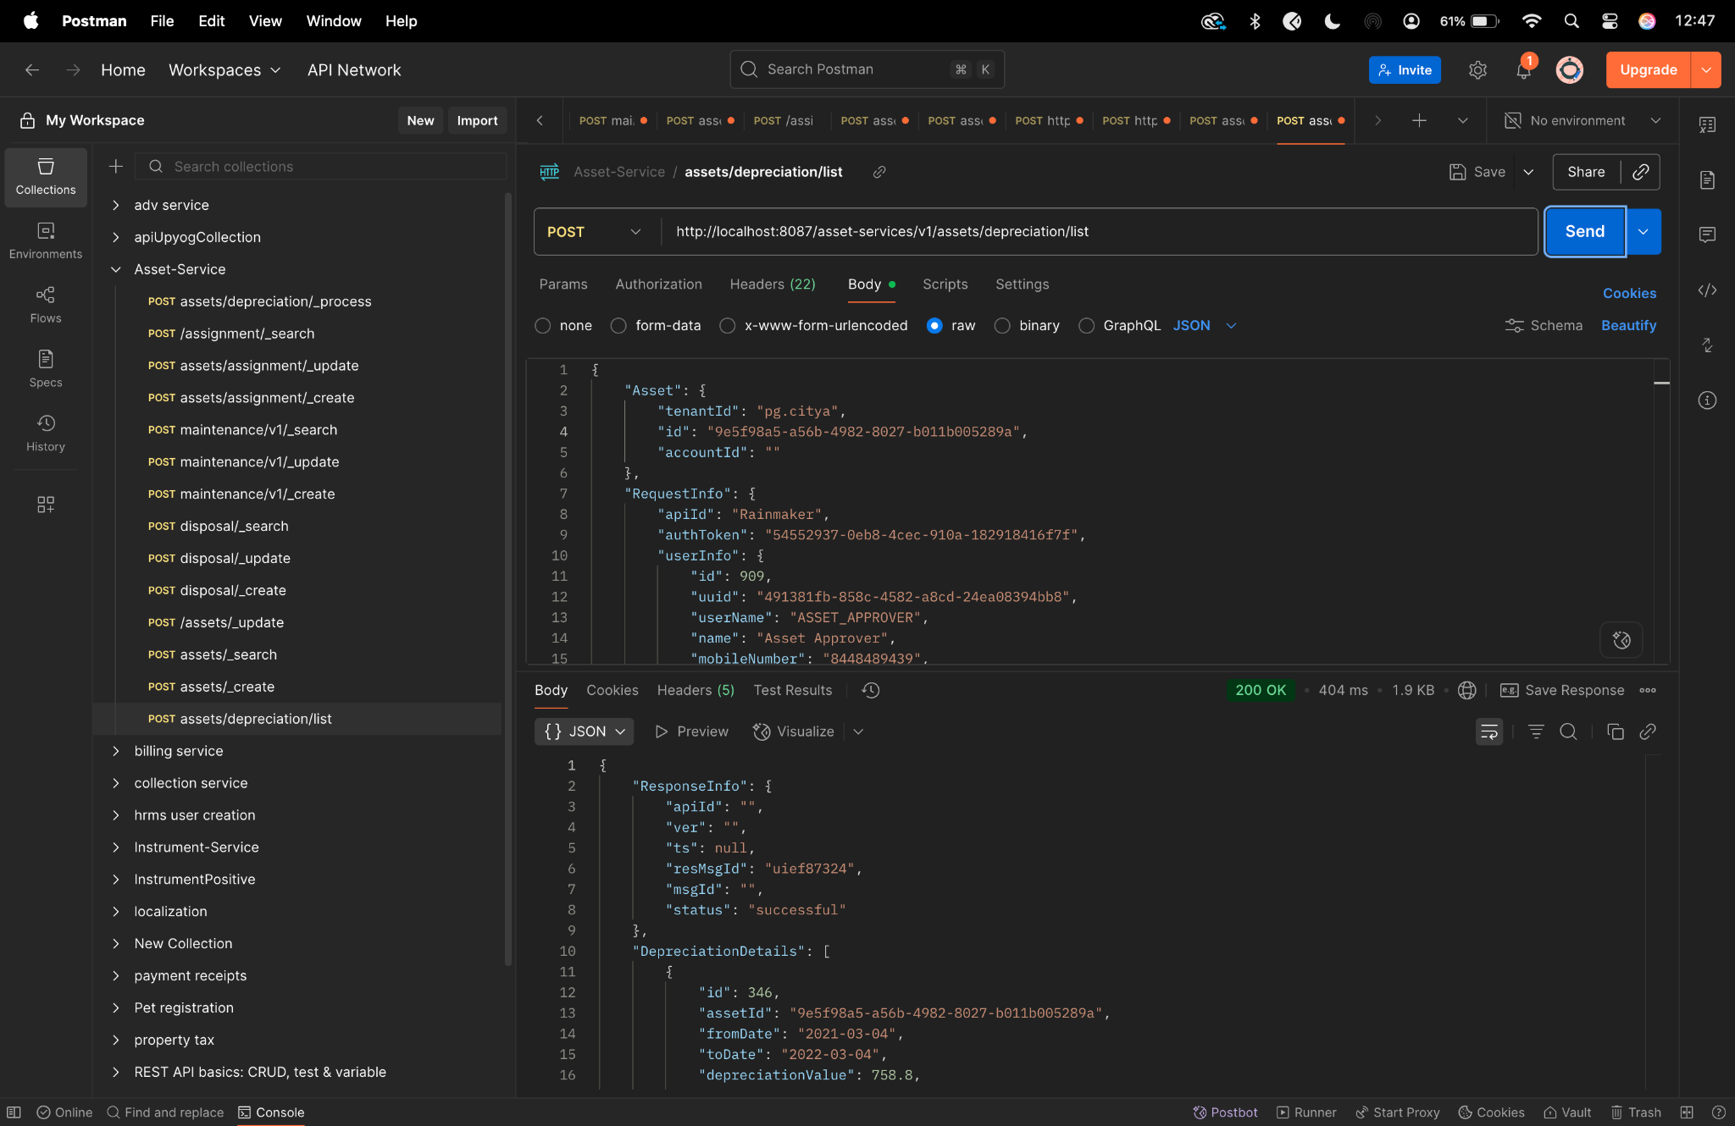

**Diff checker-**

